Use this form to apply for a grant to provide
community-led healthy meals

Important: Save this form on your computer/device and when complete, email it to commissioning@norwich.gov.uk

You must read the guidance note before starting to complete this application form

Using money from Norfolk County Council’s Public Health we are offering grants for organisations to deliver a series of community-led meals, designed to bring residents together and provide opportunities to find out more or develop healthy food cooking skills.

We are looking for interesting and innovative ideas for how local communities can be engaged through these meals to promote healthy-eating as well as to reduce loneliness and improve wellbeing. We are keen to see proposals from a range of organisations that are well placed to engage residents who may benefit from these meals, whether a local pub or café, a community group or school.

The maximum amount you can apply for each series of meals is £500. If you are proposing to deliver more than one series of meals, you can include them on one application form.

The deadline for submitting your application is Thursday 31 January 2019

When you have completed the application form please save it and email it as an attachment to: commissioning@norwich.gov.uk.

If you need to complete the form as a paper copy, please contact us and we can provide a printed form and the address to return it.

You will receive confirmation of receipt of your application by email. Following this your application will be assessed by council officers. The guidance notes include dates for what happens after assessment.

Please note that any personal details given on this form such as names and contact details are only used for the purpose of this grant. Your details will not be used elsewhere and will be kept safe and secure. If at any time you wish to have your data removed from our storage, please ask and this will be done.

 | Organisation details
Organisation name
Name of main contact
Position
 | Address (if there are no confirmed premises please include the address of the person applying)
Postcode
Contact telephone |  |  | Email

What type of organisation are you? Please tick

Registered charity
Company limited by guarantee
Unincorporated club or association
Community Interest Group
Charitable Incorporated Organisation
Other – please state

Declaration

Please confirm that you have read the guidance for applicants and are authorised to make this application on behalf of the organisation named above by signing below

------------------------------------------------------------------------------------------

1. Please tell us, briefly, about your proposed community meals project
Please tell us:
- Where and when you will be running the meals?
- How many meals you will be running (we are hoping to see a series of 5 or more meals)?
- Who you will be targeting to attend the meals and how you will let them know about the project?
- How many people you expect to attend each meal?
- Who will cook the meals and run the events?

2. How will you use the meals to deliver the outcomes set out in the guidance, particularly to encourage or support attendees to think differently about healthy eating or develop new skills in this area?

3. a. How much funding are you applying for?
b. What do you plan to spend it on?

4. What do you need to get in place before the meals begin?
We may be able help you with these things if you do not already have them in place

- Have volunteers been Food Safety trained? YES NO
- Have you got a confirmed venue to work from? YES NO
- Is the organisation registered for food provision at the venue? YES NO

7. Does your organisation have any of the following?
If you already have them, please put a Y in the box. If we think you need any of the others, we will let you know and will offer you support to develop them. We may ask to see copies if your application is successful
Constitution |  | Public liability insurance
Volunteer policy or statement |  | Health and safety policy or statement
Equal opportunities policy |  | Complaints procedure
Disciplinary and grievance procedure |  | Safeguarding children policy or statement
Safeguarding vulnerable adults policy or statement |  | Risk assessments

8. In order to receive a grant you will need a bank account in your organisation’s name. If you are a community group this will need to be set up with at least two unrelated signatories. Do you already have this set up?
If you don’t have this yet we can still approve your award but we cannot release the funds until we see evidence of the account and get the sort code and account number.

Checklist for submitting:

 | YES | N/A
Have you answered every question where you can?

Have you asked for help if you’re unsure (commissioning@norwich.gov.uk)
Have you saved this form and attached ready to email?

If the answers are ‘yes’ then you’re ready to email your application to commissioning@norwich.gov.uk

You will receive email confirmation that we have received your application

Showing your impact

If your application is successful we will provide you with a simple evaluation framework to complete. We will send this to you before you get started. This will enable us to evaluate the whole project by gathering the same data from each series of meals.

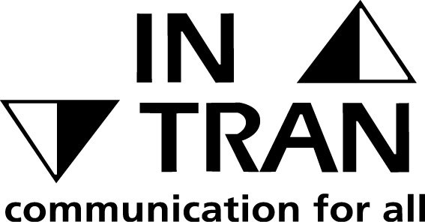

If you would like this document in large print, Braille, audiotapes, or translated in to another language, please call 0344 980 3333 or email info@norwich.gov.uk

