Appendix C - Site Policies
Contents
Introduction 2
Context 2
Background 3
Meeting the Need for Pitches 4
Consideration of Equalities Issues 6
Responding to this Consultation 6
Future Work in Allocating Gypsy and Traveller Sites 7
Favoured Sites 8
Policy GNLP5004 Land off Buxton Road, Cawston 8
Policy GNLP5005 Wymondham Recycling Centre, Strayground Lane, Wymondham 10
Policy GNLP5009 Hockering Lane, Bawburgh 12
Policy GNLP5014 A47 North Burlingham Junction 14
Policy GNLP5019 Woodland Stable, Shortthorn Road, Stratton Strawless 16
Policy GNLP5020 Romany Meadow, The Turnpike, Carleton Rode 18
Policy GNLP5021 Land of Holt Road, Horsford 20
Policy GNLP5022 Land off Reepham Road, The Oaks, Foulsham 22
Policy GNLP5023 Land of Strayground Lane, Wymondham 25
Policy GNLP5024 Upgate Street, Carleton Rode 27
Reasonable Alternative Site 29
Policy GNLP5013 Ketteringham Depot Land west of Station Lane, Ketteringham 29
Contingency Site 31
Proposed Change to Policy GNLP0581/2043: Land off Bawburgh Lane, north of New Road and east of A47 – incorporation of a Gypsy and Traveller site into the Costessey contingency site allocation 31
Unreasonable Alternatives 33
VCHAP Site 1 and Site 2, Middle Road, Denton 34
VCHAP Site 3, Land off London Road, Suton, Wymondham 35

Introduction

- The Greater Norwich authorities (Broadland, Norwich and South Norfolk - the ‘Partnership’) submitted the Greater Norwich Local Plan (GNLP) for independent examination in July 2021.

- In resolving to submit the GNLP for independent examination, the partnership councils agreed to “proactively identify and bring forward sufficient Gypsy and Traveller sites to meet identified needs in accordance with the criteria-based policies of the current and emerging Development Plans”.

- During the GNLP hearing sessions in February/March 2022 the inspectors indicated that they would require Gypsy and Traveller accommodation needs to be addressed through site allocations in the plan in accordance with the expectations set out in paragraph 68 of the NPPF.

- This document responds by considering 10 favoured sites to provide permanent residential pitches for Gypsies and Travellers, 1 reasonable alternative site and an opportunity provided by proposed changes to the policy for an existing contingency site for housing development at Costessey.

- Three sites have been submitted for consideration through the South Norfolk Village Clusters Plan which have been rejected as “unreasonable”. As a result, no policies for these sites have been included in this document. However, maps for these sites are included and comments can be submitted. More information on the reasons for classifying the sites as unreasonable is in the Site Assessment Information document.

- This consultation also provides a further opportunity for landowners to propose more sites for Gypsies and Travellers.

Context

- The July 2021 submission of the GNLP to the Secretary of State stated that a further 64 pitches for Gypsies and Travellers will be required across Greater Norwich by the end of the plan period in 2038. Since then, the Partnership has kept its requirement under review and has continued working with RRR Consultancy (‘RRR’) to produce a new Gypsy and Traveller Accommodation Assessment (‘GTAA’) which was produced in June 2022.

- The GTAA, with the most recent updates, shows there are 132 permanent authorised Gypsy and Traveller pitches in Greater Norwich. This consists of 98 existing authorised pitches, 24 potential sites with planning permission that will be built, 4 vacant pitches, and 6 transit pitches (although the latter are currently not occupied). Also, the 2011 Census shows there were 354 Gypsies and Travellers living in the area, representing 0.09% of the total population.

Background

- The requirements for providing Gypsy and Traveller sites are set out in the National Planning Policy Framework (NPPF) (2021). Paragraph 68 of the NPPF sets out that local plans should include specific deliverable sites for years 1 to 5 of the plan period and developable sites for years 6-10 and where possible years 11-15.

- The allied guidance to the NPPF specifically for Gypsies and Travellers is called the Planning Policy for Travellers Sites (PPTS) (2015). This makes the same point at paragraph 10 about local plans having ‘specific deliverable sites sufficient to provide 5 years-worth of sites against their locally set targets… [and] specific, developable sites, or broad locations for growth, for years 6 to 10 and, where possible, for years 11-15’.

- The PPTS also contains a definition of Gypsies and Travellers for planning purposes which focuses on people who continue to lead a nomadic lifestyle, as opposed to those households who are Gypsies and Travellers by ethnic background but who have permanently ceased to travel. However, this definition was the subject of a Court of Appeal decision in October 2022. The judgment concluded that the PPTS discriminates against Gypsies and Travellers who have ceased to travel due to disability or old age. No data is currently available to fully answer the question that the court case raises as it is not possible to determine how many Gypsies and Travellers living in bricks and mortar accommodation would want to move back into a caravan, including those who have ceased to travel through age or disability. Work for the GNLP is ongoing on this issue.

- As required by national planning policy, the Partnership has evidence showing how many Gypsy and Traveller pitches the Greater Norwich area needs. This evidence was commission from RRR. The GTAA that RRR produced found a total need for 50 residential pitches to meet the total ethnic need. This figure has since been revised to 53 pitches as more recent evidence has shown that refurbishment work at the existing Swanton Road site in Norwich will deliver 3 fewer pitches than was originally expected.

- Using the GTAA as the evidence base and applying the most recent information about sites under construction, the need for 53 pitches to meet ethnic needs to the timescales in Table 1 below has been identified:

  - Table 1 Pitch Numbers for the Ethnic Need Requirement
Ethnic Requirement | Time Period | Pitches
Specific Sites for Year 1 to 5 | April 2022 to March 2027 | 31
Specific sites or broad locations for Years 6 to 10 | April 2027 to March 2032 | 10
Specific Sites or broad locations for Years 11-15 | April 2032 to March 2037 | 10
Specific Sites or broad locations for Year 16 | April 2027 to March 2038 | 2
Total |  | 53

Meeting the Need for Pitches

- The Partnership recognises the benefits of a plan-led approach to providing suitable sites for Gypsies and Travellers. We are consulting on a choice of possible sites so that the best available sites can be identified.

- The very recent appeal court decision suggests that providing sufficient pitches to ensure that the full ethnic need can be met should prevent any potential unlawful discrimination. Legal advice has confirmed that this is the case. It could also provide the strongest guarantee that full needs can be met.

- This consultation includes 10 favoured sites along with a reasonable alternative site and the potential opportunity provided by the submitted housing contingency site as follows:

Table 2: Favoured Sites
Reference | Address | Pitches | Pitches Delivered years 1 to 5
GNLP5004 | Land off Buxton Road, Eastgate, Cawston | 4 | 4
GNLP5005 | Strayground Lane, Wymondham Recycling Centre | 2 | 0
GNLP5009 | Hockering Lane, Bawburgh | 6 | 6
GNLP5014 | A47 North Burlingham Junction | 15 | 15
GNLP5019 | Woodland Stable, Shortthorn Road, Stratton Strawless | 4 | 4
GNLP5020 | Romany Meadow, The Turnpike, Carleton Rode | 6 | 6
GNLP5021 | The Old Produce Shop, Holt Road, Horsford | 6 | 6
GNLP5022 | The Oaks, Foulsham | 5 | 5
GNLP5023 | Strayground Lane, Wymondham | 10 | 10
GNLP5024 | Upgate Street, Carleton Rode | 4 | 4
Total |  | 62 | 60

Table 3: Reasonable Alternative
Reference | Address | Pitches | Pitches Delivered years 1 to 5
GNLP5013 | Ketteringham Depot | 10 | 0
Total |  | 10 | 0
Table 4: Proposed change to Contingency Site
Reference | Address | Pitches | Pitches Delivered years 1 to 5
GNLP5007R | Costessey Contingency Site | 18 | 0
Total |  | 18 | 0

- The Partnership is confident that allocations to meet needs can be found from its list of favoured, reasonable and contingency sites.

- This public consultation is an important part of the plan-making process as responses could provide feedback which alters the favoured sites currently identified.

- In addition to the proposed allocations in this consultation, windfall sites on non-allocated locations could also come forward through planning applications. Existing development management policies which are currently used to assess such applications will be supplemented by policy 5 of the GNLP on adoption of the plan.

- From analysing past trends, the Partnership estimates that 8 pitches are likely to be built over the current 5-year period between April 2022 and March 2027 on windfall sites.

- In combination, the supply of pitches from consultation sites and windfall pitches that are anticipated would comfortably meet the identified need for pitches under the ethnic definition of need.

Consideration of Equalities Issues

- The GNLP has been prepared with regard to the Public Sector Equality Duty, as defined by the Equality Act 2010 and an Equalities Impact Assessment (EqIA) accompanies the submission draft of the plan (document A10).

- This Focused Consultation is a further positive step in meeting the Public Sector Equality Duty because Gypsies and Travellers are a key ethnic minority in the area and making specific site allocations will give added assurance that this group’s housing needs are addressed.

Responding to this Consultation

- There are consultation questions for the favoured, reasonable alternative and proposed change to the contingency site, as well as the opportunity to comment on the non-inclusion of unreasonable sites. These will allow respondents to express their support or objections and to give comments. The submitted opinions and comments will be published on the GNLP website and will be used in assessing which sites are progressed as allocations.

- Ideally, consultation responses should be submitted online at www.gnlp.org.uk. However, written responses can also be made on a response form that can be requested by telephoning 01603 306603, emailing gnlp@norfolk.gov.uk or downloading from www.gnlp.org.uk.

- The following supporting documents provide site by site analysis. They are intended to assist respondents in commenting on issues such as access to local facilities, landscape impact and ecological impact so that the best sites are chosen and they are built out in the best possible way:

  - Site Assessment Information (Appendix D for Cabinet Reports - Insert links when available)
  - Sustainability Appraisal of the Greater Norwich Local Plan Gypsy and Traveller Sites and Policies by Lepus Consulting (Appendix E for Cabinet Reports- Insert links when available)
  - Habitats Regulations Assessment of published Proposed Submission Greater Norwich Local Plan – Gypsy and Traveller Sites Addendum by The Landscape Partnership. (Appendix F for Cabinet Reports- Insert links when available)
- A review of new and carried forward residential, employment and mixed-use allocations was undertaken which concludes that none of the allocations in the GNLP have the potential to accommodate pitches for Gypsies and Travellers. (Appendix F for Cabinet Reports- Insert links when available).

- Please follow the links above to comment on these supporting documents.

Future Work in Allocating Gypsy and Traveller Sites

- Following the close of the consultation on 13th March 2023 the GNLP team will process and analyse the responses received and finalise the preferred site allocations for consideration by the authorities in June 2023. The councils will then decide on submitting the Gypsy and Traveller sites into the GNLP process. If this is agreed, the finalised sites information and representations will be provided to the inspectors for their consideration. Hearing sessions and possible modifications to the plan will follow.

- Main modifications to the GNLP are expected to be consulted on in Autumn 2023. This will provide a further opportunity to comment on selected sites and allow the Inspectors to produce their report on the plan before the end of 2023, with adoption anticipated early in 2024.

Favoured Sites

Policy GNLP5004 Land off Buxton Road, Eastgate, Cawston

- This privately owned greenfield site is located on the Buxton Road in the hamlet of Eastgate to the south-east of Cawston.

- Additional landscaping is required as part of the design and layout of the scheme to enhance screening and to maintain the residential amenity of adjoining properties. An archaeological assessment is also required prior to development due to the site being close to an area of Roman settlement.
Policy GNLP5004

Land off Buxton Road, Eastgate, Cawston (0.12 ha) is allocated for a permanent residential Gypsy and Travellers site. The site will accommodate approximately 4 residential Gypsy and Traveller pitches.

The development will address the following site-specific matters:

- Access will be via Buxton Road. Any trees or hedgerow lost to form the access or visibility splay must be compensated for with new planting within the development.
- Additional landscaping will be provided to enhance screening and to maintain the residential amenity of adjoining properties.
- An archaeological assessment will be required prior to development.
- The residential pitches shall not be occupied by any persons other than Gypsies and Travellers and their families.

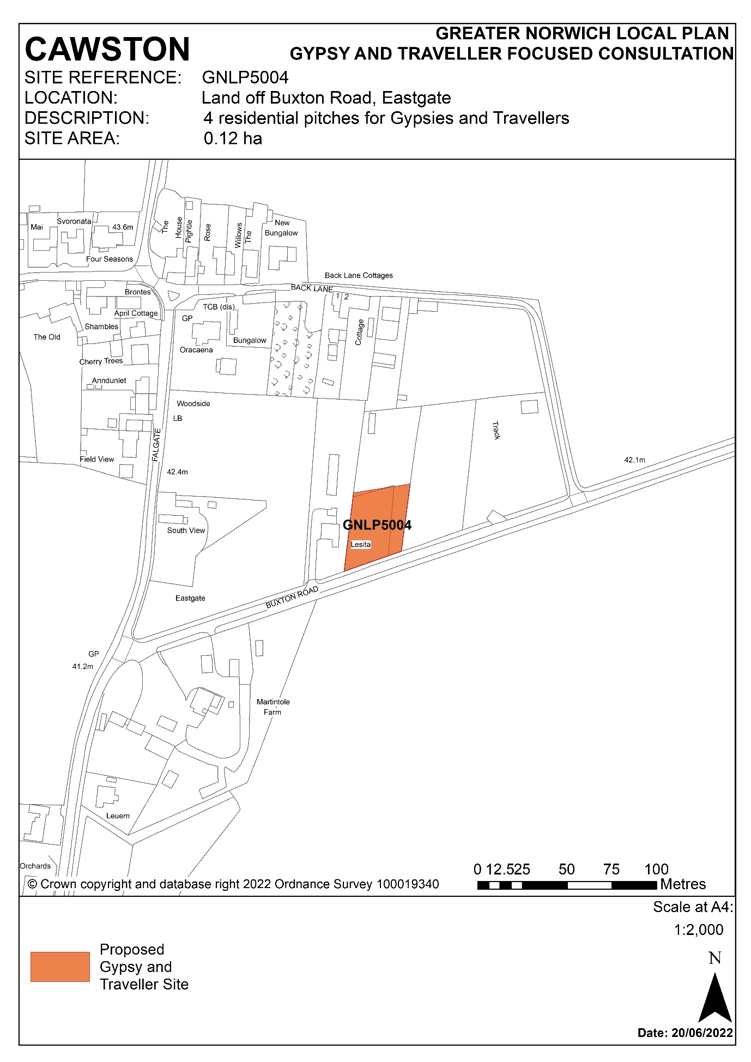

Policy GNLP5005 Land at Strayground Lane Wymondham Recycling Centre, , Wymondham

- This is a publicly owned brownfield site that is expected to become vacant due to the decision to relocate Wymondham Recycling Centre. Strayground Lane is a quiet country road that connects to the built edge of Wymondham to the north via Whartons Lane. The Bays River Meadow North County Wildlife Site is located to the north, and partly overlaps the site, and immediately to the west is an established paving business.

- The redevelopment of this site will require local highways improvements, consideration of noise and dust from neighbouring activities, investigation of possible land contamination from previous uses, and conducting an ecological assessment prior to development due to the neighbouring County Wildlife Site.
Policy GNLP5005

Land at Strayground Lane Wymondham (0.07 ha), currently the Wymondham Recycling Centre, is allocated for a residential Gypsy and Traveller site. The site will accommodate approximately 2 residential Gypsy and Traveller pitches.

The development will address the following site-specific matters:

- Access will be via Strayground Lane using the existing vehicular access for the recycling centre.
- Improvements will be required to the passing bays along Strayground Lane and an adequate visibility is required at the junction of Whartons Lane with London Road (the B1172).
- A contaminated land assessment is required, and any mitigation must be completed prior to development.
- An ecological assessment must be carried out and any identified impacts on nearby sites mitigated.
- Pollution mitigation measures are required as the site is within the catchment of groundwater source protection zone (III).
- The residential pitches shall not be occupied by any persons other than Gypsies and Travellers and their families.

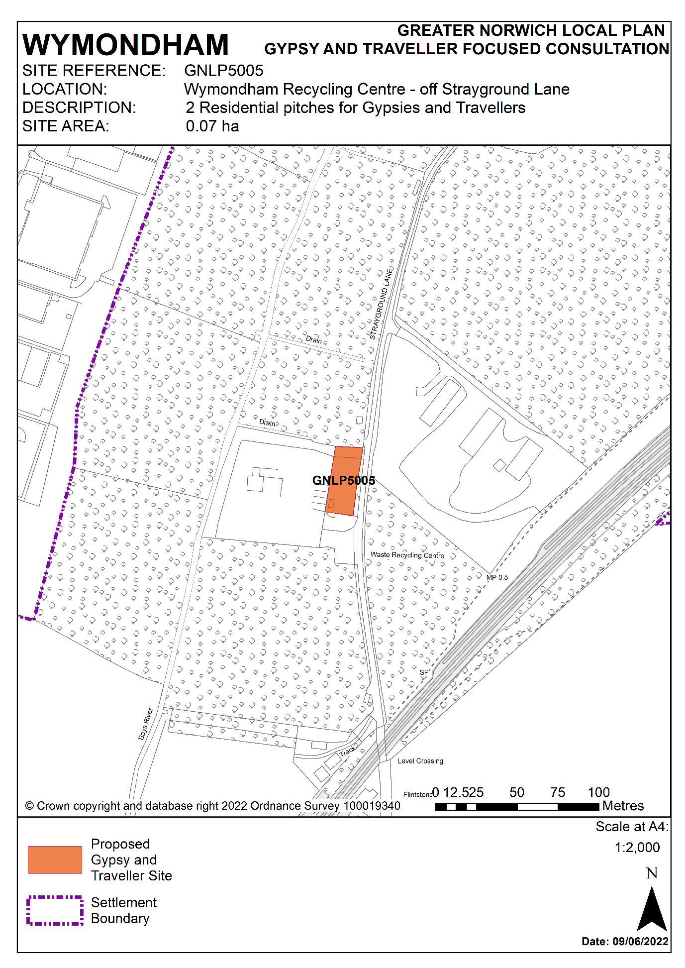

Policy GNLP5009 Land off Hockering Lane, Bawburgh

- The is a privately owned greenfield site to the east of Hockering Lane in Bawburgh. The site, which measures 0.59 ha, is part of an agricultural field that is bounded to the north, east and west by trees and hedges, whilst the remainder of the field is to the south.

- An issue that will affect the design and layout of the site is a Cadent gas pipeline running north to south through the western part of the site. This will limit the number of pitches that can be positioned on the western part of the site and will require engagement with the Health & Safety Executive (HSE). Other considerations are that prior to development an ecological assessment will be required due to there being potential habitats for Great Crested Newts on-site, and an archaeological investigation is needed as some prehistoric features have been identified on adjacent land.
Policy GNLP5009

Land off Hockering Lane Bawburgh (0.59 ha) is allocated for a residential Gypsy and Traveller site. The site will accommodate approximately 6 residential Gypsy and Traveller pitches.

The development will address the following site-specific matters:

- Access will be from Hockering Lane via a private road, therefore third-party rights of access will be required.
- An ecological assessment must be carried out and any identified impacts on protected species and nearby sites mitigated.
- An archaeological assessment will be required prior to development.
- Development will be designed to avoid impacts to and from the underground gas pipeline.
- The residential pitches shall not be occupied by any persons other than Gypsies and Travellers and their families.

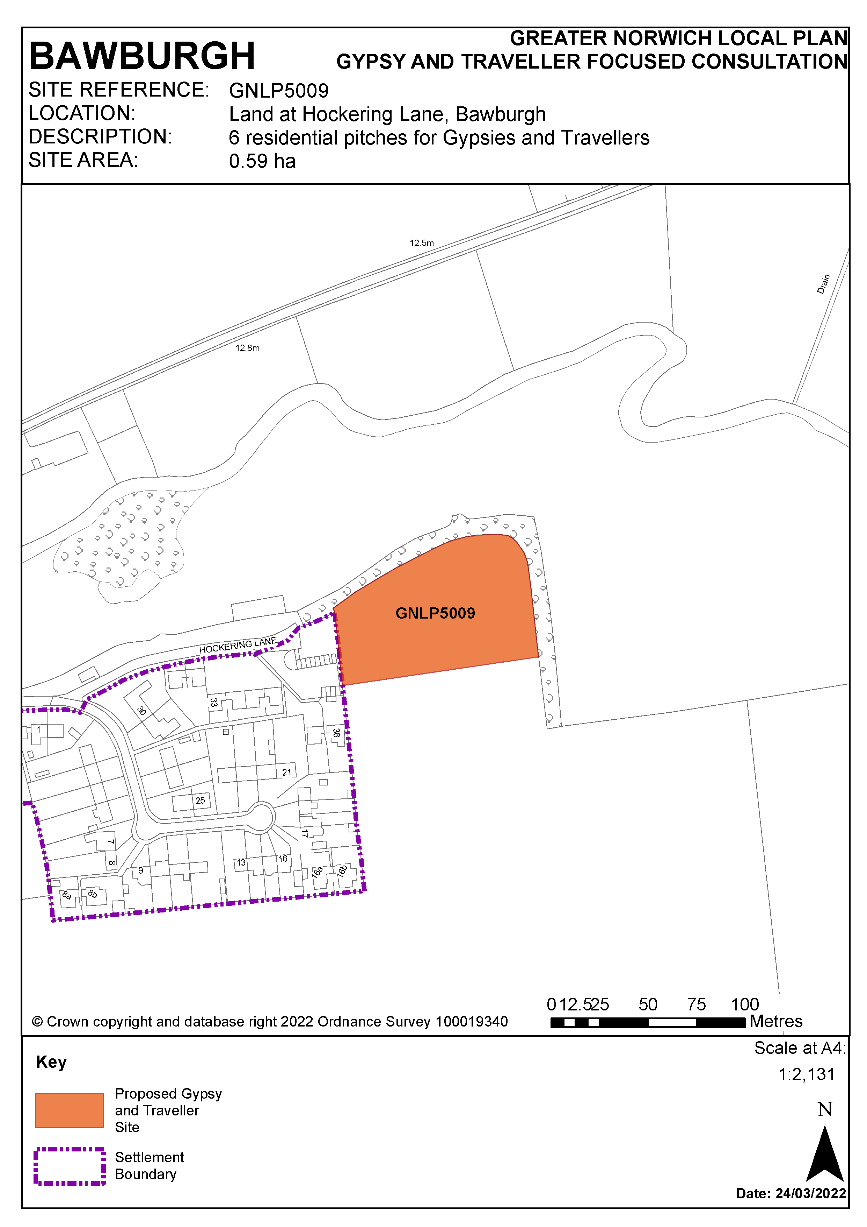

Policy GNLP5014 A47 North Burlingham Junction

- This is a broad location of 2.48 ha providing for a site of up to 1 hectare for approximately 15 residential pitches for Gypsies and Travellers. The land in this broad location is in public ownership which will facilitate delivery of a site once the forthcoming A47 road improvements from Blofield to North Burlingham have been completed.

- The proximity to the A47 and its associated road improvement scheme presents noise and air quality issues that will require mitigation through the design of the development. Landscaping and tree planning will also be required to preserve the character of the surrounding area and views of non-designated heritage assets.
Policy GNLP5014

Land off A47 North Burlingham Junction is allocated as a 2.48 ha broad location for a residential Gypsy and Traveller site within which a 1 ha site will accommodate approximately 15 residential Gypsy and Traveller pitches.

The development will address the following site-specific matters:

- Access will be from the stopped-off road linking to the newly aligned B1140.
- Noise and air quality investigations will be required, with provision of a layout and design that incorporates a landscape buffer to the nearby major roads and noise mitigation measures to protect residential amenity.
- Landscaping and tree planting will be required to preserve the landscape character of the surrounding area and to protect views of non-designated heritage assets nearby.
- The residential pitches shall not be occupied by any persons other than Gypsies and Travellers and their families.

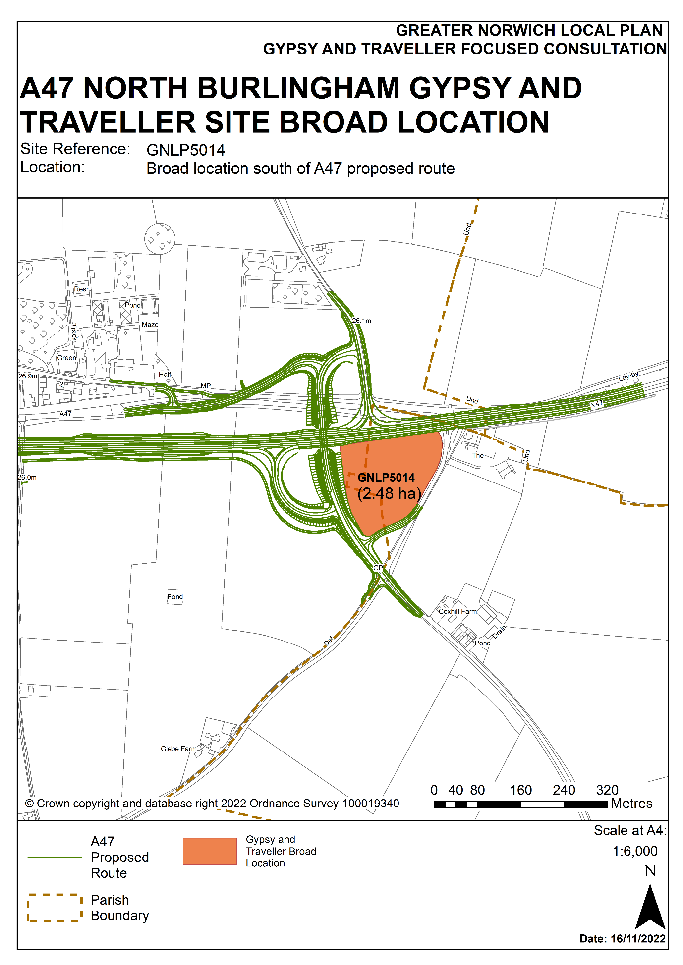

Policy GNLP5019 Woodland Stable, Shortthorn Road, Stratton Strawless

- This is a privately owned greenfield site which will extend a well-established privately owned Gypsy and Traveller site known as Woodland Stable located on Shortthorn Road in Stratton Strawless. The allocation of GNLP5019 will result in an expansion from the existing 9 pitches to 17 pitches in total.

- Prior to development an ecological assessment is required due to the surrounding trees and the potential habitat for protected species.

- The land shown as GNLP5019 already has planning permission for 4 pitches (20211657). This allocation therefore adds 4 pitches to the number already consented at Woodland Stable.
Policy GNLP5019

Woodland Stable, Shortthorn Road, Stratton Strawless (0.33 ha) is allocated for a residential Gypsy and Traveller site. The site will accommodate approximately 8 additional residential Gypsy and Traveller pitches.

The development will address the following site-specific matters:

- Access should be via the existing access off Shortthorn Road that serves the Woodland Stables site.
- An ecological assessment must be carried out and any identified impacts on protected species and nearby sites mitigated.
- The residential pitches shall not be occupied by any persons other than Gypsies and Travellers and their families.

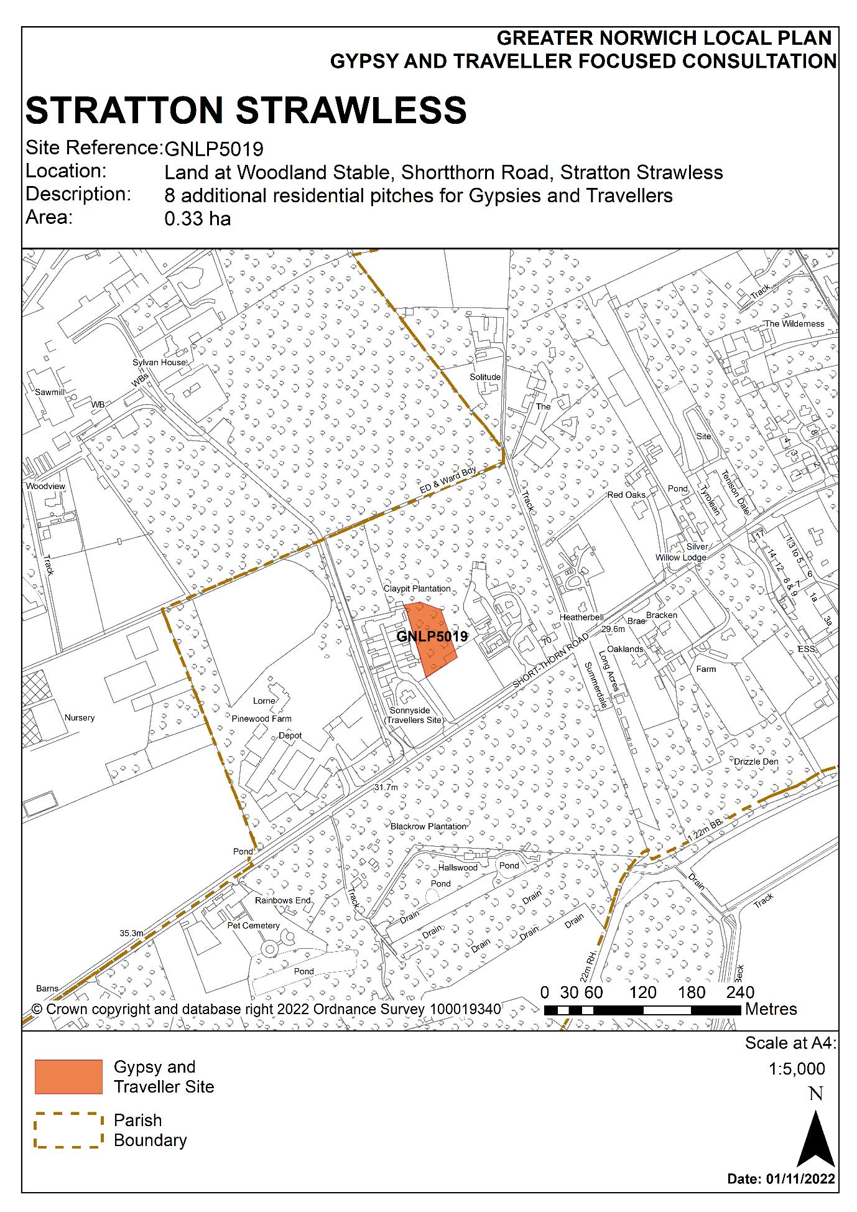

Policy GNLP5020 Romany Meadow, The Turnpike, Carleton Rode

- This is a privately owned greenfield site which will extend a well-established Gypsy and Traveller site known as Romany Meadow on The Turnpike, Carleton Rode. The allocation of GNLP5020 will result in an expansion from the existing 6 pitches to 12 pitches in total.

- Site specific issues will impact on the design of the development. A surface water flow path that crosses the southern part of the site is likely to limit where caravans and other structures can be located, and additional landscaping is required at the boundaries of the site to protect views of nearby listed buildings. An ecological assessment is also required due to the proximity of nearby mature trees and hedgerows.
Policy GNLP5020

Land off the B1113 (0.54 ha) at Romany Meadow, The Turnpike, Carleton Rode is allocated for a residential Gypsy and Traveller site. The site will accommodate approximately 6 additional residential Gypsy and Traveller pitches.

The development will address the following site-specific matters:

- Access should be via the existing access off The Turnpike that serves the Romany Meadow site.
- A surface water flood risk assessment must be carried out with caravans and other structures positioned away from areas at surface water flood risk.
- An ecological assessment must be carried out and any identified impacts on protected species and nearby sites mitigated.
- Landscaping and tree planting will be required to preserve the landscape character of the surrounding area and to protect views of nearby listed buildings.
- The residential pitches shall not be occupied by any persons other than Gypsies and Travellers and their families.

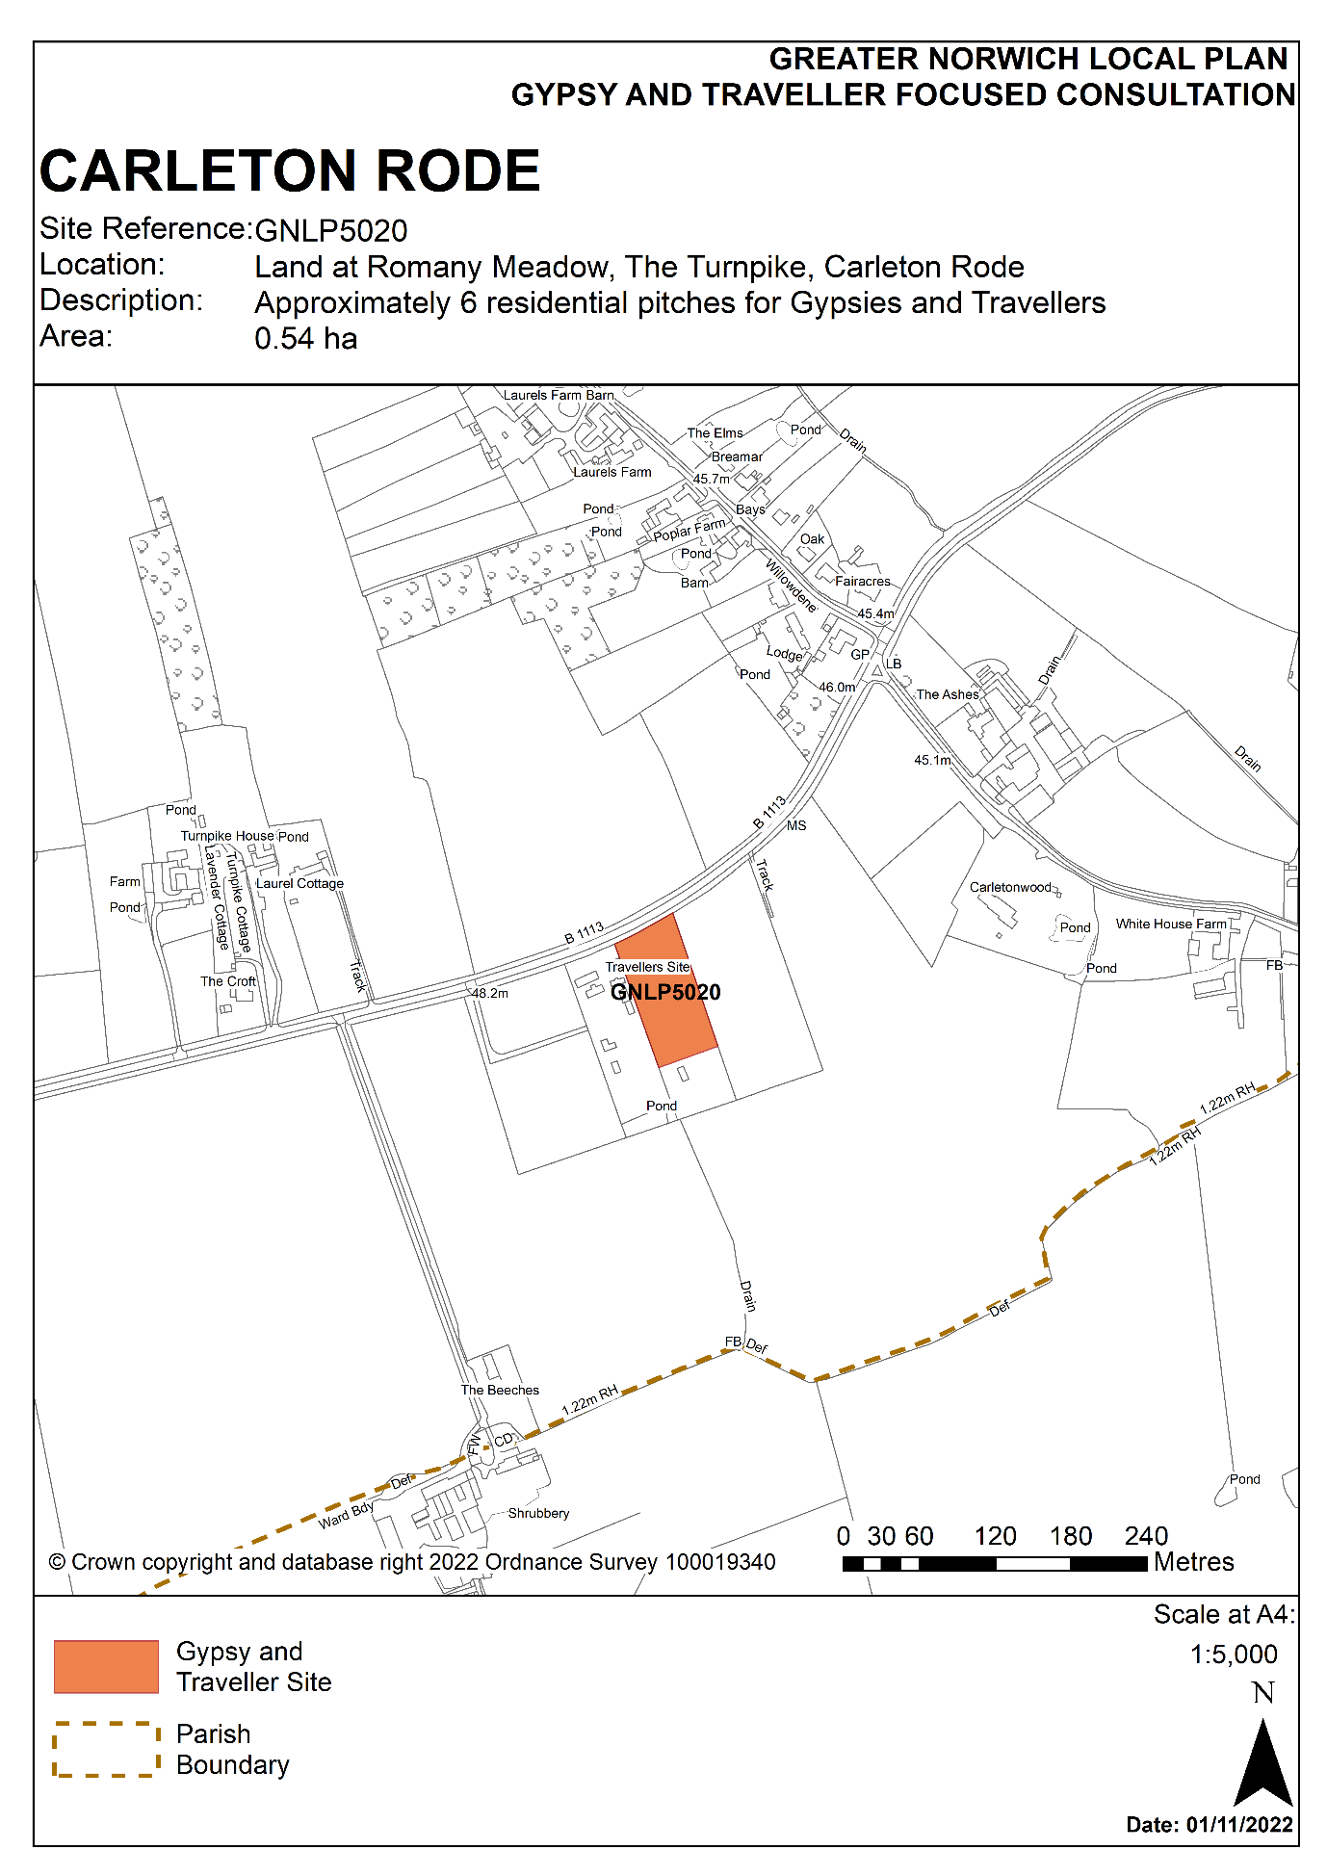

Policy GNLP5021 Land of Holt Road, Horsford

- This is a privately owned site which will extend an existing Gypsy and Traveller site known as The Old Produce Shop, Holt Road, Horsford. The allocation of GNLP5021 will result in its expansion from the existing single pitch to 7 pitches in total.

- The design and layout of the site should consider measures to mitigate any noise, air quality and landscape issues that may arise from the site being located just to the north-west of the Broadland Northway (A1270) junction with the A140.

Policy GNLP5021

The Old Produce Shop, Holt Road, Horsford (0.9 ha) is allocated for a residential Gypsy and Traveller site. The site will accommodate approximately 6 additional residential Gypsy and Traveller pitches.

The development will address the following site-specific matters:

- Access should be via the existing access off Holt Road that serves the Old Produce Shop site.
- Noise and air quality investigations are required, with provision of a layout and design that incorporates a landscape buffer to the nearby major roads and noise mitigation measures to protect residential amenity.
- The residential pitches shall not be occupied by any persons other than Gypsies and Travellers and their families.

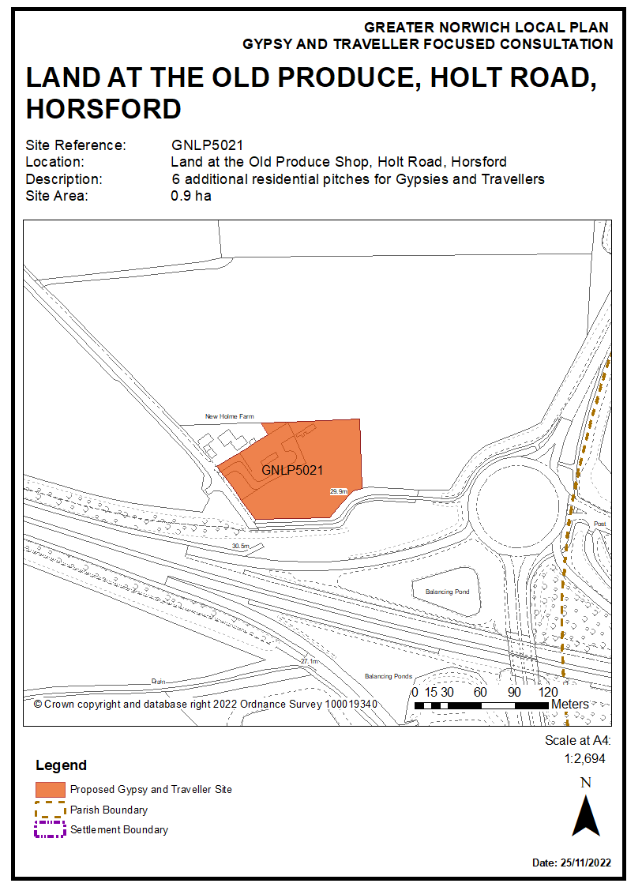

Policy GNLP5022 Land off Reepham Road, The Oaks, Foulsham

- This site allocation would extend a well-established privately owned Gypsy and Traveller site by 5 further pitches. The site is located off the Reepham Road, approximately 2 km from the edge of the village of Foulsham which has a limited range of services and facilities including Foulsham Primary School.

- Further development of the site will require investigations into highway safety, including vehicle speeds along Reepham Road, with widening of the visibility splay at the site entrance if required.

- The Bacton to Kings Lynn gas pipeline crosses from east to west below the site at its mid-point. This will require further investigation, engagement with the Health & Safety Executive (HSE) and National Grid and consequent consideration of site design. A surface water flow path that crosses the southern portion of the site is also likely to limit where caravans and other structures can be located.

- An ecological assessment is needed due to the presence of several County Wildlife Sites within 2.5 km.

- The allocation of GNLP5022 will result in its expansion from the existing 2 pitches to 7 pitches in total.
Policy GNLP5022

The Oaks off Reepham Road, is allocated for a residential Gypsy and Traveller site (3.3 ha). The site will accommodate approximately 5 additional residential Gypsy and Traveller pitches.

The development will address the following site-specific matters:

- Access will be via the existing access on Reepham Road. A highway safety assessment is required and an appropriate visibility splay must be achieved.
- A surface water flood risk assessment must be carried out with caravans and other structures positioned away from areas at surface water flood risk.
- An ecological assessment must be carried out and any identified impacts on protected species and nearby sites mitigated.
- Landscaping and tree planting will be required to preserve the landscape character of the surrounding area and to protect views of nearby listed buildings.
- Development will be designed to avoid impacts to and from the underground gas pipeline.
- The residential pitches shall not be occupied by any persons other than Gypsies and Travellers and their families.

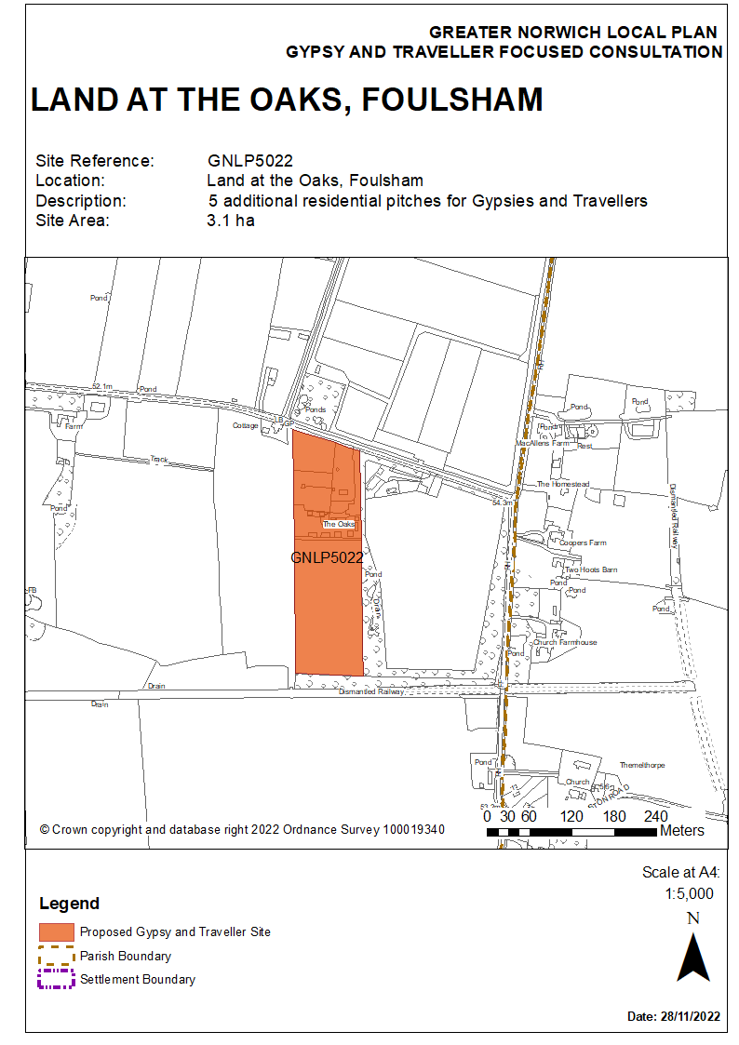

Policy GNLP5023 Land off Strayground Lane, Wymondham

- This is a privately owned piece of land that has been put forward by the owner and is located towards the southern end of Strayground Lane, Wymondham. There is an established paving business to the north. There are mineral extraction activities on the land to the north-east and east. The Norwich to Cambridge railway line is to the south and the Bays River Meadow North County Wildlife Site is on the western boundary.

- The development of this site will need to take account of a number of issues. These are highways improvements, consideration of noise and dust from neighbouring activities, investigation of possible land contamination from previous uses, consideration of neighbouring flood risk, an ecological assessment due to the neighbouring County Wildlife Site as well as trees and hedgerow on site, and pollution control measures for the groundwater source protection zone.
Policy GNLP5023

Land off Strayground Lane, Wymondham (1.1 ha) is allocated for a residential Gypsy and Traveller site. The site will accommodate approximately 10 residential Gypsy and Traveller pitches.

The development will address the following site-specific matters:

- Access will be via Strayground Lane, using either the existing access point at the north-east corner of the site or a new access on the eastern boundary. If a new access is provided any loss of trees or hedgerows will be compensated for by new planting within the site.
- Highway improvements will be required to the passing bays along Strayground Lane and an adequate visibility is required at the junction of Whartons Lane with London Road (the B1172).
- As the land adjacent to the south-west is in Flood Zones 2 and 3, caravans and other structures shall also be positioned away from this area.
- A contaminated land assessment is required and any mitigation must be completed prior to development.
- Screening will be required to the neighbouring paving company.
- An ecological assessment must be carried out and any identified impacts on nearby sites mitigated.
- Pollution mitigation measures are required because the site is within the catchment of groundwater source protection zone (III).
- The residential pitches shall not be occupied by any persons other than Gypsies and Travellers and their families.

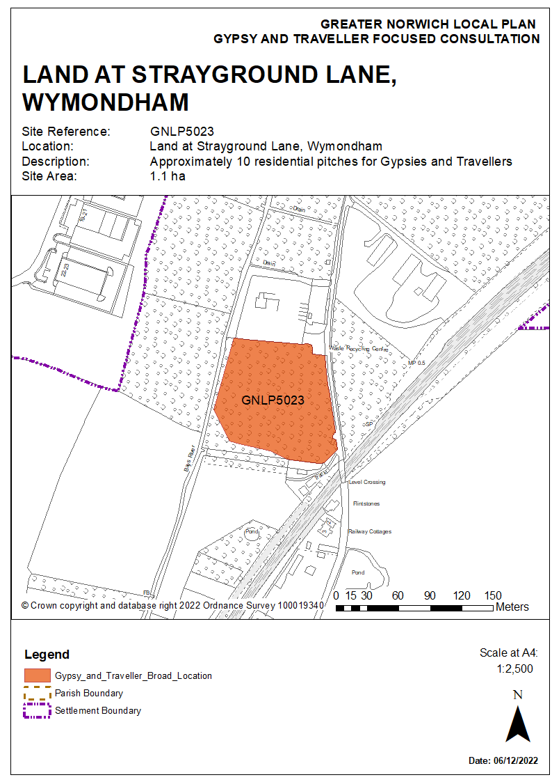

Policy GNLP5024 Upgate Street, Carleton Rode

- This is an existing privately owned Gypsy and Traveller site located on Upgate Street, Carleton Rode. The allocation of GNLP5024 will result in an expansion from the existing 2 pitches to 6 pitches in total.

- Further development of the site will require investigation of highway safety, including of vehicle speeds along Upgate Street, with widening of the visibility splay at the site entrance as appropriate. An ecological assessment prior to development is required due to the presence of a veteran tree on the northern boundary of the site and because New Buckenham Common is approximately 250 metres to the south-west.
Policy GNLP5024

Upgate Street, Carleton Rode (0.62 ha) is allocated for a residential Gypsy and Traveller site. The site will accommodate approximately 4 additional residential Gypsy and Traveller pitches.

The development will address the following site-specific matters:

- Access should be via the existing access off Upgate Street. A highway safety assessment is required and an appropriate visibility splay must be achieved.
- An ecological assessment must be carried out and any identified impacts on protected species and nearby sites mitigated.
- The residential pitches shall not be occupied by any persons other than Gypsies and Travellers and their families.

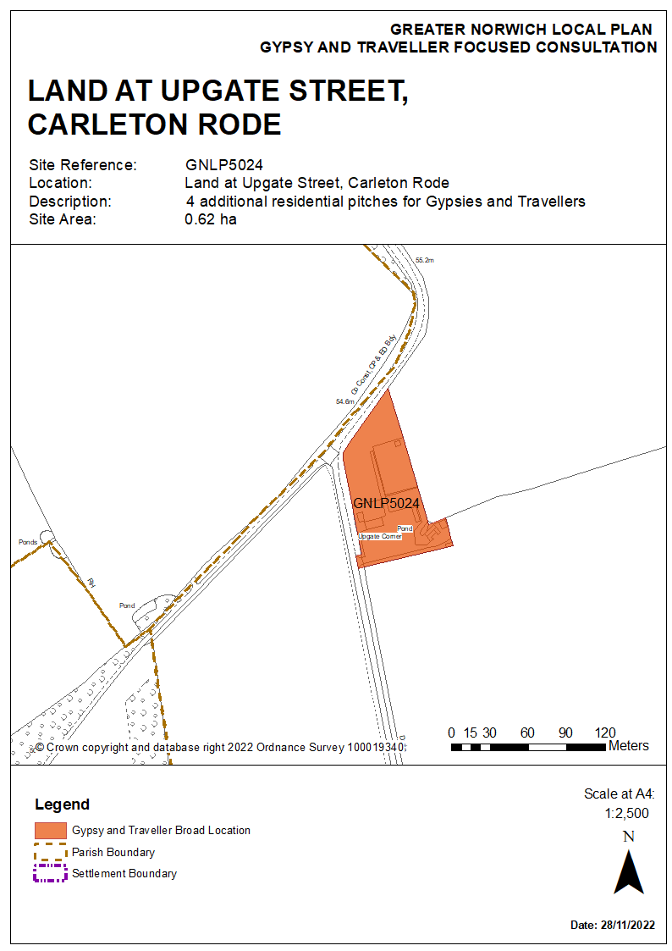

Reasonable Alternative Site

Policy GNLP5013 Ketteringham Depot land west of Station Lane, Ketteringham

- This site is on publicly owned land located west of Station Lane, Ketteringham. It is currently used as a depot which is expected to be relocated.

- This site is separated from the nearest services and facilities which are in Hethersett., but nevertheless this site is considered a reasonable alternative for consultation. If GNLP5013 became allocated in the local plan a draft policy for the site is shown in the red box below.

- A number of assessments will be required prior to development if the site is allocated. These are an assessment of possible land contamination from previous uses, an ecological survey for the potential for hibernating bats in the existing buildings and an investigation of potential noise and dust from neighbouring depot and waste processing businesses nearby.
Policy GNLP5013

Land west of Station Lane, Ketteringham, (0.86 ha) is allocated for a residential Gypsy and Traveller site. The site will accommodate approximately 10 residential Gypsy and Traveller pitches.

The development will address the following site-specific matters:

- Access should be via the existing access that currently serves the depot.
- Investigation is required of the potential for the conversion of existing buildings, particularly at the frontage, as part of the redevelopment.
- Noise and air quality investigations are required, and the layout and design of the site should include boundary treatments that protect residential amenity.
- A contaminated land assessment is required, and any mitigation must be completed prior to development.
- An ecological survey is required due to the potential presence of protected species such as bats or barn owls in the existing buildings.
- The residential pitches shall not be occupied by any persons other than Gypsies and Travellers and their families.

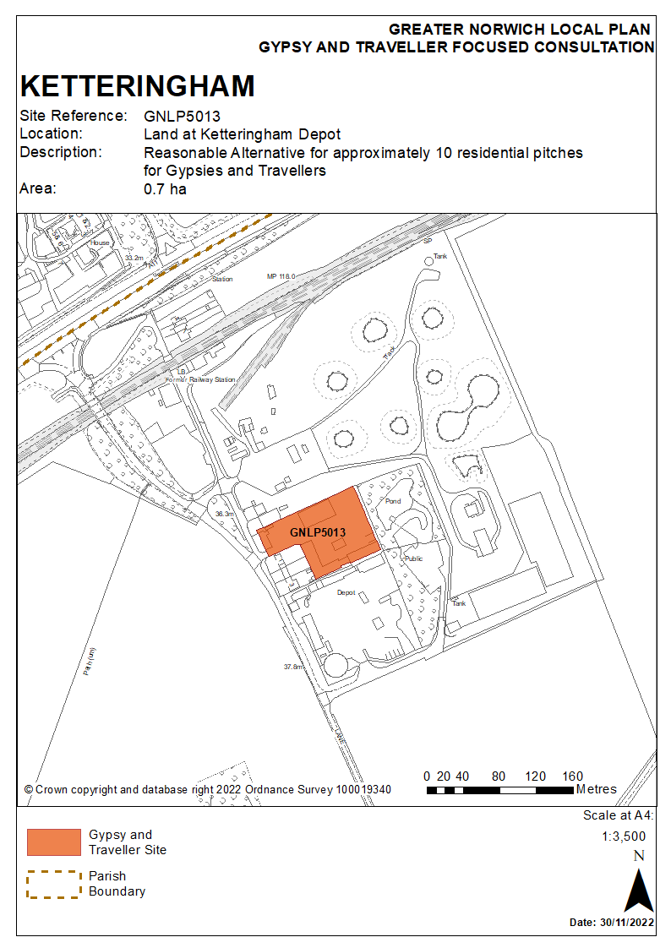

Contingency Site

Proposed Change to Policy GNLP0581/2043: Land off Bawburgh Lane, north of New Road and east of A47 – incorporation of a Gypsy and Traveller site into the Costessey contingency site allocation

- A 62 ha site at Costessey is included in the submitted GNLP as a contingency housing site which can come forward in the event that the overall delivery of homes in the Greater Norwich Local Plan area falls significantly below annual targets. Should the need for the contingency site be triggered then the option would exist to provide a Gypsy and Traveller site as part of this urban extension.

- The landowners for the contingency site are willing to incorporate a Gypsy and Traveller site for up to 18 pitches if the accommodation needs evidence at the time shows it is required. To allow for the master planning of the whole site, it is proposed to only identify a broad location for the potential Gypsy and Traveller site within the southern part of the contingency allocation. Not detailing a specific site at this time will ensure that a Gypsy and Traveller site could be properly integrated into any wider development. The southern part of the site gives the opportunity for early delivery of Gypsy and Traveller accommodation with vehicular access from New Road if the need for the contingency site is triggered.

- Delivering this option would require the amendment of the contingency site policy wording originally submitted to the inspectors for examination. The original policy text for the contingency site can be found at section 8 of the ‘Part 2 – The Sites’. The proposal is to insert the following additional criterion to the list of specific matters which would need to be addressed:
“Subject to up-to-date evidence of need in the remainder of the plan period evidence at the time, provision of a 1 ha Gypsy and Traveller site providing approximately 18 pitches.”

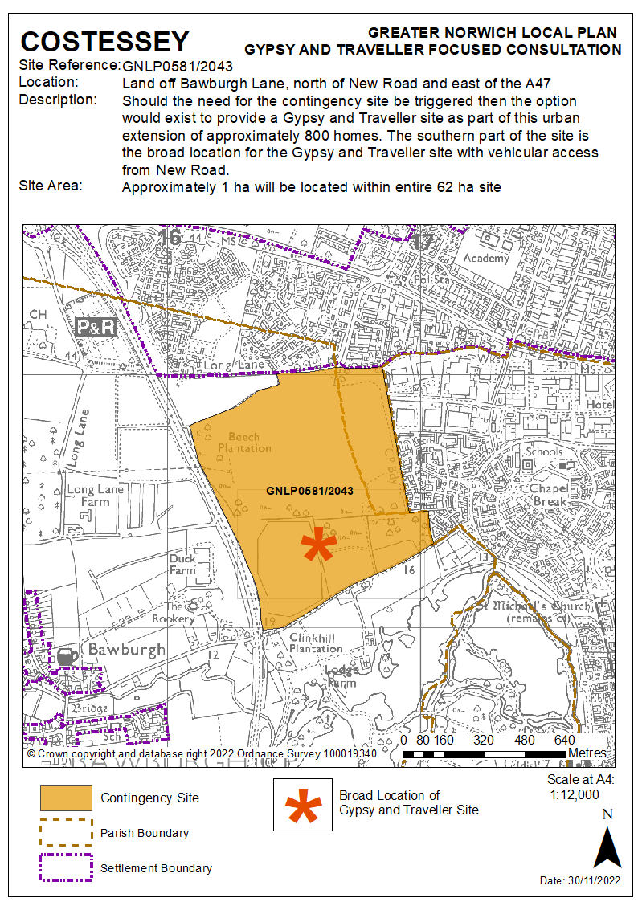

Unreasonable Alternatives

- The following three sites are considered unreasonable alternatives but respondents to the consultation can comment upon them.

VCHAP Site 1 and Site 2, Middle Road, Denton
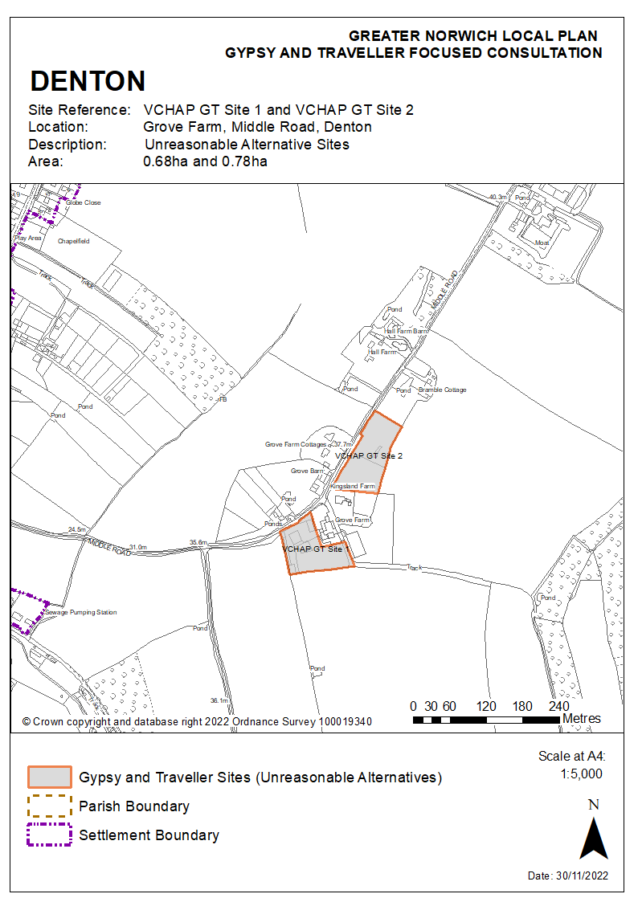

VCHAP Site 3, Land off London Road, Suton, Wymondham
