Appendix D - Site Assessment Information
Contents
Introduction 3
Background 3
Methodology 3
Sustainability Appraisal and Habitats Regulation Assessment 4

Favoured Sites 6
Parish: Cawston 6
Site reference: GNLP5004 6
Parish: Wymondham 9
Site reference: GNLP5005 9
Parish: Bawburgh 12
Site reference: GNLP5009 12
Parish: Lingwood and Burlingham 15
Site references: GNLP5014 15
Parish: Stratton Strawless 18
Site reference: GNLP5019 18
Parish: Carleton Rode 21
Site reference: GNLP5020 21
Parish: Horsford 24
Site reference: GNLP5021 24
Parish: Foulsham 28
Site reference: GNLP5022 28
Parish: Wymondham 31
Site reference: GNLP5023 31
Parish: Carleton Rode 34
Site reference: GNLP5024 34

Reasonable Alternative 37
Parish: Ketteringham 37
Site reference: GNLP5013 37

Proposed change to Contingency Site 40
Parish: Costessey 40
Site reference: GNLP5081/2023 40

Unreasonable Sites 43
Parish: Denton 43
Site reference: VCHAP GT Site 1 43
Site reference: VCHAP GT Site 2 43
Parish: Wymondham 46
Site reference: VCHAP GT Site 3 46

Conclusion 49

Introduction

- This document provides site assessment information for sites proposed for inclusion in the Greater Norwich Local Plan (GNLP) as Gypsy and Traveller sites.

- It is a background document to the Site Policies document (Appendix C for the Cabinet Reports) which is the main consultation document for the focused consultation which takes place from January 30th to March 13th 2023.

- This Site Assessment Information document provides an analysis of constraints and potential mitigation for sites proposed for allocation for Gypsy and Traveller accommodation in the GNLP. As such, it is both intended to assist wider consultation responses and its content can be commented on.

Background

- The GNLP was submitted for independent examination in July 2021.

- During the examination the two inspectors appointed on behalf of the Secretary of State made it clear that they expected to include specific site allocations for Gypsies and Travellers in the plan in accordance with national policy in paragraph 68 of the National Planning Policy Framework NPPF.

- This assessment is limited in scope to sites that have been proposed to meet the accommodation needs of Gypsies and Travellers, considering 15 sites.

Methodology

- Landowners have provided a “redline” outline plan for each of the proposed sites and a judgement has been made about how many pitches could be accommodated. As a guideline, to avoid the risk of pitches being too small, around 300 square metres is required per pitch. This accords with design guidance that suggests 320 square metres per pitch is needed to also provide space for an amenity block (with a kitchen, bathroom and living room) and touring caravan space for up to 2 caravans and 2 vehicles.

- The Norfolk-wide Housing and Economic Land Availability Assessment (HELAA) methodology has been the starting point for assessing all development proposals in the GNLP. This has been adapted to include criteria specific to the needs of Gypsy and Traveller communities including access, landscaping, acoustic screening and proximity to the main road network. The assessment of access to services takes account of the requirements for Gypsy and Traveller sites in more rural locations.

- The proposed Gypsy and Traveller sites have been compared against the 14 suitability criteria in the HELAA methodology to assess if they are reasonable for development. The purpose of this is to screen out sites with no development potential; and, for the remaining sites, to identify issues that may need to be addressed to allow development to be progressed.

- A ‘red’, ‘amber’ or ‘green’ rating is given for each site for each criterion, accompanied by a commentary and a conclusion. The ratings are informed by information from a broad range of professionals and are based on the following:

  - Green – no identified constraints;
  - Amber – constraints identified are either not significant enough to prevent development and/or could be mitigated;
  - Red – Significant constraints which can not be mitigated.

- An ‘Availability and Achievability’ section identifies when sites could be delivered, either within the current 5-year time period to March 2027 or, due to site specific issues, to a longer timeframe to March 2032. This approach is in line with national policy.

- Following assessment, the sites are classified into four categories below:

- 10 sites are favoured options. Analysis shows that these sites have limited constraints which can be overcome and provide potential for allocation.
- 1 site, at Ketteringham Depot, is a reasonable alternative which also has some potential for allocation, though with some constraints primarily related to accessibility and neighbouring uses.
- 1 site at Costessey is a proposed policy change to the submitted contingency housing site. This is an option if a Gypsy and Traveller site is delivered as part of a larger scheme for approximately 800 homes if the evidence at the time supports the need for a Gypsy and Traveller site.
- 3 sites have been rejected as unreasonable due to site constraints.

Sustainability Appraisal and Habitats Regulation Assessment

- The Sustainability Appraisal of the Gypsy and Travellers sites (Appendix E for the Cabinet reports) is another background document for the consultation which provides additional assessment of the sites above, apart from the 3 which have been concluded to be unreasonable. It covers the sustainability performance of each favoured site, the reasonable alternative and the Costessey site. The appraisal feeds into the assessment of sites and provides recommendations for mitigation measures which have been incorporated into the Site Policies document as appropriate (Appendix C for the Cabinet reports).

- The Habitats Regulation Assessment (HRA) (Appendix F for the Cabinet reports) assesses a wide range of potential impacts on nature conservation sites of international importance, including any in-combination impacts with other development in the area.

- It concludes that no allocations will be close enough to a European site to have any construction related impacts such as land-take or disturbance from construction activities. It also concludes that as there will be no allocations within 1.5 kilometres of a European site, there would also be no direct recreational impacts.

- The HRA also concludes that the tariff payment of £185.93 per Gypsy and Traveller Pitch (and for other types of home) which has been set which will be sufficient to ascertain no adverse effect upon the integrity of any European site from the in-combination effects of residential developments across the plan area and beyond.

- Subject to satisfactory policy modification of the GNLP with respect to Nutrient Neutrality, the HRA concludes that the proposed allocations for Gypsy and Traveller sites will have no adverse effect upon the integrity of any European site acting alone, in combination with other development in the GNLP or any other plan or project.

Favoured Sites

Parish: Cawston
Suitability Assessment

Site reference: GNLP5004 | Site area: 0.12 Ha
LOCATION:  Land off Buxton Road, Eastgate  District: Broadland | PROPOSED DEVELOPMENT:  A permanent residential Gypsy and Travellers site for 4 pitches

CONSTRAINTS ANALYSIS
Site Access | Amber
Accessibility to Services | Amber
Utilities Capacity | Green
Utilities Infrastructure | Green
Contamination and Ground Stability | Green
Flood Risk | Green
Market Attractiveness | Green

IMPACTS ANALYSIS
Significant Landscapes | Amber
Sensitive Townscapes | Green
Biodiversity and Geodiversity | Amber
Historic Environment | Amber
Open Space and GI | Green
Transport and Roads | Green
Compatibility with neighbouring uses | Amber

SITE SUITABILITY CONCLUSIONS
- This greenfield site is off Buxton Road in the hamlet of Eastgate, south-east of Cawston. It is 0.12 ha in size and could accommodate 4 permanent residential Gypsy and Traveller pitches.

- A suitable vehicular access from Buxton Road is likely to be achievable, subject to demonstrating an acceptable visibility splay, but this might require the removal of a hedgerow.

- The site is slightly disconnected from the local services including a primary school in Cawston 1.7 kilometres away. However, as this is a relatively small development proposal it will not to lead to a significant increase in traffic on local roads or a significant increase in unsustainable travel patterns.

- There are no known constraints relating to utilities capacity, contamination or ground stability. The site is within Flood Zone 1, so is at low risk of fluvial flooding and no surface water flooding risk has been identified.

- Market attractiveness is evidenced by the landowner promoting the site.

- GNLP5004 is on grade 2 agricultural land, so development would result in a minor loss of high-quality agricultural land. There would be a no loss of open space resulting from development and the site is not situated on a strategic green infrastructure corridor.

- In relation to biodiversity, Cawston and Marsham Heaths SSSI is located approximately 1 kilometre from the site. There are four further SSSIs within a 5 kilometre radius (Booton Common, Buxton Heath, Alderford Common and Swannington Upgate Common) and the site is in a ‘green’ impact risk zone for Great Crested Newts. However, Natural England has not raised an objection to the site.

- Cawston Conservation Area, which includes a number of Grade I and II listed buildings, is approximately 1.6 kilometres west of the site, so no adverse impact is expected on existing heritage assets. Since the site is close to an area of Roman settlement further archaeological investigation will be required which should identify any necessary mitigation.

- There are residential properties to the north of the site on Back Lane, a field to the east, agricultural land on the south side of Buxton Road and a home to the west. Additional landscaping and hedges will be needed to enhance screening and to maintain the residential amenity of adjoining properties.

- As with many locations in Greater Norwich, mitigation of the impacts on nutrient levels in river catchments will be required.

- Overall, GNLP5004 is considered suitable as a favoured option for allocation, subject to any proposed development achieving an acceptable visibility splay and site investigations being undertaken.

Availability and Achievability Conclusions
- GNLP5004 is in private ownership and the landowner is willing to make the site available for Gypsy and Traveller accommodation use. As a relatively unconstrained greenfield site, there is no reason why development could not come forward quickly. 3 to 5 years is considered ample time to market the land, gain planning permission, and to develop site GNLP5004.

Overall Conclusions for Site

- Subject to the caveats identified above, GNLP5004 is considered suitable as a favoured option for allocation. If allocated in the local plan, GNLP5004 would be deliverable within 5 years and could be completed by March 2027.

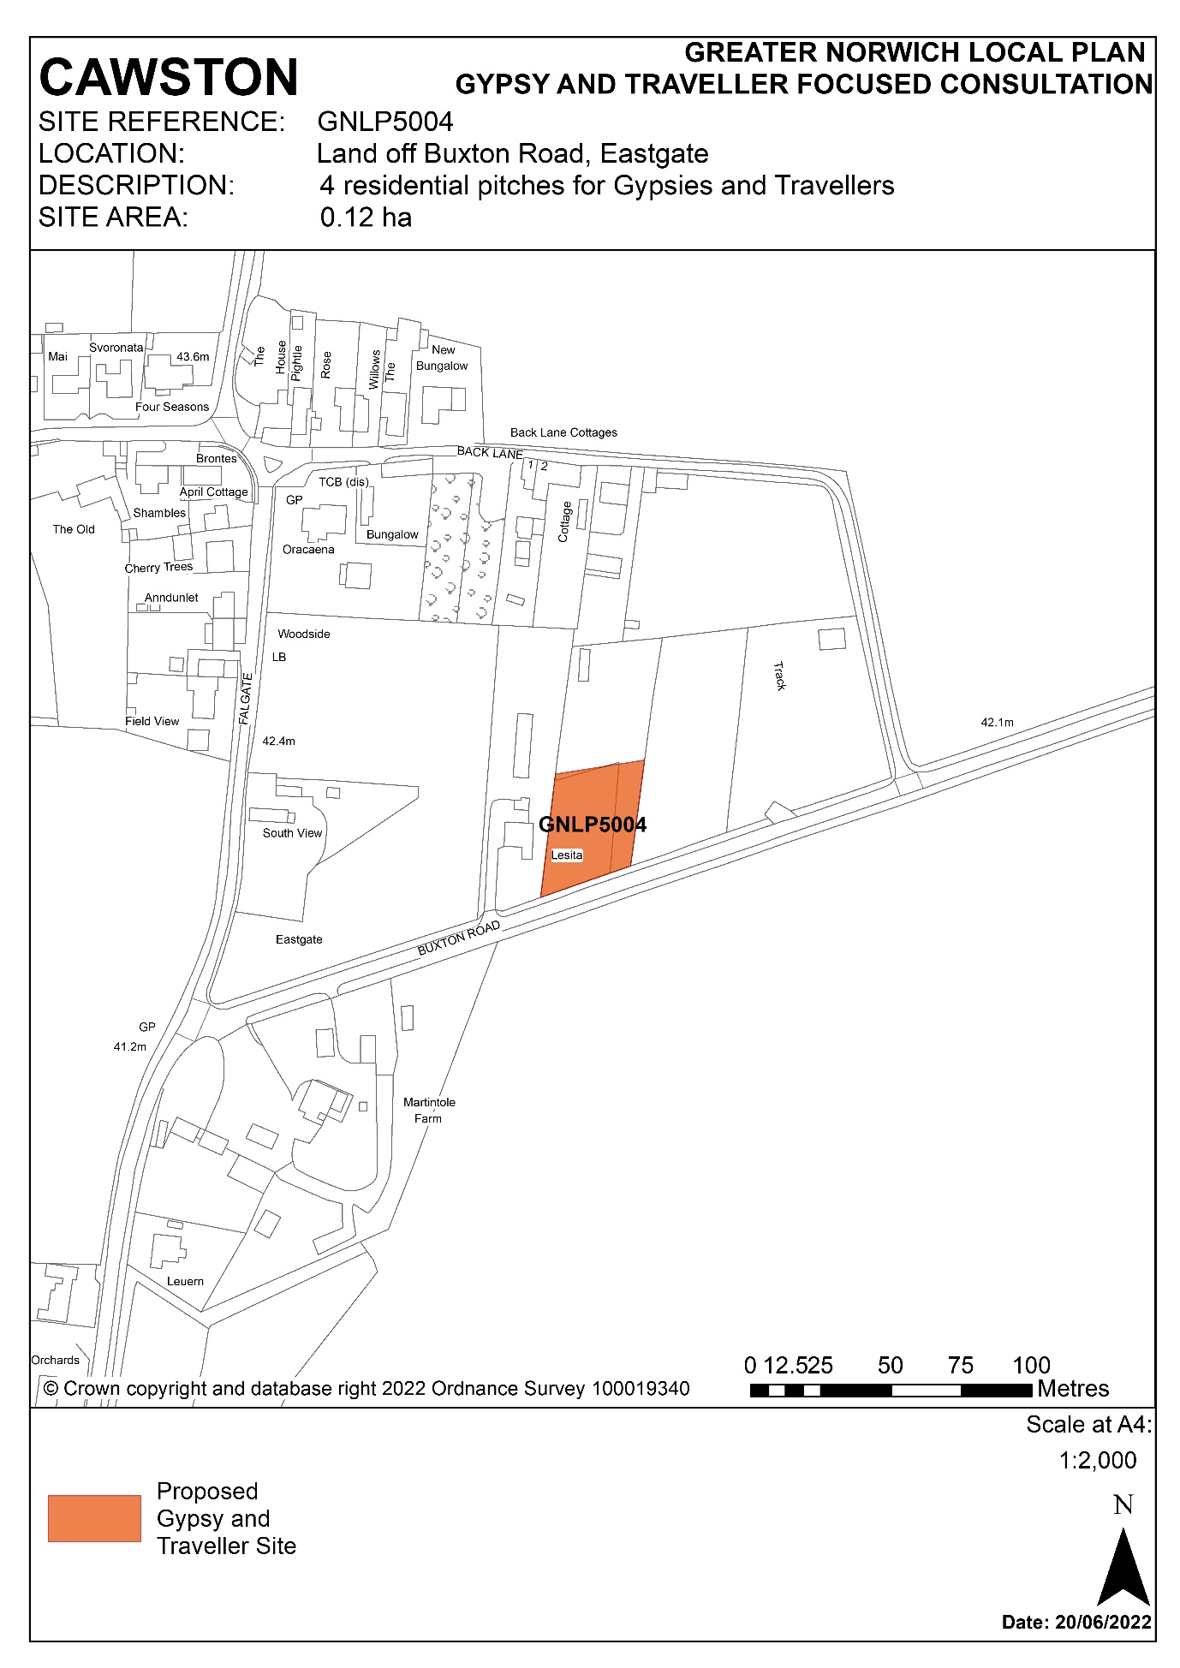

Parish: Wymondham
Suitability Assessment

Site reference: GNLP5005 | Site area: 0.07 Ha
LOCATION: Land at Strayground Lane, Wymondham Recycling Centre  District: South Norfolk | PROPOSED DEVELOPMENT:  A permanent residential Gypsy and Travellers site for 2 pitches

CONSTRAINTS ANALYSIS
Site Access | Amber
Accessibility to Services | Amber
Utilities Capacity | Green
Utilities Infrastructure | Green
Contamination and Ground Stability | Amber
Flood Risk | Green
Market Attractiveness | Green

IMPACTS ANALYSIS
Significant Landscapes | Green
Sensitive Townscapes | Green
Biodiversity and Geodiversity | Amber
Historic Environment | Green
Open Space and GI | Green
Transport and Roads | Green
Compatibility with neighbouring uses | Amber

SITE SUITABILITY CONCLUSIONS
- Site GNLP5005 measures 0.07 ha and is currently used as Wymondham Recycling Centre. The landowner intends to close this facility, so an opportunity exists to redevelop it for 2 residential Gypsy and Traveller pitches. However, the site is not likely to become available until 2027 at the earliest.

- GNLP5005 has a vehicular access onto Strayground Lane which serves the existing recycling centre. Though the proposed use will generate less traffic than the existing recycling centre, Strayground Lane has no footpaths and the passing bays will require improvement. As Strayground Lane is a quiet road, pedestrians and cyclists would be able to use this route to access facilities in Wymondham. There is a local shop approximately 700 metres away and Browick Road Primary School is approximately 1 kilometre away.

- The site is in flood zone 1, so is at low risk of river flooding, whilst a small area in the south of the site is at low risk of surface water flooding. The site is within the catchment of a groundwater Source Protection Zone (Zone III). As such, pollution mitigation measures for water quality protection will be required, but this does not rule out development potential.

- Good road and public transport connections in Wymondham are accessible from the site and its location suggests it will be attractive to the market.

- GNLP5005 presents no substantive concerns in relation to heritage constraints as the nearest listed building (Grade II ‘Ivy Green Villa’) is 300 m away and is separated from the site by the industrial area on Chestnut Drive.

- There will be a need for an ecological survey as the site is approximately 50m from undeveloped areas along the Bays River, which is a lowland fens priority habitat. GNLP5005 also partly intersects the Bays River Meadows North County Wildlife Site on its northern boundary.

- Whilst not prohibiting possible development, there are other issues resulting from past and present neighbouring uses which may impact on the form of the development:
- A paving company adjoins the site to its west and south. This will cause impacts from vehicle movements, noise and possibly dust, so screening may be required.
- A neighbouring historic landfill site will require investigation for possible contamination.
- There are various planning consents dating back to the 1990s for a gravel quarry, stockpiling aggregates, and landfilling of inert waste (references include C/92/7023 and C/94/7016) immediately to the north-east, east, and south of the site.

- As with many locations in Greater Norwich, mitigation of the impacts on nutrient levels in river catchments will be required.

- Overall, GNLP5005 is considered suitable as a favoured option for allocation subject to providing appropriate mitigation measures.

Availability and Achievability Conclusions
- GNLP5005 is owned by Norfolk County Council and will become available for development once that existing recycling centre there closes. However, the site is not likely to become available until 2027 at the earliest. Further time would then be required to market the land, gain planning permission and to develop GNLP5005.

Overall Conclusions for Site

- Subject to the caveats identified above, GNLP5005 is considered suitable as a favoured option for allocation. If allocated in the local plan, GNLP5005 would be developable within 6 to 10 years and should be completed by March 2032.

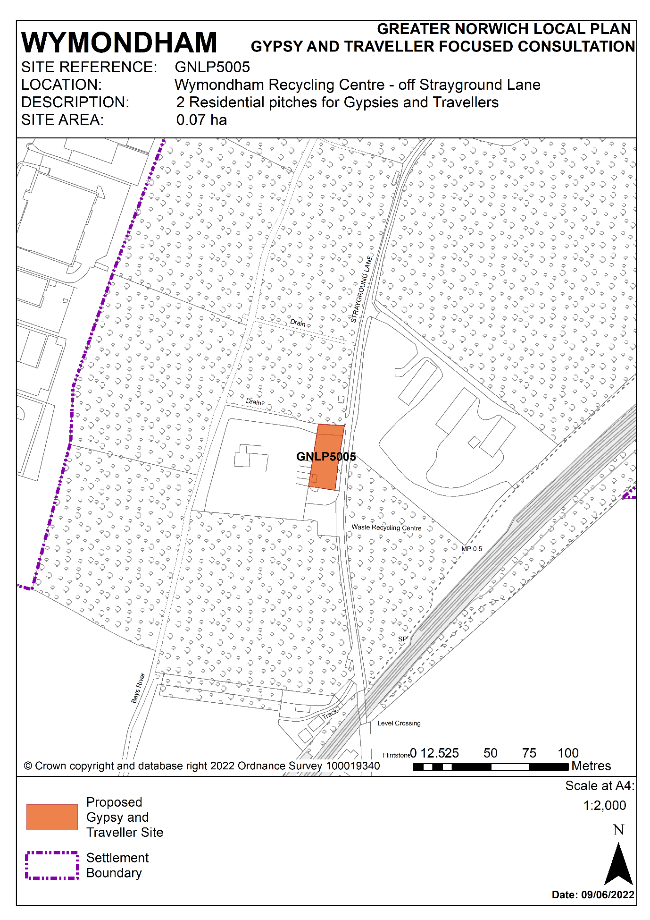

Parish: Bawburgh
Suitability Assessment

Site reference: GNLP5009 | Site area: 0.59 ha
LOCATION: Land off Hockering Lane, Bawburgh  District: South Norfolk | PROPOSED DEVELOPMENT: A permanent residential Gypsy and Travellers site for 6 pitches

CONSTRAINTS ANALYSIS
Site Access | Amber
Accessibility to Services | Amber
Utilities Capacity | Green
Utilities Infrastructure | Amber
Contamination and Ground Stability | Green
Flood Risk | Green
Market Attractiveness | Green

IMPACTS ANALYSIS
Significant Landscapes | Amber
Sensitive Townscapes | Green
Biodiversity and Geodiversity | Green
Historic Environment | Amber
Open Space and GI | Green
Transport and Roads | Green
Compatibility with neighbouring Uses | Green

SITE SUITABILITY CONCLUSIONS
- GNLP5009 is a proposal for 6 pitches on a greenfield site to the east of Hockering Lane in Bawburgh. The site, which measures 0.59 ha, is part of an agricultural field that is bounded to the north, east and west by trees and hedges, with the remainder of the field to the south.

- Access to GNLP5009 would be via a private road, therefore third-party rights of access would be required. GNLP5009 is 200 metres from Bawburgh Primary School, but otherwise facilities are limited and residents would likely need to travel by private vehicle, for example the nearest shops are at Longwater Retail Park 3 kilometres away.

- A gas pipeline runs north to south through the western part of the site. This is part of the Cadent Norfolk network and initial investigations suggest that an easement of 12.2 metres would be required. This is likely to dictate that the majority of pitches would be positioned towards the central and eastern part of the site.

- GNLP5009 is on the southern bank of the River Yare, meaning that there could be some adverse impact on the locally designated Yare/Tiffey River Valley landscape. Development would therefore be likely to require mitigation, such as additional tree planting on the site boundaries, to ensure visual impacts on the landscape are minimised.

- There are no statutory designated environmental sites immediately affecting GNLP5009. The nearest is Bawburgh/Colney Gravel Pits County Wildlife Site and candidate County Geodiversity site which is 290 metres to the east of the site on the opposite side of the A47. The River Wensum SSSI and SAC is 3 kilometres to the north at its closest point to GNLP5009 and the Sweetbriar Road Meadows SSSI is 4.6 kilometres away to the east. However, an ecological assessment will be required due to there being potential habitats for Great Crested Newts on-site.

- The site is 180 metres east of Bawburgh Conservation Area where the majority of the village’s listed buildings are located, and it is possible that a Historic Impact Assessment (HIA) will be required due to the proximity of the scheduled grade II* garden buildings at the former Bawburgh Hall to the north-west of the site. Archaeological investigation may be required as some prehistoric features have been identified on land adjacent to GNLP5009.

- There are limited concerns in relation to the remaining criteria. The site is in flood zone 1, so is at low risk of river flooding and is not at risk of surface water flooding. There are no issues over the loss of designated open space and the site is on relatively low-quality agricultural land (Grade 4). Whilst the site is less than 300 metres from the A47, noise impacts could be mitigated.

- As with many locations in Greater Norwich, mitigation of the impacts on nutrient levels in river catchments will be required.

- The site is in private ownership and the landowner is willing to make it available as a Gypsy and Traveller site. Although there are some constraints, most particularly the gas pipeline passing under the site and the possible adverse impact on the adjacent River Yare landscape, there is no reason why development with mitigation could not come forward quickly. 4 to 5 years is considered ample time to market the land, gain planning permission, and to develop the site.

Overall Conclusions for the Site

- Subject to the caveats identified above, GNLP5009 is considered suitable as a favoured option for allocation. If allocated in the local plan, GNLP5009 would be deliverable within 5 years and could be completed by March 2027.

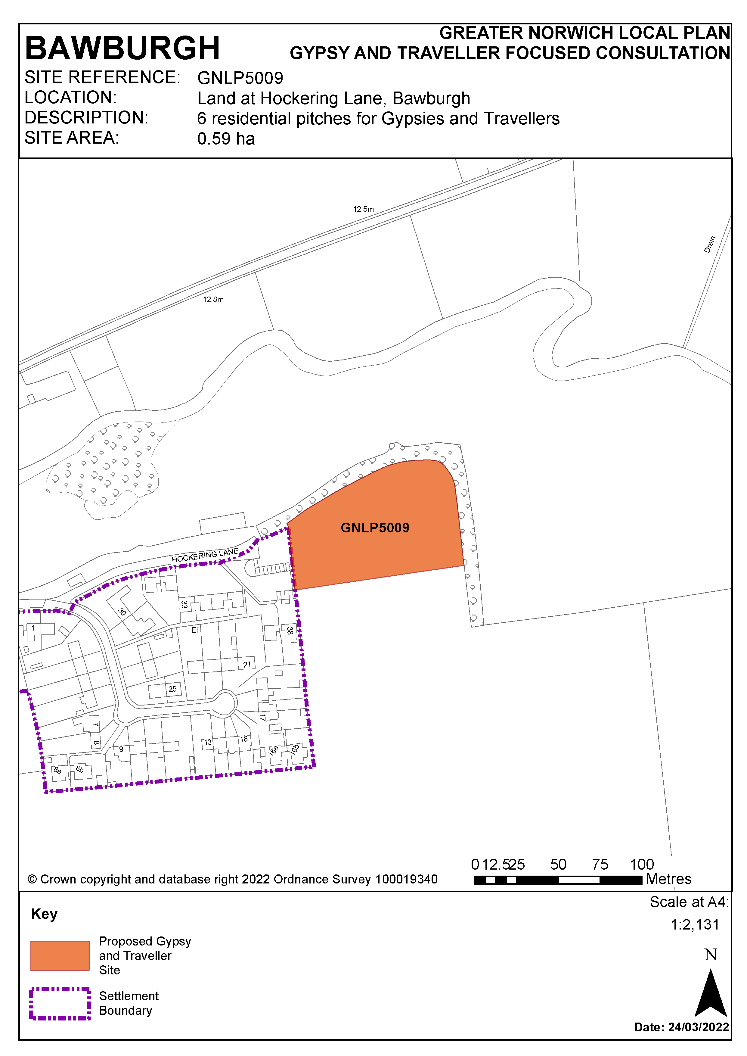

Parish: Lingwood and Burlingham
Suitability Assessment

Site references: GNLP5014 | Site area: 1 ha (within a 2.48 ha area)
LOCATION: A47 North Burlingham Junction  District: Broadland | PROPOSED DEVELOPMENT:  A permanent residential Gypsy and Travellers site for 15 pitches within a broad site location.

CONSTRAINTS ANALYSIS
Site Access | Green
Accessibility to Services | Amber
Utilities Capacity | Green
Utilities Infrastructure | Green
Contamination and Ground Stability | Green
Flood Risk | Green
Market Attractiveness | Green

IMPACTS ANALYSIS
Significant Landscapes | Amber
Sensitive Townscapes | Green
Biodiversity and Geodiversity | Green
Historic Environment | Amber
Open Space and GI | Green
Transport and Roads | Green
Compatibility with neighbouring uses | Green

SITE SUITABILITY CONCLUSIONS
- A broad site location has been identified to provide a site of up to 1 hectare for 15 residential pitches for Gypsies and Travellers. The 1 hectare site is located within a larger area of greenfield land (2.48 ha) which is owned by Norfolk County Council and is currently in agricultural use. The potential site and the wider area will gain excellent access to the main road network due to the forthcoming A47 dualling from Blofield to North Burlingham.

- Vehicular access to the proposed site is very likely to be achievable given the wider road improvements around this site which will create of a cul-de-sac on the current alignment of the B1140. This will allow easy access to the site.

- The site is located between Blofield to the west, Acle to the east and Lingwood to the south. It is very likely to be an attractive location for the gypsy and traveller community given the access to main roads that will be provided when the upgrades to the A47 have been completed. Whilst the site is in close proximity to a school bus route, there is somewhat limited access to local services in Lingwood as there is currently no footpath on the local road.

- There are no known issues from contamination or ground stability. The site is in flood zone 1, so is at low risk of river flooding and there is not at risk of surface water flooding.

- The site is grade 1 agricultural land, so development would result in a minor loss of high-quality agricultural land. However, the road scheme will greatly reduce the agricultural utility of this land.

- There are county wildlife sites at Church and Belt Plantations which are located to the north-west of the proposed site and to the north of the A47. The impact of the proposed development on these designated habitats would be negligible.

- St Peter’s Church, a grade II listed building, is located in North Burlingham to the north-west of the site. Given that it is on the opposite side of the A47, it will not be impacted. As the landscape is relatively flat and open and there are nearby non-designated heritage assets, screening for any development would need to be provided. Depending on the exact location of development, such screening could also provide noise mitigation from the upgraded A47.

- Development of this site would not result in the loss of formal open space. As the site will be adjacent to the local road network which will be in place after the dualling of the A47 at the North Burlingham junction, it is not expected to affect the functioning of local roads.

- Overall, the site is suitable as a favoured option for allocation subject to a providing a suitable vehicular access, screening and possibly noise mitigation measures.

Availability and Achievability Conclusions
- Norfolk County Council Farms is the owner of the site and land required for a Gypsy and Traveller site is available for development. Investigations are underway into how best to bring a Gypsy and Traveller site forward.

Overall Conclusions for Site

- Subject to the caveats identified above, site GNLP5014 is considered suitable as a favoured option for allocation. Timescales are dependent on the trunk road scheme, but it is anticipated that GNLP5014 would be deliverable within 5 years and could be completed by March 2027.

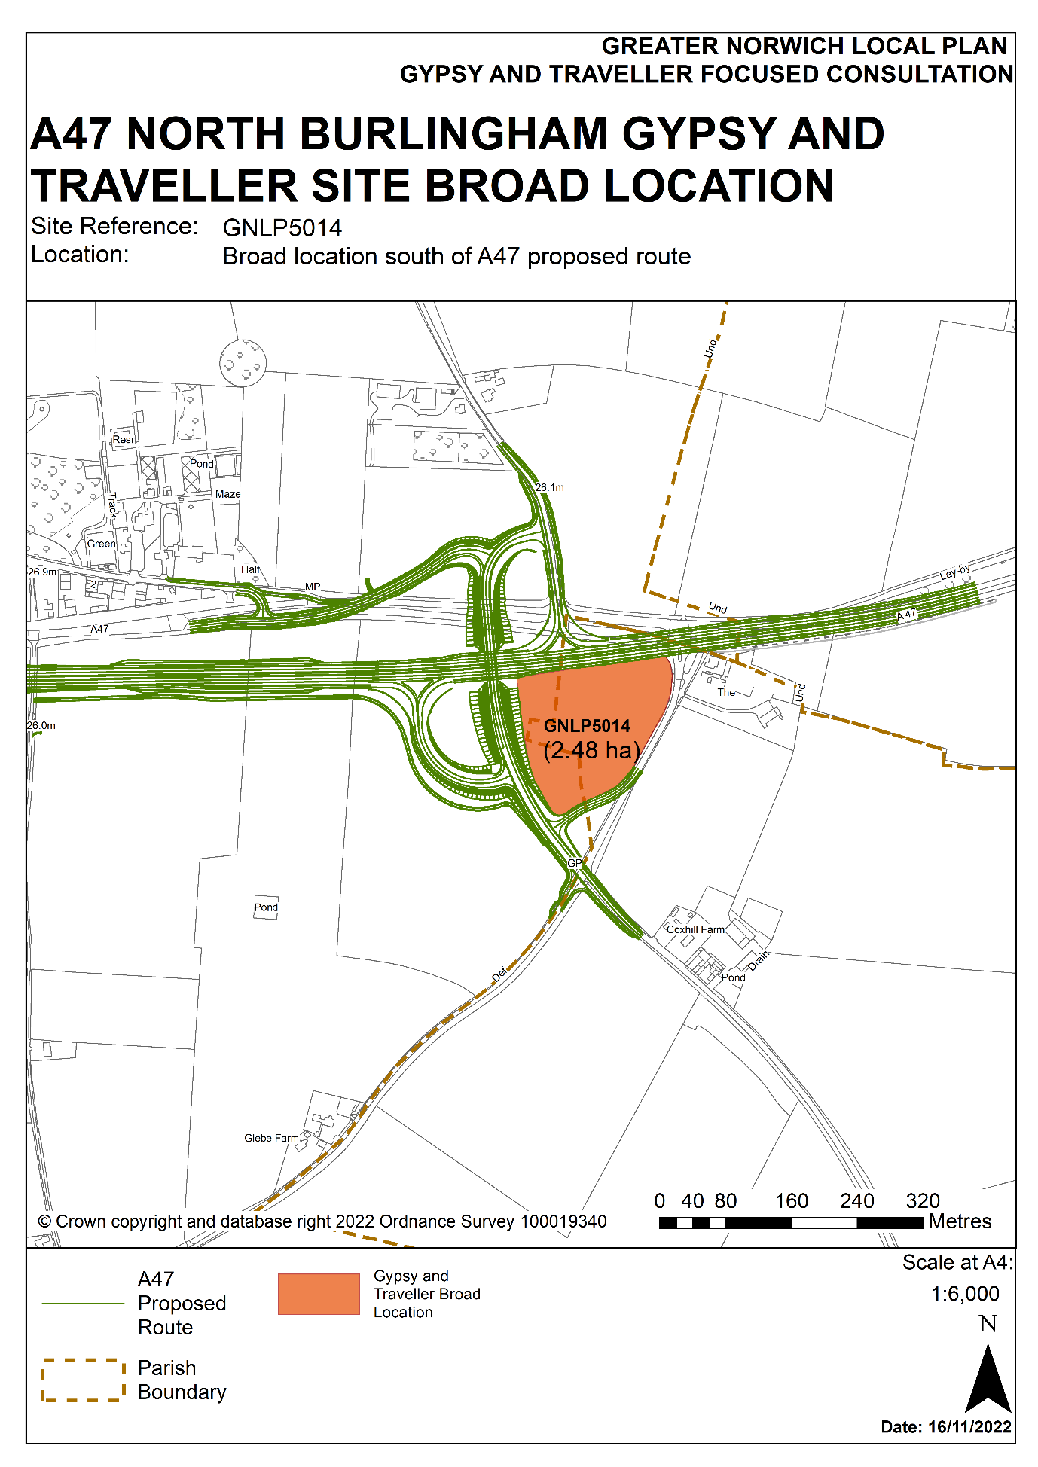

Parish: Stratton Strawless
Suitability Assessment

Site reference: GNLP5019 | Site area: 0.33 ha
LOCATION: Land north of  Shortthorn Road, Stratton Strawless  District: Broadland | PROPOSED DEVELOPMENT:  To provide 8 pitches, extending the existing 9 pitches to 17 pitches in total. This would provide 4 more pitches than are currently permitted.

CONSTRAINTS ANALYSIS
Site Access | Green
Accessibility to Services | Amber
Utilities Capacity | Green
Utilities Infrastructure | Green
Contamination and Ground Stability | Green
Flood Risk | Green
Market Attractiveness | Green

IMPACTS ANALYSIS
Significant Landscapes | Green
Sensitive Townscapes | Green
Biodiversity and Geodiversity | Amber
Historic Environment | Green
Open Space and GI | Green
Transport and Roads | Green
Compatibility with neighbouring Uses | Green

SITE SUITABILITY CONCLUSIONS
- GNLP5019 is a proposal to extend a well-established privately owned Gypsy and Traveller site which is known as Woodland Stable and is located on Shortthorn Road in Stratton Strawless. The planning history on this site includes a decision in 2009 to grant planning permission for ‘8 Traveller Residential Pitches’ (reference 20091534 2016), and a further decision in 2016 to permit a community building and an additional ninth pitch (reference 20161500). In February 2022 planning permission was granted for a further 4 pitches (reference 20211657).

- The GNLP5019 proposal is to expand the permitted extension by a further 4 pitches by providing 8 pitches on the area of land earmarked on the site plan for planning application 20211657. If this proposal goes ahead the entire Woodland Stable site would grow from the existing 9 pitches to 17 pitches in total.

- The distance to services and facilities is a constraint. Whilst there are various businesses along Shortthorn Road, the majority of facilities such as schools and shops are only accessible by a short car journey to the neighbouring villages of Hainford, Horsford, or Hevingham. Nevertheless, this is a well-established site, it is in a location with good access to the A140 Cromer Road to the east and would be an extension to an existing Gypsy and Traveller site.

- In other respects, GNLP5019 performs well against the assessment criteria and confidence can be drawn for the success of the existing site. The market attractiveness of the site is reflected in the demand from the Gypsy and Traveller community to extend it. There are no constraints created by proximity of designated ecological sites or heritage sites, and the site has no significant constraints in terms of land contamination, ground stability, or flood risk.

- The Woodland Stable site, including the land promoted as GNLP5019, also benefits from being bounded by trees and is set back from Shortthorn Road, meaning there are no concerns about intrusion from incompatible neighbouring uses. As the site includes mature trees/ woodland and grassland and therefore has the potential to support priority habitats as well as protected species such as bats, reptiles and breeding birds, a Preliminary Ecological Appraisal is likely to be required. In addition, the site is located within a great crested newt 'amber zone' and therefore has the potential to impact on newts.

- As with many locations in Greater Norwich, mitigation of the impacts on nutrient levels in river catchments will be required.

- In summary, the Woodland Stable site is suitable for expansion to 17 pitches, subject to detailed considerations such as design layout. On this basis GNLP5019 is considered suitable as a favoured option for allocation.

Availability and Achievability Conclusions
- GNLP5019 is in private ownership and the landowner is willing to make the site available for Gypsy and Traveller accommodation use. The owners would be likely to progress this proposal quickly, so 1 to 3 years is considered ample time to market the land, gain planning permission and to develop the site.

Overall Conclusions for Site

- Subject to the caveats identified above, GNLP5019 is considered suitable as a favoured option for allocation. If allocated in the local plan, GNLP5019 could be completed by March 2025.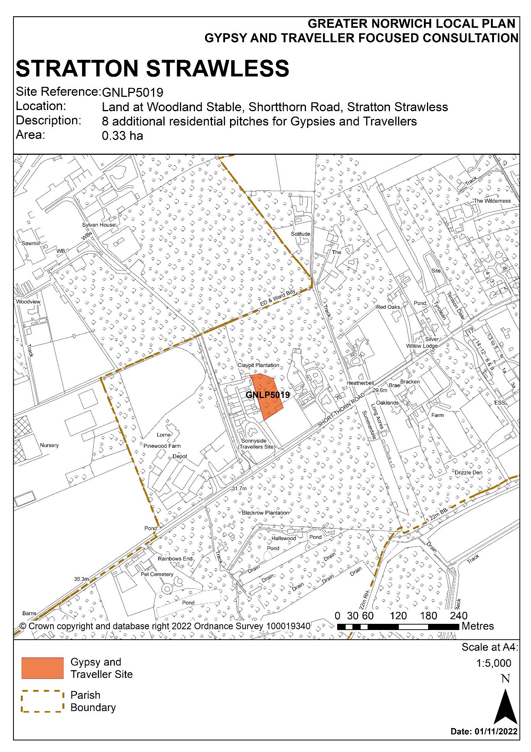

Parish: Carleton Rode
Suitability Assessment

Site reference: GNLP5020 | Site area: 0.54 Ha
LOCATION: Romany Meadow, The Turnpike, Carleton Rode  District: South Norfolk | PROPOSED DEVELOPMENT:  To provide an additional 6 pitches to extend the site to 12 pitches in total

CONSTRAINTS ANALYSIS
Site Access | Green
Accessibility to Services | Amber
Utilities Capacity | Green
Utilities Infrastructure | Green
Contamination and Ground Stability | Green
Flood Risk | Amber
Market Attractiveness | Green

IMPACTS ANALYSIS
Significant Landscapes | Amber
Sensitive Townscapes | Green
Biodiversity and Geodiversity | Amber
Historic Environment | Amber
Open Space and GI | Green
Transport and Roads | Green
Compatibility with neighbouring Uses | Green

SITE SUITABILITY CONCLUSIONS
- GNLP5020 is a proposal to extend a well-established privately owned Gypsy and Traveller site known as Romany Meadow which is located on the B1113 (The Turnpike) at Carleton Rode. The planning history on this site goes back to 2009 when 6 pitches were granted planning permission (reference 2009/0086). Since then, subsequent applications have amended conditions to allow Gypsy and Traveller families to occupy the site that are not related to the owner, and the design of a building has been revised to allow the storage of horse drawn touring caravans.

- The GNLP5020 proposal is to expand the site on land immediately to the east of the existing site to provide 6 additional pitches. The proposal would grow Romany Meadow using the existing site access to a total of 12 pitches on a relatively compact area of land adjacent to the B1113.

- The distance to services and facilities is a constraint. The nearest village is New Buckenham, which is 2.5 kilometres to the west along the B1113, with Old Buckenham 5 kilometres away. Romany Meadows has direct access to the ‘A’ and ‘B’ class road network.

- There are flood risk, landscape and heritage issues that will require mitigation. In terms of flood risk, a surface water flow path passes through the southern part of the site, so the layout of the site should avoid development in this area. In terms of landscape and heritage, the surrounding countryside is open with scattered listed farm buildings and cottages nearby. Of these the most likely to be affected are the Grade II listed cottages which are 300 metres to the north-east of the site. While there are no significant constraints created by proximity of designated ecological sites, an ecological assessment is required due to the proximity of nearby mature trees and hedgerows. Additional tree planting should be provided to minimise landscape impacts.

- In other respects, GNLP5020 performs well against the assessment criteria. and the site is not constrained by land contamination or ground stability issues. The market attractiveness of the site is reflected in the demand from the Gypsy and Traveller community to extend it.

- The Romany Meadow site is considered suitable for expansion to 12 pitches, subject to detailed design layout considerations. On this basis site GNLP5020 is considered suitable as a favoured option for allocation.

Availability and Achievability Conclusions
- The site is in private ownership and the landowner is willing to make the site available for Gypsy and Traveller accommodation use. The owner would be likely to progress this proposal quickly, so 1-3 years is considered ample time to market the land, gain planning permission and to develop the site.

Overall Conclusions for Site

- Subject to the caveats identified above, GNLP5020 is considered suitable as a favoured option for allocation. If allocated in the local plan, GNLP5020 would be deliverable within 5 years and could be completed by March 2025.
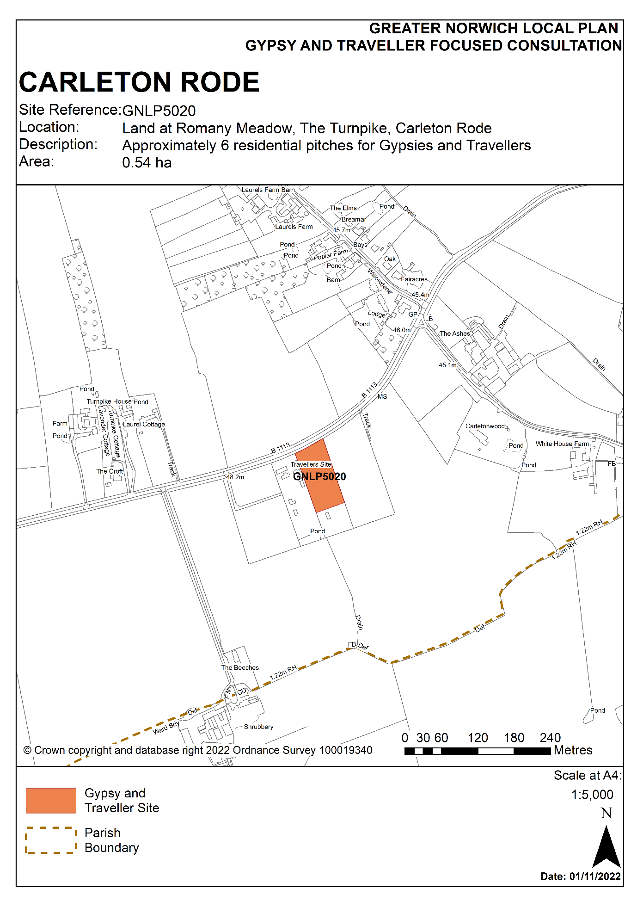

Parish: Horsford
Suitability Assessment

Site reference: GNLP5021 | Site area: 0.9
LOCATION: Land at the Old Produce Shop, Holt Road, Horsford  District: Broadland | PROPOSED DEVELOPMENT: Expansion of an existing site with 1 pitch to provide a permanent residential Gypsy and Travellers site for 7 pitches

CONSTRAINTS ANALYSIS
Site Access | Green
Accessibility to Services | Amber
Utilities Capacity | Green
Utilities Infrastructure | Amber
Contamination and Ground Stability | Green
Flood Risk | Green
Market Attractiveness | Green

IMPACTS ANALYSIS
Significant Landscapes | Green
Sensitive Townscapes | Green
Biodiversity and Geodiversity | Green
Historic Environment | Green
Open Space and GI | Green
Transport and Roads | Green
Compatibility with neighbouring uses | Amber

SITE SUITABILITY CONCLUSIONS
- GNLP5021 is promoted as an extension to an existing Gypsy and Traveller site at the Old Produce Shop, Horsford. It is located to the south-east of Horsford, off the Holt Road, near where the road has been stopped-off close to the A1270 Broadland Northway junction with the A140 Cromer Road.

- There is currently 1 pitch on the site which was approved in 2013 (reference 20120414) and the land is now promoted for an additional 6 pitches to give a total of 7 pitches. The land put forward as GNLP5021 is within the curtilage of the existing site and given that the site measures 0.9 ha the addition of a further 6 pitches is considered a realistic and achievable proposal.

- Access to services is somewhat of a constraint as the site is 2 kilometres from services in Horsford. Although the Holt Road is stopped-off to through traffic and so is little used, there is no footpath from the site to Horsford until the roundabout junction at Brewery Lane which is 1 kilometre from the site. Services are also accessible in Horsham St. Faiths to the north-east via a dedicated pedestrian/cycle route.

- A further constraint is the proximity of GNLP5021 to the A1270 Broadland Northway, which at its nearest point is 100 metres from the junction with the A140 and Norwich Airport which is approximately 2.5 kilometres away. While trees adjacent to the new road are becoming established, additional landscaping and possibly acoustic fencing may be required.

- GNLP5021 performs relatively well against the other assessment criteria. The existing vehicle access from the Holt Road could serve the additional pitches, there is good access to the wider ‘A’ and ‘B’ class road network, there are no known concerns over land contamination and ground stability, the site is in Flood Zone 1 and utilities already serve the site.

- GNLP5021 is neighboured by agricultural fields to its east, north and west, with heritage features further away and unlikely to be affected by expanding the site. The Scheduled Ancient Monument Horsford Castle is 1.2 kilometres to the north and the nearest listed buildings on the southern edge of Horsford, including the Grade II* Church of All Saints, are over 1 kilometre to the north-west.

- There are no ecological designations in close proximity to GNLP5021 that are likely to be adversely affected by the proposed development. The nearest County Wildlife Sites are Black Park & Thicket 1.2 kilometres to the north, Canham’s Hill 1.2 kilometres to the south-west and Horsham Meadows which is 1.3 kilometres to the north-east. There are also no significant mature trees or hedgerows on GNLP5021 that raise particular ecological concerns.

- The market attractiveness of the site is reflected in the demand from the Gypsy and Traveller community to extend it.

- As with many locations in Greater Norwich, mitigation of the impacts on nutrient levels in river catchments will be required.

- In summary, GNLP5021 is considered suitable as a favoured option for allocation.

Overall Conclusions for Site

Availability and Achievability Conclusions
- GNLP5021 is in private ownership and the landowner is willing to make the site available for Gypsy and Traveller accommodation use. As a relatively unconstrained greenfield site there is no reason why development could not come forward quickly. 1 to 3 years is considered sufficient time to gain planning permission and to develop the site.

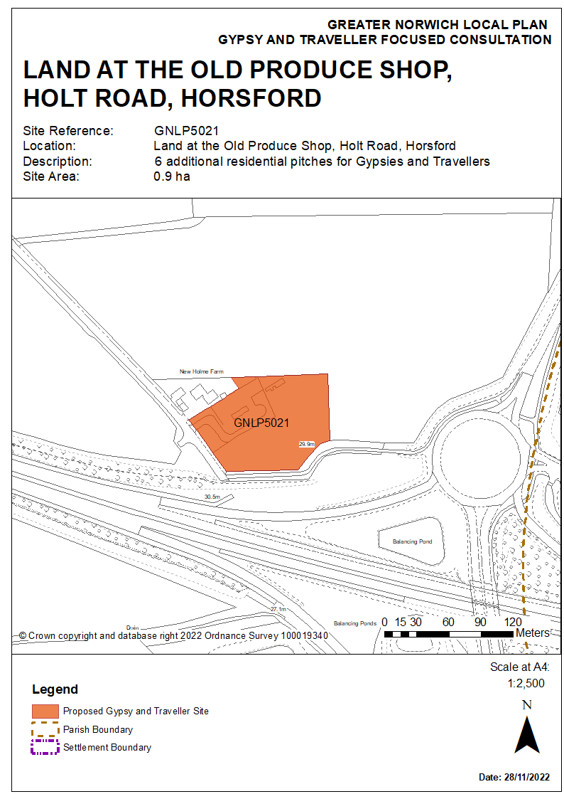

Parish: Foulsham
Suitability Assessment

Site reference: GNLP5022 | Site area: 3.1 ha
LOCATION: Land at the Oaks, south-east of Letter Box Cottage, Reepham Road, Foulsham  District: Broadland | PROPOSED DEVELOPMENT:  Expansion of an existing site of 2 pitches by 5 further pitches to provide a permanent residential Gypsy and Travellers site for 7 pitches.

CONSTRAINTS ANALYSIS
Site Access | Amber
Accessibility to Services | Amber
Utilities Capacity | Green
Utilities Infrastructure | Amber
Contamination and Ground Stability | Green
Flood Risk | Amber
Market Attractiveness | Green

IMPACTS ANALYSIS
Significant Landscapes | Amber
Sensitive Townscapes | Green
Biodiversity and Geodiversity | Amber
Historic Environment | Green
Open Space and GI | Green
Transport and Roads | Amber
Compatibility with neighbouring Uses | Green

SITE SUITABILITY CONCLUSIONS

- GNLP5022 is a proposal to extend a well-established privately owned Gypsy and Traveller site by 5 further pitches to 7 pitches in total.

- The site is located off the Reepham Road, which is part of a local road network which is narrow with some poor alignments and lacks lighting or pavements. Further development of the site will require investigation of highway safety, including of vehicle speeds along Reepham Road, with widening of the visibility splay at the site entrance as appropriate. There is also somewhat limited access to the “A” and B class road network.

- GNLP5022 is approximately 2 kilometres from the village of Foulsham which has a limited range of services and facilities which include a school. The nearest bus stop, which provides regular links to Fakenham and Norwich, is at the far end of the village some 3 kilometres from the site.

- The site has access to utilities infrastructure. The National Grid Bacton to Kings Lynn gas pipeline crosses below the site from east to west and a surface water flow path of 1 in 1,000 probability affects the central portion of the site. However, the northern section of the site is not impacted by the pipeline or flood risk. Whilst further investigation of these issues will be necessary, it is considered that locating development in the north of the site will address these constraints.

- An ecological survey will be required as there are a number of protected habitats and sites within 2.5 kilometres of the site. These are:
- Foxley Wood (SSSI) 950 m to the south of the site;
- The Marriott’s Way (CWS) 570 m to the east;
- Land adjacent to disused railway (CWS) 1,120 m to the east of the site;
- Moat Meadow near Bates Moor (CWS) 1,700 m to the west,
- Westfield Meadow (CWS) 2,500 m to the south-west and
- Barney Brickyard, a county geodiversity candidate site which is 2,300 m to the north-west.

- As the site is classified as grade 3 agricultural land and is currently a Gypsy and Traveller Site there would be no loss of high-quality agricultural land resulting from expanding the site. There would also be no loss of open space resulting from this development proposal.

- GNLP5022 presents no substantive concerns in relation to heritage constraints as the nearest listed buildings are at some distance from the site:
- The Old Hall is 280 m to the east,
- Old Hall Farm House is 480 m to the north-west,
- St Andrews Church is 320 m to the south-west and
- Manor Farm House is 720 m to the west.

- The site has been landscaped with significant tree planting by the disused railway to the south of the site. These trees would need to be retained, with additional soft landscaping required to the north of the site to complement the layout of additional pitches.

- The market attractiveness of the site is reflected in the demand from the Gypsy and Traveller community to extend it. The Oaks site is considered suitable for expansion to 7 pitches subject to detailed consideration of the impact of the gas pipeline, flood risk, design layout, landscaping and an ecological survey. On this basis GNLP5022 is considered appropriate for allocation.

Overall Conclusions for Site

Availability and Achievability Conclusions
- Subject to the caveats identified above, GNLP5022 is considered suitable as a favoured option for allocation. If allocated in the local plan, the additional pitches would be likely to come forward quickly over the next 1-3 years.
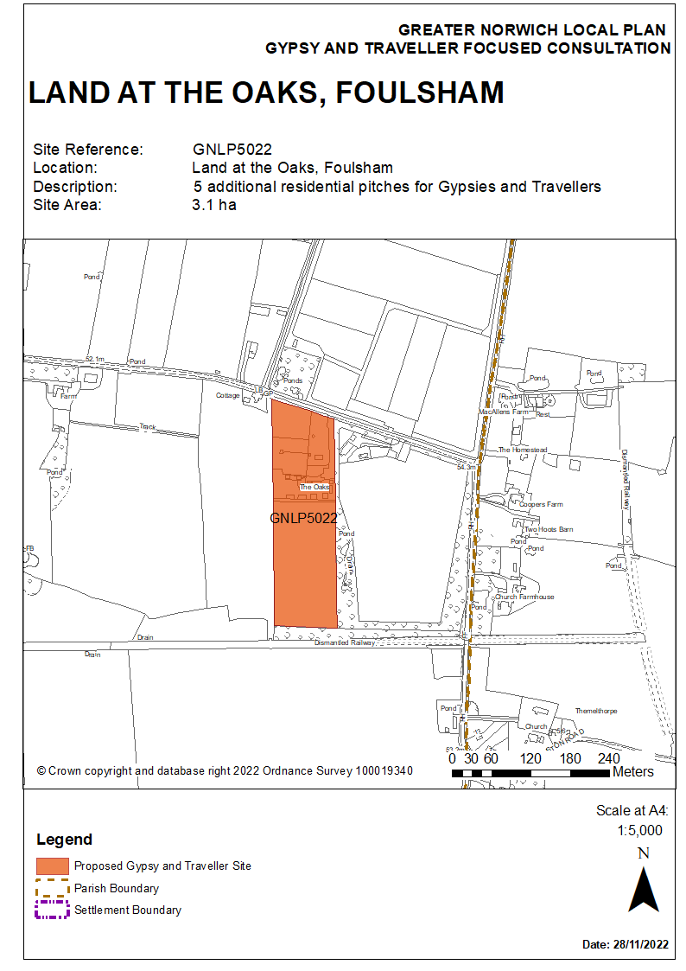

Parish: Wymondham
Suitability Assessment

Site reference: GNLP5023 | Site area: 1.1 Ha
LOCATION: Land off Strayground Lane, Wymondham  District: South Norfolk | PROPOSED DEVELOPMENT:  A permanent residential Gypsy and Travellers site for 10 pitches

CONSTRAINTS ANALYSIS
Site Access | Amber
Accessibility to Services | Amber
Utilities Capacity | Amber
Utilities Infrastructure | Amber
Contamination and Ground Stability | Amber
Flood Risk | Green
Market Attractiveness | Green

IMPACTS ANALYSIS
Significant Landscapes | Green
Sensitive Townscapes | Green
Biodiversity and Geodiversity | Amber
Historic Environment | Green
Open Space and GI | Green
Transport and Roads | Green
Compatibility with neighbouring uses | Amber

SITE SUITABILITY CONCLUSIONS
- Site GNLP5023 is a 1.1 hectare privately owned site which has been put forward by the owner for approximately 10 residential Gypsy and Traveller pitches and is immediately available for development. The site is located on Strayground Lane, south of the existing Wymondham Recycling Centre and north of the Norwich to Cambridge railway line.

- GNLP5023 has an access point at its north-eastern corner which would require improvement; or, alternatively, depending on the trees and hedgerow along the land’s eastern boundary, other points of access could be achievable to Strayground Lane. As Strayground Lane and the adjoining Whartons Lane which links site GNLP5023 back to the B1172 London Road are narrow, improvements to the passing bays on the Strayground Lane will be required and visibility issues at the London Road junction will need to be addressed.

- There are no footpaths on Strayground Lane, but as it is a quiet road, pedestrians and cyclists would be able to use this route. There is a local shop approximately 700 metres away and Browick Road Primary School is approximately 1 kilometre away.

- An ecological assessment will be required as the western boundary of the site is adjacent to the Bays River, which is lowland fens priority habitat and a designated County Wildlife Site. The retention of trees and hedgerows should form part of the assessment.

- Whilst not prohibiting possible development, there are other issues resulting from past and present on-site and neighbouring uses which may impact on the form of development:
- A paving company adjoins the site to its north. This will cause impacts from vehicle movements, noise and possibly dust. Screening will therefore be required.
- The northern half of the site is a historic landfill site so contamination investigation and possibly mitigation will be required.
- There are various planning consents dating back to the 1990s for a gravel quarry, stockpiling aggregates, and landfilling of inert waste (references include C/92/7023 and C/94/7016) to the north-east of the site.

- GNLP5023 is in the catchment of a groundwater Source Protection Zone (Zone III) and as such pollution mitigation measures for water quality would be required.

- The site presents few concerns in relation to the remaining assessment criteria:
- The nearest listed buildings are some distance away and are separated by the industrial area along Chestnut Drive.
- The site is in Flood Zone 1. A small area to the west and south-west of the site is within flood zone 2 and 3a and the site boundary has been redrawn to exclude it. Development should not be located close to this area.
- The site is close to the ‘A’ and ‘B’ class road network and to public transport and its location suggests it would be attractive to the market.

- As with many locations in Greater Norwich, mitigation of the impacts on nutrient levels in river catchments will be required. Subject to addressing access and site constraints and the design of development taking account of site investigations and providing screening, GNLP5023 is considered suitable as a favoured option for allocation.

Overall Conclusions for Site

- GNLP5023 is in private ownership and the landowner has stated that the site is available immediately and as such development could come forward relatively quickly. 3 to 5 years is thought to be sufficient time to market the land, gain planning permission and to develop the site.
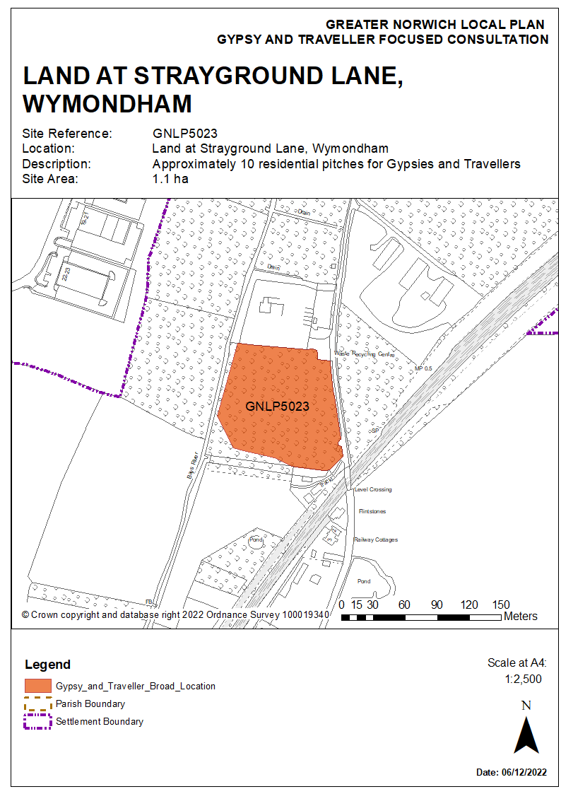

Parish: Carleton Rode
Suitability Assessment

Site reference: GNLP5024 | Site area: 0.62 Ha
LOCATION: Land off Upgate Street, Carleton Rode  District: South Norfolk | PROPOSED DEVELOPMENT:  A permanent residential Gypsy and Travellers site for 4 additonal pitches, expanding the site from 2 to 6 pitches in total.

CONSTRAINTS ANALYSIS
Site Access | Amber
Accessibility to Services | Amber
Utilities Capacity | Green
Utilities Infrastructure | Green
Contamination and Ground Stability | Green
Flood Risk | Green
Market Attractiveness | Green

IMPACTS ANALYSIS
Significant Landscapes | Green
Sensitive Townscapes | Green
Biodiversity and Geodiversity | Amber
Historic Environment | Amber
Open Space and GI | Green
Transport and Roads | Green
Compatibility with neighbouring Uses | Green

SITE SUITABILITY CONCLUSIONS
- GNLP5024 is a proposal to extend a well-established privately owned Gypsy and Traveller site located on Upgate Street at Carleton Rode from 2 to 6 pitches. The site was initially granted permission in 2010. The site is 0.62 hectares in size and the addition of 4 further pitches is considered appropriate.

- However, the distance to services is a constraint. The nearest villages with local services are New Buckenham, which is 1.7 kilometres to the south-west and Old Buckenham, which is 5 kilometres away. There is no footpath provision, but some of the quiet lanes such as Wymondham Road, which is stopped-off to through traffic and provides a direct route to New Buckenham, could be used for walking and cycling. Further evidence/speed data would be needed to demonstrate acceptability in relation to site access and visibility requirements.

- The Upgate Street site is surrounded by agricultural fields, there are no immediate neighbouring properties and the site itself is bounded by established trees and hedgerows, minimising impacts on the landscape and the setting of nearby heritage assets. The site is adjacent to Bunns Bank Linear Earthwork, which elsewhere in its course is a Scheduled Monument, so this should be taken into consideration in design. While the Grade II listed South Farmhouse is in close proximity, there is effective screening by hedgerows and trees.

- New Buckenham Common is approximately 250 metres to the south-west, but it is unlikely that the addition of 4 Gypsy and Traveller pitches would pose a significant adverse effect on ecology. The site is unlikely to support priority habitats, however, boundary trees and hedgerows have the potential to support protected species such as bats and breeding birds. Therefore, a Preliminary Ecological Appraisal is likely to be required and the veteran tree on the northern boundary of the site should be retained.

- In other respects, GNLP5024 performs well against the assessment criteria. There are no constraints from contamination or ground stability, the site is in Flood Zone 1, is not at risk of surface water flooding and there are existing utilities at the site. The market attractiveness of the site is reflected in the demand from the Gypsy and Traveller community to extend it.

- Overall, GNLP5024 is suitable for expansion to 6 pitches, subject to detailed considerations, in particular in relation to safe access. On this basis GNLP5020 is considered suitable as a favoured option for allocation.

Overall Conclusions for Site
Availability and Achievability Conclusions
- GNLP5024 is in private ownership and the landowner is willing to make the site available for more Gypsy and Traveller accommodation use quickly. Consequently, it is anticipated that development could come forward in 1 to 3 years.
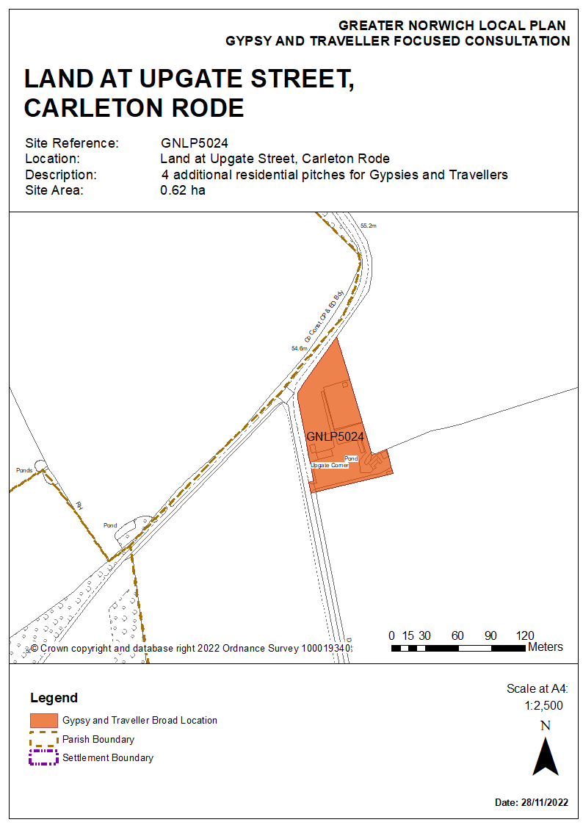

Reasonable Alternative Site

Parish: Ketteringham
Suitability Assessment

Site reference: GNLP5013 | Site area: 0.7 Ha
LOCATION: Ketteringham Depot Land west of Station Lane, Ketteringham  District: South Norfolk | PROPOSED DEVELOPMENT:  A permanent residential Gypsy and Travellers site for 10 pitches

CONSTRAINTS ANALYSIS
Site Access | Green
Accessibility to Services | Amber
Utilities Capacity | Green
Utilities Infrastructure | Green
Contamination and Ground Stability | Amber
Flood Risk | Green
Market Attractiveness | Amber

IMPACTS ANALYSIS
Significant Landscapes | Green
Sensitive Townscapes | Green
Biodiversity and Geodiversity | Amber
Historic Environment | Green
Open Space and GI | Green
Transport and Roads | Green
Compatibility with neighbouring uses | Amber

SITE SUITABILITY CONCLUSIONS
- This 0.7 ha brownfield site is owned by South Norfolk Council. It is currently used as a depot which is expected to be relocated. The site could accommodate 10 residential pitches for Gypsies and Travellers.

- The site has good access to the A11 south-west bound and development would not affect the functioning of local roads. There is an established vehicular access to serve its existing use. However, accessibility to public transport and services is limited. The nearest bus stop is approximately 1.6 kilometres to the north in Hethersett, which also provides the nearest services and facilities such as primary and secondary schools and food shopping. Station Road does not have footpaths and there is no direct safe crossing of the A11 dual carriageway. An alternative route exists via Ketteringham High Street and over a narrow bridge to Ketteringham Lane, but there are no footpaths along this significantly longer route.

- There are no known constraints relating to utilities capacity. Ground investigation, contamination assessments, noise and air quality investigations are required as there is a Norfolk County Council depot and salt storage to the west, and a former fuel depot to the north. There will be a need for screening to neighbouring homes to the west of the site

- The site is in flood zone 1, so is at low risk of river flooding and is not at risk of surface water flooding.

- The proposed development is unlikely to have any impacts on biodiversity and geodiversity as there are no locally or national designated environmental sites within a 1 kilometre radius. The only designated site within a 5 kilometre radius is Eaton Chalk Pit SSSI which is designated for its hibernating bats. The closest County Wildlife Site, Ketteringham Hall Lake, is 1 kilometre to the south. The site is considered unlikely to support priority habitats, however, buildings have the potential to support protected species such as bats and barn owls, therefore a Preliminary Ecological Appraisal is likely to be required.

- There are two ancient monuments around 500 m to the south of the site and a listed monument close to Norwich Lodge, which is a grade II listed building. There is another listed building in the vicinity (Ivy Farmhouse). However, there are no concerns over the impact of development on these buildings and structures, or issues related to the loss of protected trees. In addition, development of this site would not result in the loss of formal open space.

- Overall, the site is suitable as a reasonable alternative for allocation, subject to suitable mitigation measures to address possible noise or odour from the waste management site nearby. As with many locations in Greater Norwich, mitigation of the impacts on nutrient levels in river catchments would be required.

Availability and Achievability Conclusions
- South Norfolk Council is the owner of the site which is available for development.

Overall Conclusions for Site

- GNLP5013 is considered suitable as a reasonable alternative site. If allocated in the local plan, GNLP5013 would be developable within 5 to 10 years and could be completed by March 2032.
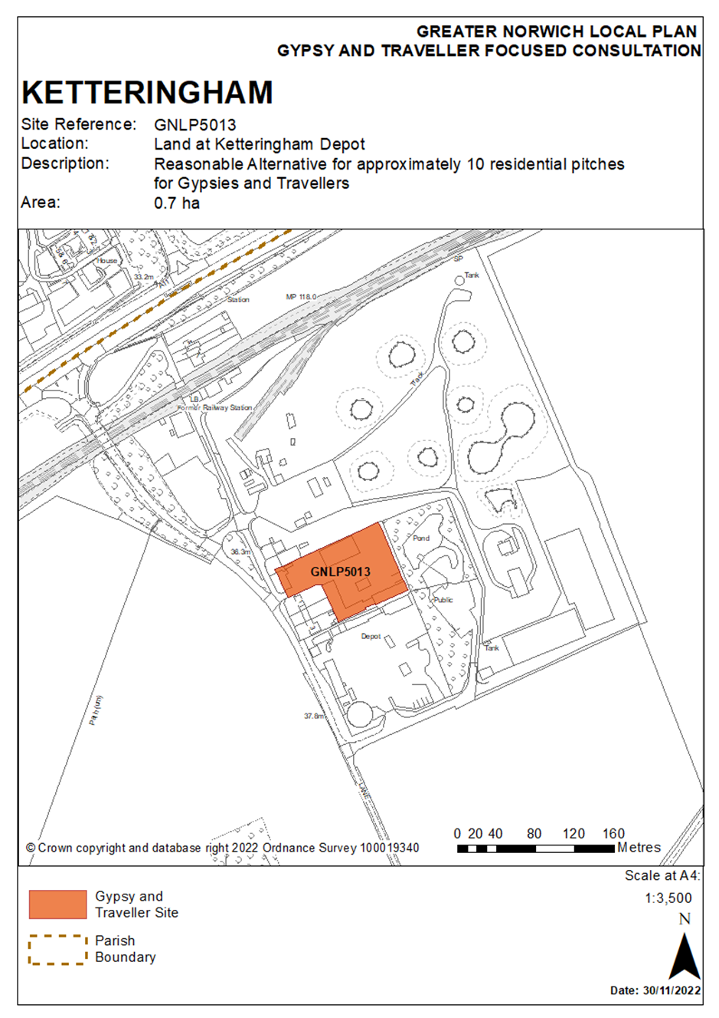

Proposed change to Contingency Site

Parish: Costessey
Suitability Assessment

Site reference: Proposed change to GNLP5081/2023 | Site area: 1 ha
LOCATION:  Land off Bawburgh Lane, north of New Road and east of the A47 (Costessey contingency site ref GNLP0581/2043)  District: South Norfolk | PROPOSED DEVELOPMENT:  A broad location for a permanent residential Gypsy and Travellers site for 18 pitches.

CONSTRAINTS ANALYSIS
Site Access | Amber
Accessibility to Services | Amber
Utilities Capacity | Amber
Utilities Infrastructure | Amber
Contamination and Ground Stability | Green
Flood Risk | Amber
Market Attractiveness | Green

IMPACTS ANALYSIS
Significant Landscapes | Amber
Sensitive Townscapes | Amber
Biodiversity and Geodiversity | Amber
Historic Environment | Green
Open Space and GI | Green
Transport and Roads | Green
Compatibility with neighbouring uses | Green

SITE SUITABILITY CONCLUSIONS
- This is a proposed change to provide a variation of the contingency site GNLP5081/2043, which measures 62 ha, and is being promoted as a residential-led urban extension of approximately 800 homes. Subject to formal agreement from the landowners, the southern portion of the site is identified as a potential broad contingency location for a Gypsy and Traveller site (denoted by a star on the map below). To ensure good planning, the need for a Gypsy and Traveller site at this broad location would need to be evidenced if and when the wider contingency site for housing is brought forward for development.

- There is an area of land affected by surface water flood risk in the central and part of the northern area of GNLP5081/2043. GNLP5081/2043 is also in the Norwich Southern Bypass Protection Zone and is adjacent to the A47, so there could be amenity concerns from disturbance caused by traffic and screening may be required. Other constraints include providing a new site access, overhead power lines, landscape impacts, townscape impacts, and the potential for protected species on site requiring further investigation. Site constraints would need to be mitigated through a comprehensive master-planning exercise.

- Due to its location on the edge of the urban area close to existing services and the major road network, the site is likely to be attractive to the market.

- Site GNLP5081/2043 was considered suitable for inclusion in the land supply assessment, and that conclusion remains the same with the inclusion of a Gypsy and Traveller site into the overall proposal for an urban extension. As with many locations in Greater Norwich, mitigation of the impacts on nutrient levels in river catchments would be required.

Availability and Achievability Conclusions
- Norwich City Council is a part owner of the land promoted as GNLP0581/2043. Subject to confirmation of agreement with the other two landowners and the need for a Gypsy and Traveller site at this broad location being evidenced if and when the site comes forward for a wider urban extension, the land required for a Gypsy and Traveller site is considered to be likely to be available for development within 4 to 6 years.

Overall Conclusions for Site

The proposed change to GNLP5081/2023 offers the potential for a Gypsy and Traveller site to be delivered in a sustainable location if and when the submitted contingency site comes forward for a wider urban extension. Evidence would need to be provided at that time that additional Gypsy and Traveller accommodation is required. Inclusion of this site in this consultation provides flexibility for later decision making.
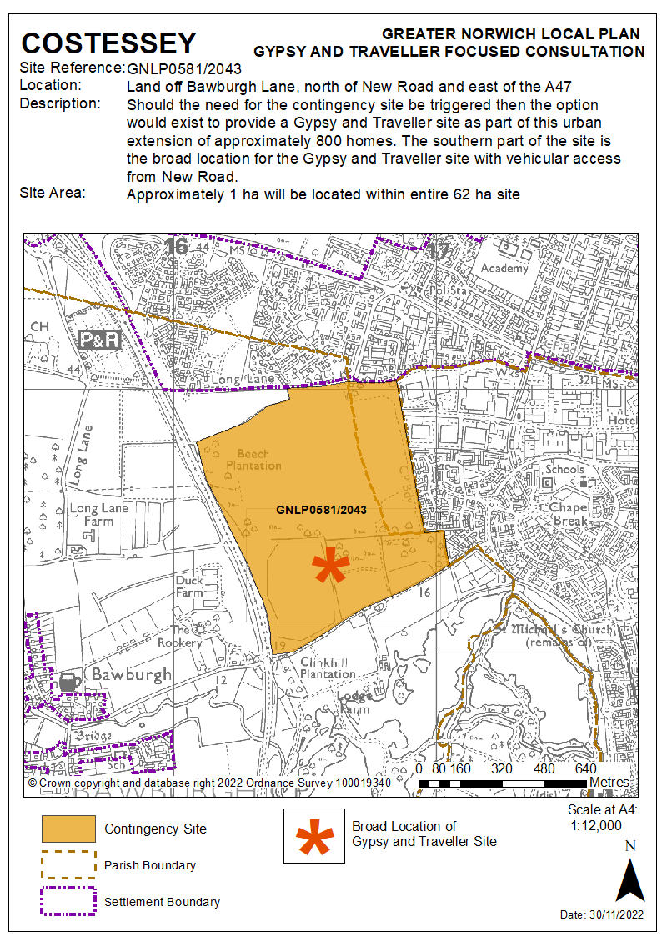

Unreasonable Sites

Parish: Denton
Suitability Assessment

Site reference: VCHAP GT Site 1 | Site area: 0.68 Ha
LOCATION: Land west of Grove Farm, Middle Road, Denton  District: South Norfolk | PROPOSED DEVELOPMENT:  A permanent residential Gypsy and Travellers site

Site reference: VCHAP GT Site 2 | Site area: 0.78 Ha
LOCATION: Land north of Kingsland Farm, Middle Road Denton  District: South Norfolk | PROPOSED DEVELOPMENT:  A permanent residential Gypsy and Travellers site

CONSTRAINTS ANALYSIS
Site Access | Red
Accessibility to Services | Red
Utilities Capacity | Green
Utilities Infrastructure | Green
Contamination and Ground Stability | Green
Flood Risk | Amber
Market Attractiveness | Amber

IMPACTS ANALYSIS
Significant Landscapes | Red
Sensitive Townscapes | Red
Biodiversity and Geodiversity | Green
Historic Environment | Amber
Open Space and GI | Green
Transport and Roads | Red
Compatibility with neighbouring Uses | Amber

- Two areas of land in Denton, measuring 0.68 ha and 0.78 ha, were promoted in 2021 as Gypsy and Traveller sites through the public consultation for the South Norfolk Village Clusters Housing Allocations Plan (VCHAP). The two sites are both on Middle Road, located less than 100 metres apart, and are either side of Grove Farm. Whilst being very similar in locational terms, a key difference is Site 1 is partially covered by farm buildings and Site 2 is used as paddocks.

- There is a significant planning history to Site 2, where there have been appeal decisions against developing a Gypsy and Traveller site – see planning applications 2004/0495 and 2006/0797. While the following appeal refusal criteria apply directly to Site 2, the close proximity of Site 1 makes them applicable here as well:
- highway safety on Middle Road
- the relationship to the primary road network and the distance to facilities
- the effect on the greenfield setting of two listed buildings
- the landscape visual impact and
- the amenity impact for nearby residents.

- The inspectors stated that as Middle Road is narrow, and due to its location, access to services would be dependent upon having access to a vehicle. The remoteness of the location is evidenced by the distance to schools: Earsham Primary School is 6 kilometres away, Harleston Primary School is 7 kilometres and it is 10 kilometres to Bungay High School. These factors present significant constraints when considering the sites against the assessment criteria.

- Other notable constraints are the impacts on listed buildings and surface water flood risk. Kingswood Farm and Grove Cottages are Grade II listed buildings and the setting of both would be affected by the development of a Gypsy and Traveller site in this location. A lesser constraint is flood risk as there are areas at 1 in 1,000 and 1 in 100 flood risk probability on both Sites 1 and 2 that would warrant consideration if the sites were to be developed.

- Ecological impacts are less of a concern because the nearest designations are some distance away. The nearest is Wayside County Wildlife Site which is 300 metres to the north-east and East Wood County Wildlife Site is 500 metres to the east. The River Waveney is 1.7 kilometres away, making it unlikely that development would have any adverse impact on this habitat and landscape.

- In summary, there are significant concerns in relation to these sites, most notably about highways, the distance to facilities and the impact on the setting of adjacent listed buildings. For these reasons Sites 1 and 2 are not considered suitable for allocation.

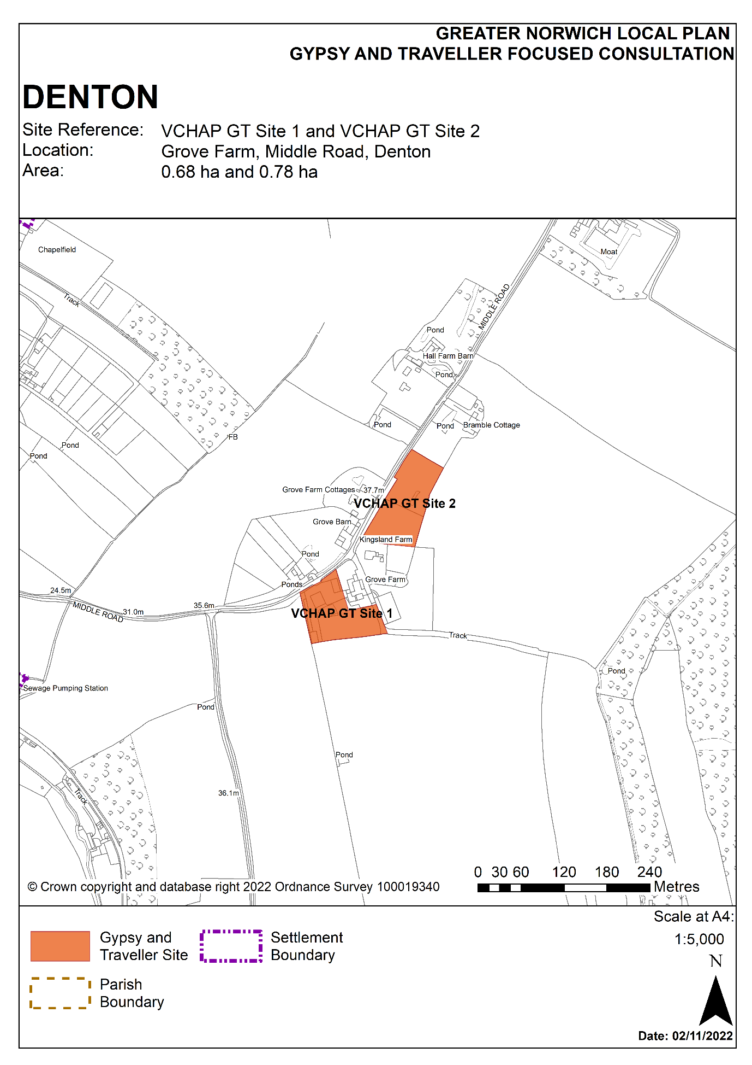

Parish: Wymondham
Suitability Assessment

Site reference: VCHAP GT Site 3 | Site area: 3.34 Ha
LOCATION: Land off London Road, Suton, Wymondham  District: South Norfolk | PROPOSED DEVELOPMENT:  A permanent residential Gypsy and Travellers site for 8 pitches

CONSTRAINTS ANALYSIS
Site Access | Red
Accessibility to Services | Red
Utilities Capacity | Green
Utilities Infrastructure | Green
Contamination and Ground Stability | Green
Flood Risk | Amber
Market Attractiveness | Amber

IMPACTS ANALYSIS
Significant Landscapes | Red
Sensitive Townscapes | Red
Biodiversity and Geodiversity | Green
Historic Environment | Amber
Open Space and GI | Green
Transport and Roads | Red
Compatibility with neighbouring Uses | Amber

SITE SUITABILITY CONCLUSIONS
- VHCAP Site 3, which measures 3.35 ha, is located on the B1172 London Road, 4.2 kilometres from the centre of Wymondham and 5.4 kilometres from the centre of Attleborough. It has been largely built out as a Gypsy and Traveller site for 8 pitches, but a planning appeal to allow the scheme was dismissed in June 2021. As of December 2022 consideration is ongoing as to when the unlawful development shall be fully vacated.

- The site’s accessibility to services is a notable constraint. Although there is a bus stop 600 metres from the site, there is no footpath to it, and it is likely that most journeys from this location would be by car. Spooner Row Primary School is 1.8 kilometres away on the opposite side of the A11 dual carriageway and there is no easily accessible walking and cycling route. The other nearest services are 3.8 kilometres away in Wymondham.
- The site’s setting amongst flat and open agricultural fields has been assessed to have a significant impact on the surrounding landscape and on nearby estate cottages which are non-designated heritage assets.

- There are fewer constraints in relation to other assessment criteria including biodiversity, flood risk, market attractiveness, compatibility with neighbouring uses and the availability of utilities connections.

- The recent planning history provides further useful information when considering VCHAP Site 3 against the assessment criteria. The inspector cited the following justification in refusing appeal (2019/0330) in June 2021:
- landscape intrusion,
- impact on the nearby estate cottages,
- journeys would be predominately by car and ,
- the site would amount to a small village in its own right in the context of a sparsely populated community.

- In summary, there are significant concerns relating to this site as evidenced in a recent appeal decision, most notably relating to accessibility to services, landscape impact and the effect on the nearby non-designated heritage assets. For these reasons VCHAP Site 3 is not considered suitable for allocation.
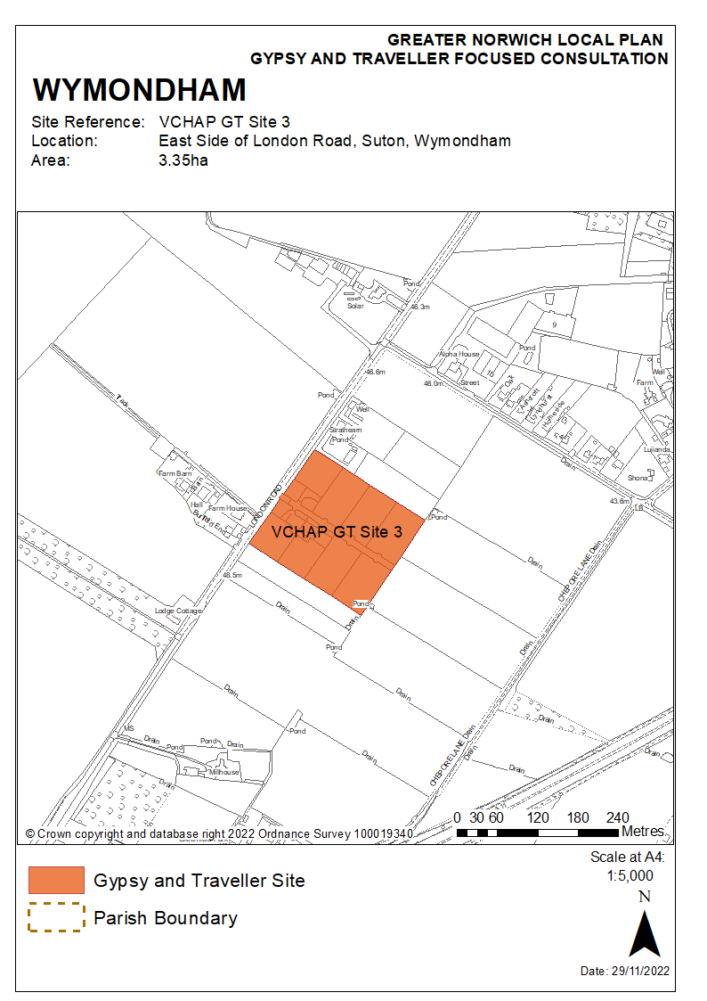

Conclusions
- This assessment, along with the SA and HRA, has assisted in identifying a “favoured option” for Gypsy and Traveller accommodation sites to be consulted on. Although all of the favoured sites have some constraints, the limited scale of the development proposed and the specific nature of the constraints means that these can be overcome with appropriate mitigation measures.

- In some cases, proposed sites do not have immediate access to everyday services. However, the needs of the Gypsy and Traveller community in a predominantly rural area mean that it is not always possible, or necessary, to locate sites with immediate access to facilities.

- The favoured option provides a variety of sites. There are different types of ownership, both public or private, and both new sites and existing sites for expansion. There is also a relatively wide geographical spread of sites across the area, providing choice, and a range of likely delivery timescales which should meet national policy requirements to ensure evidenced needs are met. This diverse choice of site is the outcome of extensive engagement with various landowners, including direct liaison with the Gypsy and Traveller community.

- Two of the favoured option sites are new sites put forward by public authorities (GNLP 5005 at Wymondham and GNLP5014 at North Burlingham). Three are new privately owned sites (GNLP5004 at Cawston, GNLP5009 at Bawburgh and GNLP5023 at Wymondham) and five are existing privately owned sites which are proposed for expansion (GNLP5019 Stratton Strawless, GNLP5020 and GNLP5024 at Carleton Rode, GNLP5021 at Horsford, and GNLP5022 at Foulsham).

- Whilst no sites were identified in the Norwich City Council area in addition to the expansion of the Swanton Road site which has already been accounted for in the calculation of need, there is a distribution and choice of sites across Broadland and South Norfolk. Foulsham, Cawston, Stratton Strawless and Horsford are in the north and west of Broadland, whilst North Burlingham is in the east. In South Norfolk the choice of sites is more clustered in Wymondham and Carleton Rode, with two new sites proposed in the former and two for expansion in the latter.

- The Greater Norwich partnership recognises there is a current unmet need for pitches and therefore it is important to identify a supply of sites that can deliver over the current 5-year period to March 2027. Expanding existing sites is a good way to build new pitches quickly, and the existing sites at Carleton Rode, Horsford, Foulsham, Stratton Strawless are well-placed to expand over the next 5 years because infrastructure is already in place and the landowners are willing and able to build them out.

- Some of the newly proposed sites also provide potential for pitches to be built over the current 5-year period. Landowners for the Cawston, Bawburgh, and Wymondham (GNLP5023) sites have stated could deliver pitches in the current 5-year period. The new site at North Burlingham (GNLP5014), although contingent on the A47 road improvement scheme, can be built on publicly owned land and is also deliverable over the current 5-year period.

- The reasonable alternative site at Ketteringham and proposed policy change to the submitted contingency housing site at Costessey provide further options.

https://www.leeds.gov.uk/docs/Gypsy and Traveller Site Design Guide.pdf designinggypsysites.pdf (publishing.service.gov.uk)

