**Appendix G**

**Outcomes from a Systematic Review of Existing and Proposed Allocations to Accommodate Gypsy and Traveller Pitches**

1. In attempting to find pitches for Gypsies and Travellers to include in the local plan the GNLP Team undertook a systematic review of all existing and proposed new site allocations.
2. This review began by narrowing down which sites genuinely offered some potential; so it ruled out sites likely being deleted from the plan, allocations where the use proposed (such as open space) is inconsistent with a Gypsy site, ruling out small sites of less than 50 homes where it would be financially unrealistic to provide a Gypsy site, and ruling out sites with a consent or planning application pending. The process undertaken, which involved officers from each of the three development management teams, left 8 sites with potential for further consideration.
3. R29 – Sites at Hurricane Way, Norwich
4. GNLP0132 – White House Farm, Sprowston
5. HAR7 – Land south of Spirketts Lane, Harleston
6. GNLP0354R – Land at Johnsons Farm, Wymondham
7. GNLP3013 – Land north of Tuttles Lane, Wymondham
8. GNLP0378R/2139R – Land west of Acle
9. GNLP0125R – Land to west of West Lane, Horsham St Faith
10. SWA1/GNLP0382 – Land to rear of Burlingham Road, South Walsham
11. For each of the 8 sites officers approached the relevant promoter/landowner during late October and early November, attempting to make contact both by telephone and email, but none have responded positively. Promoters or agents have either politely said they are not interested in this form of development on their site, or they have not replied to voicemails and emails.
12. As a result, it is concluded that there is no potential for existing and proposed allocation sites in the Greater Norwich Local Plan to provide Gypsy and Traveller accommodation pitches.

**List of Sites**

1. R29 – Sites at Hurricane Way, Norwich

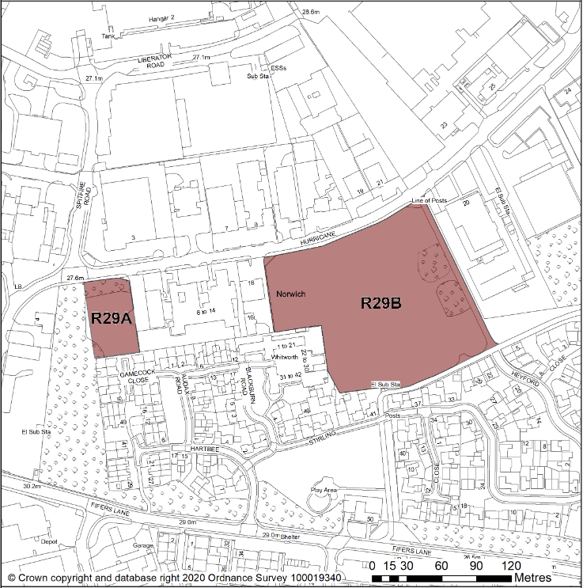

1. GNLP0132 – White House Farm, Sprowston

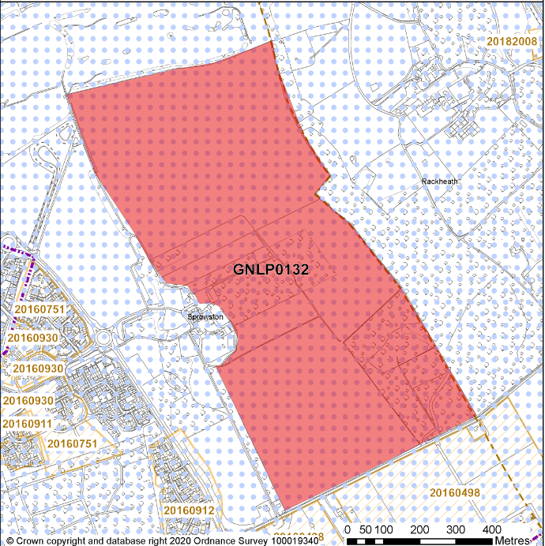

1. HAR7 – Land south of Spirketts Lane, Harleston

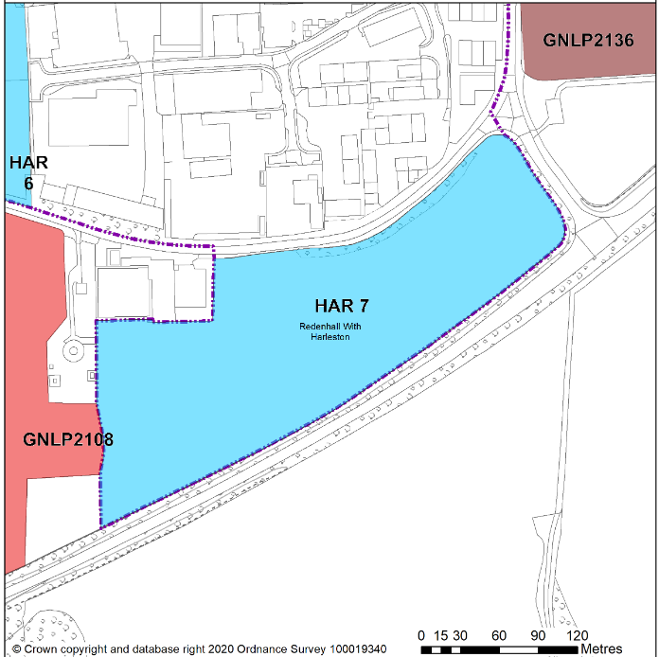

1. GNLP0354R – Land at Johnsons Farm, Wymondham

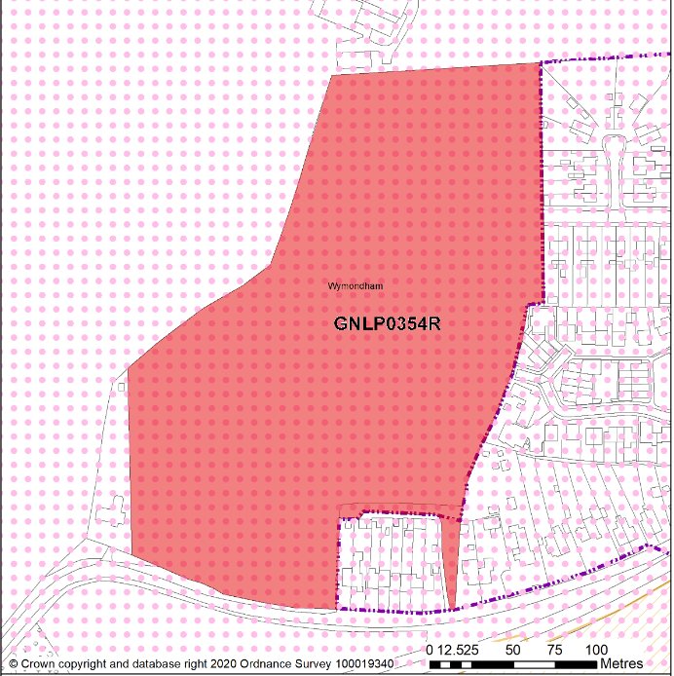

1. GNLP3013 – Land north of Tuttles Lane, Wymondham

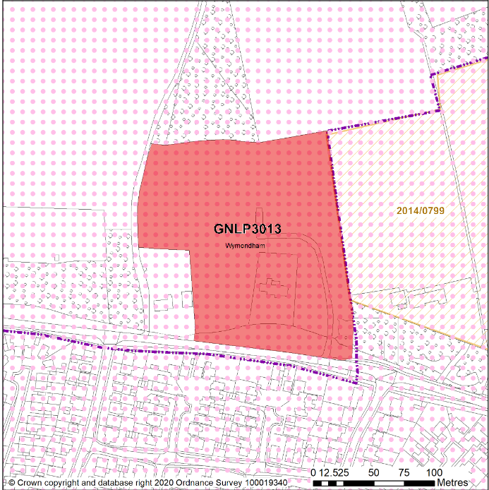

1. GNLP0378R/2139R – Land west of Acle

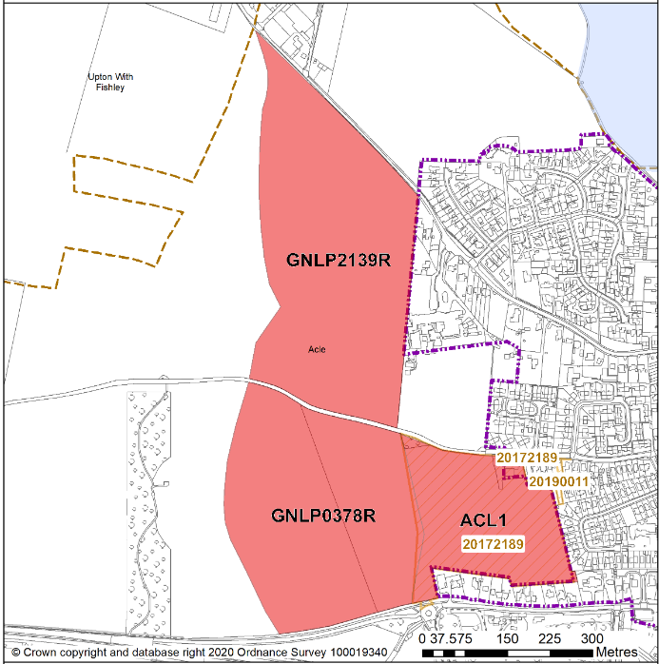

1. GNLP0125R - Land to west of West Lane, Horsham St Faith

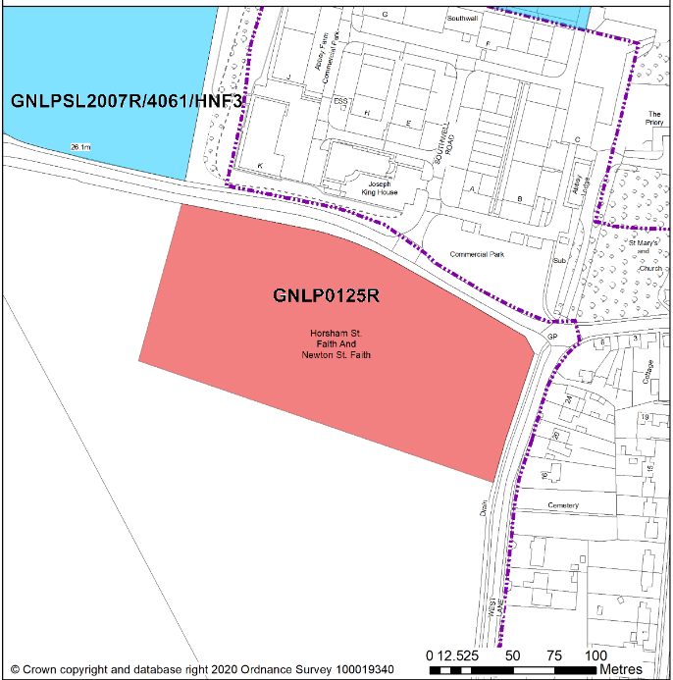

1. SWA1/GNLP0382 – Land to rear of Burlingham Road, South Walsham

