

Homelessness Strategy (2020-2025) and Rough Sleeping Strategy (2022-2027)
Review for 2025-2030 strategy

Table of Contents
1. Introduction 3
Setting the Scene 4

2 The Council’s Responsibilities 4

3 The National Picture 5
4 Investigation and Commission Key Findings 6

6 Other Factors influencing Homelessness and Rough Sleeping Trends 1
6.1 Covid 19 1
6.2 Cost of Living 1
6.3 Benefit Reform and Local Housing Allowance (LHA) rates 2
6.4 Housing Related Support Reduction 3
6.5 Affordable Housing Delivery 4
6.6 Homes for Ukraine, Refugees and People Seeking Asylum 6
6.7 Ex-Offenders and the Accommodation for Ex-Offenders (AFEO) Project 8
6.8 Disabled Facilities Grant (DFG), Sanctuary Scheme and the INTERACT service 9
7 Homelessness Statistics 11

8 Homelessness approaches 12
Homelessness prevention and relief cases 13
Reasons for loss of accommodation 16
Support needs 2
Age of main applicants owed a prevention or relief duty 3
Reasons for households’ prevention and relief duty ending 4

9 Accommodation secured 5
Household type 9

10 Main duty decisions 11
Employment status 13
Ethnicity of main applicant owed a prevention or relief duty 14

11 Rough sleeping 15
Age of people sleeping rough 17

12 Pathways Norwich 20

13 Temporary accommodation 20
14 Projecting Future Homelessness 22

Introduction
1.1 This document reviews the progress made since the implementation of the Greater Norwich Homelessness Strategy 2020–2025 and assesses our current position in delivering the priorities set out in the Norwich Rough Sleeping Strategy 2022–2027. It utilises statistics and the context of local and national changes to assess how far these strategies met their objectives, to ensure that our approach remains responsive to the evolving needs of people experiencing homelessness. It highlights key achievements, identifies outstanding actions, and helps to shape and inform the development of the emerging Norwich Homelessness Strategy
1.2 The previous Greater Norwich Homelessness Strategy 2020-2025 set out five priorities:
- Domestic Abuse
- Preventing Homelessness
- Single and Youth Homelessness, and Financial Inclusion
- Welfare Reform
- Economic Growth
1.3 The Norwich City Council Rough Sleeping Strategy 2022-2027 focuses on four key pillars:

- Prevention: Identifying and addressing the underlying causes of rough sleeping to intervene before individuals are forced to sleep on the streets.
- Intervention: Providing swift, tailored support to those already experiencing rough sleeping, ensuring that help is responsive to individual needs.
- Recovery: Assisting individuals in securing stable housing and rebuilding their lives by providing the necessary support for long-term recovery.
- Systems: Identifying and addressing blockages within the system and enhancing the connections between services and available support.

See appendix 1 for review of actions set by the last strategies.

Setting the Scene

The Council’s Responsibilities
2.1 Definition of Homelessness
The main provisions for dealing with homelessness are contained in Part 7 of the Housing Act 1996 (as amended). The Homelessness Reduction Act 2017 then came into force on 3 April 2018, making significant changes to Part 7 of the 1996 Act. Its main effect was to place increased duties on local authorities to assess an applicant’s individual needs and to prevent and relieve homelessness.
2.2 Preventing Homelessness
A person is threatened with homelessness if it is likely that they will become homeless within 56 days. This includes where they have been given a valid section 21 notice in respect of their only accommodation, and the notice is due to expire within 56 days. Where a person is threatened with homelessness, the local authority will have a duty to take reasonable steps to prevent them from becoming homeless.
2.3 Relieving Homelessness
A person is statutorily homeless if they have no accommodation available for their occupation which they have a legal right to occupy and is reasonable for them to continue to occupy. If the person is statutorily homeless, the local authority will have some form of duty towards them. This ranges from advice and assistance, or providing interim accommodation, to the relief duty or the main housing duty of securing accommodation for a continuing period. The extent of the duty will depend on whether they are, or may be, eligible for assistance, in priority need, intentionally homeless, or have a local connection. It is important to note that there is only a duty to secure accommodation for those who are eligible for assistance and have a priority need. The priority need categories are set out in Part 7 of the Housing Act 1996 as:

- Pregnant women
- Households with dependent children
- 16 and 17 year olds
- Care leavers aged 18,19 or 20
- People made homeless by an emergency
- People vulnerable because of old age, mental illness or physical disability, having been in care, having served in the armed forces, having been in custody, having to leave accommodation because of violence or abuse or those who are vulnerable for some other special reason

3 The National Picture
Recent Policy
- 3.1 Social Housing White Paper (2020): Proposed reforms to improve the quality and regulation of social housing, with an indirect impact on homelessness prevention through better housing standards and tenant empowerment.
- 3.2 Everyone In (2020): Emergency response to Covid-19 requiring local authorities to house rough sleepers immediately, leading to thousands being accommodated and supported off the streets.
- 3.3 Rough Sleeping Initiative (continued and expanded funding from 2020): Ongoing investment to help local authorities implement tailored support for rough sleepers, including outreach, accommodation, and wraparound services.
- 3.4 The Kerslake Commission on Homelessness and Rough Sleeping (2021–2022): Independent review providing long-term policy recommendations, building on the success of 'Everyone In' and advocating for systemic reforms.
- 3.5 Accommodation for Ex-Offenders Scheme (2021): Introduced to help prison leavers secure stable housing, supporting resettlement and reducing homelessness risk.
- 3.6 Levelling Up White Paper (2022): Broader government strategy aiming to reduce regional inequalities, with commitments related to housing, health, and economic opportunity relevant to homelessness prevention.
- 3.7 Rough Sleeping Strategy – Updated Delivery Plan (2022): Reaffirmed target to end rough sleeping by 2024, focusing on prevention, intervention, and long-term recovery with cross-sector collaboration.
- 3.8 Renters Reform Bill (introduced 2023): Includes measures to improve tenant security, notably by abolishing Section 21 evictions, potentially reducing evictions leading to homelessness

4 Investigation and Commission Key Findings
The Homelessness Monitor: England 2023 (Crisis UK)
- 4.1 In 2021 to 2022, 290,000 households sought help for homelessness. Although the number of people at risk of homelessness increased by 10%, actual homelessness dropped by 4%. Most local authorities (85%) reported more demand for services, especially from those evicted from private rentals.
- 4.2 The number of people in temporary accommodation doubled to over 100,000 by December 2022. Bed and Breakfast placements also rose sharply, increasing by 32% in 2022.
- 4.3 Cuts to public services, a lack of affordable rental properties, and financial pressures have made it harder to prevent homelessness. Cuts to housing support have further limited local authorities' ability to help.
- 4.4 Core homelessness (a concept which captures the most acute forms of homelessness) in England rose to 242,000 in 2022, up from 206,000 a decade ago, with 1 in 100 households experiencing severe homelessness on any given night.
- 4.5 Core homelessness is expected to continue to increase, the main drivers being rising inflation, higher private rents, evictions, and fewer social housing options.

5 Rough sleeping snapshot in England: Autumn 2024 (Ministry of Housing, Communities & Local Government)
- 5.1 The Ministry for Housing, Communities and Local Government introduced the Rough Sleeping Strategy in September 2022.
- 5.2 The estimated number of people sleeping rough in autumn 2024 is 4,667, a 20% increase from 2023.
  - This is still 2% lower than the 2017 peak rough sleeping levels, and 164% higher than 2010 levels.
- 5.3 The rough sleeping rate in England rose to 8.1 per 100,000 in 2024, up from 6.8 in 2023, but still below the 2017 peak of 8.5.
- 5.4 Nearly half (45%) of rough sleepers are in London and the South East of England, with London seeing the largest increase (16%), from 1,132 in 2023 to 1,318 in 2024. The North West of England saw a small decrease in rough sleeping levels.
- 5.5 Over half of the increase in rough sleeping is driven by 12 local authorities, with 46% of areas seeing a decrease or no change to their figures.
- 5.6 Most rough sleepers are male, over 26, and from the UK. This is consistent with previous years.
- 5.7 In December 2024, 7,524 people slept rough at some point across the month. This was 2.2 times higher than the number of individuals seen to be sleeping rough on a single night. Rough sleeping is usually lower in winter due to cold weather and temporary shelters.

Estimated number of people sleeping rough on a single night in autumn in England, 2017 to 2024 (Rough sleeping snapshot in England: Autumn 2024 (Ministry of Housing, Communities & Local Government))
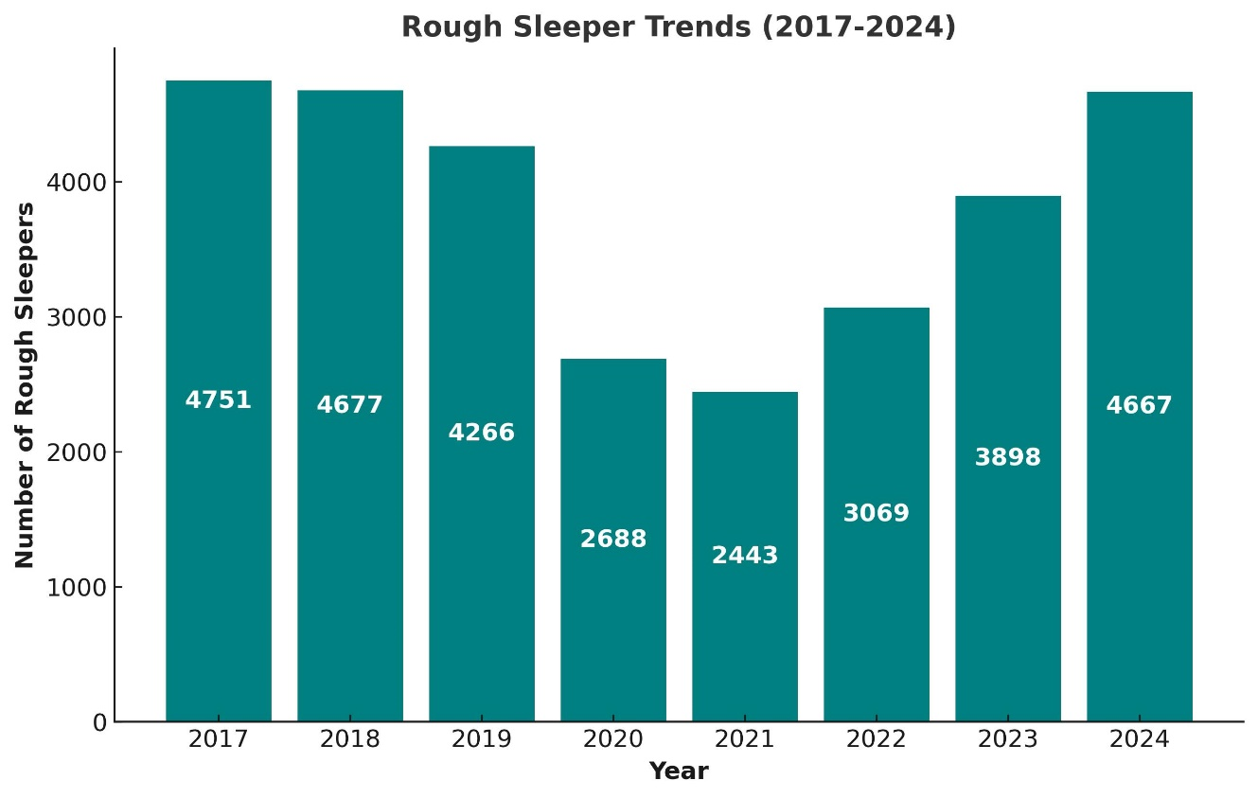
5.8 In 2017, rough sleeping reached its peak. A notable decline occurred in 2020 and 2021, during the height of the COVID-19 pandemic, when the government implemented the "Everyone In" initiative. This period also saw the introduction of the Rough Sleeper Accommodation Pathway (RSAP).

6 Other Factors influencing Homelessness and Rough Sleeping Trends

6.1 Covid 19
The Covid-19 pandemic (November 2019 - May 2023) had a profound impact on how local services were delivered, leading to changes in working practices. It placed additional pressure on households, contributing to increased stress and a notable rise in domestic abuse incidents. The pandemic also highlighted and exacerbated health inequalities, particularly relating to overcrowded living conditions and limited access to safe outdoor spaces. Crucially, it transformed the response to rough sleeping through the introduction of the 'Everyone In' initiative, which brought significant changes in how people experiencing street homelessness were supported.

6.2 Cost of Living
The cost-of-living crisis in the UK has significantly deepened homelessness and poverty, as rising prices for essentials like food, energy, and housing have outpaced wages and benefits. Many low-income households are now forced to choose between heating and eating, with growing numbers unable to afford rent or basic necessities. This financial pressure has led to a surge in evictions, food bank usage, and reliance on emergency accommodation, pushing more individuals and families into precarious living situations or outright homelessness. The crisis has exposed and worsened existing inequalities, hitting the most vulnerable the hardest.

6.3 Benefit Reform and Local Housing Allowance (LHA) rates
6.3.1 Recent reforms to the UK's disability benefits, particularly changes to Personal Independence Payment (PIP) and incapacity benefits, are anticipated to increase homelessness rates. Tightening eligibility criteria and reducing financial support are expected to push hundreds of thousands of disabled individuals into poverty. Estimates suggest that up to 250,000 people, including 50,000 children, could be affected by these changes.
6.3.2 The LHA freeze has led to substantial shortfalls between housing cost support and actual rent costs, making it increasingly difficult for low-income households to afford the private rented sector (PRS). As a result, many individuals and families could face eviction which contributes to a potential rise in homelessness. The freeze has also placed financial strain on local authorities, which are compelled to cover the growing gap between housing benefits and actual rental costs, diverting funds from other essential services. As a result of cost-of-living pressures and LHA freezes Local Authorities are increasingly utilising Discretionary Housing Payments (DHP) to provide short-term financial assistance. DHP payments are often provided to individuals or families who need extra help with housing costs, such as covering rent shortfalls, deposits, or moving expenses, particularly during times of financial hardship.
Discretionary Housing Payment (DHP) expenditure for Norwich
Year | Amount
2019 - 2020 | £411,800
2020 - 2021 | £440,019
2021 - 2022 | £449,448
2022 - 2023 | £302,351
2023 - 2024 | £258,729*
2024 - 2025 | £258,729*
*Government DHP funding has remained static since 2022 – 2023

6.4 Housing Related Support Reduction
6.4.1 In 2024 Norfolk County Council have made the decision to cut Housing Related Support (HRS) funding. This decision was driven by increased adult social care costs; this reduction will impact 237 bed spaces in Norwich. Although an impact assessment has been conducted, its practical effects are yet to be observed. For adult provision, three schemes will be decommissioned, while the remaining services face funding reductions of 20% to 30%. Young people’s provision will not see decommissioning, but all services will also experience funding cuts of 20% to 30%. Additionally, non-accommodation-based funding reductions will affect homeless prevention contracts, Norwich Pathways’ core grant, and contributions to the Severe Weather Emergency Protocol (SWEP).
6.4.2 The following services in Norwich have been impacted by this reduction in funding -
- St Martins - Bishop Bridge House and Dibden Road
- Home Group – Aspland Road, Archway, Ripley
- Sanctuary – Norwich community homes
- Orwell – Hinde Court and Hinde House
- House of Genesis – community homes
- YMCA – My Place and Central
6.4.3 To mitigate the impacts, Norwich City Council will continue to support the Pathways Norwich consortium through RSI funding and maintain its £120k contribution to the core grant. Winter pressure funding (2024-2025) from MHCLG has provided temporary relief for SWEP accommodation, though its long-term availability remains uncertain. Norfolk County Council and Norwich City Council are working with registered providers and charities to explore alternative funding solutions, such as housing benefit adjustments, to offset the impact. Both councils remain committed to ongoing collaboration with stakeholders to minimise disruption to essential services.

6.5 Affordable Housing Delivery
6.5.1 For clarity, affordable housing is defined in Annex 2 of the National Planning Policy Framework (NPPF) as housing for sale or rent that caters to those whose needs are not met by the open market. This includes housing for rent at social rent, affordable rent, or intermediate rent, as well as discounted market sales and other affordable routes to home ownership.
6.5.2 Since 2020, several factors have contributed to a lower-than-expected delivery of affordable housing. These include the impact of the Covid-19 pandemic and the introduction of new planning requirements such as Biodiversity Net Gain regulations and Nutrient Neutrality, which have stalled development over the past two years.
6.5.3 Despite these challenges, the council has actively sought ways to boost affordable housing delivery. One key initiative is the Norwich Orwell Partnership, a collaboration through which predominantly brownfield, council-owned land is being transferred to Orwell Housing for development. This supports progress towards the target of delivering 254 new affordable homes annually, as identified in the Greater Norwich Housing Needs Assessment.
6.5.4 As part of the partnership, the council will retain nomination rights for all new homes built. This ensures that the properties will be allocated to individuals and families on the council’s housing register.

Affordable housing completions since 2020.
Year | Total affordable housing completions | Total housing delivery excluding C2 & PBSA (number in brackets include C2 &PBSA*) | Additionality
2020-21 | 20 | 166 (300) | 0
2021-22 | 64 | 320 (316) | 37
2022-23 | 72 | 221 (228) | 13
2023-24 | 83 | 246 (564) | 0
*Note that C2 & PBSA development is not required to provide affordable housing for these years.
- PBSA= Purpose built student accommodation
- C2= Residential institution, i.e. Care Home
6.5.5 All affordable completions from 2020 have been secured as social rented accommodation, with the exception of 25 units secured in 2023 - 2024 which were secured as affordable rented.

6.6 Homes for Ukraine, Refugees and People Seeking Asylum
6.6.1 The Homes for Ukraine scheme was launched in March 2022, following the Russian invasion of Ukraine. The scheme allows UK residents to sponsor Ukrainian nationals and their families and provide them with refuge from the war. The scheme provides three-year visas with full access to public services, benefits, and support. As of 2023, 131,000 people had arrived in the UK under the Homes for Ukraine scheme. By September 2023, the government had provided £2.1 billion to fund the scheme. Between March 2022 and August 2023, 4,890 Ukranian households had become homeless or were at risk of homelessness.
Ukranian individuals housed as guests in Norwich under the Homes for Ukraine scheme since 2022.
TOTAL NORWICH guests | 290 (218 adults & 72 children) | Total number of people supported
Active hosted guests | 58 (48 adults & 10 children) | These are currently being hosted by 41 hosts
Guests left | 232 (170 adults & 62 children) | These guests have:  - Moved to social housing  - Returned to Ukraine  - Rematched to another district  - Moved to private rented  - Moved to a private arrangement  - Closed as close relationship (change of policy in April 25)
6.6.2 The Norwich Homes for Ukraine scheme works in close partnership with Norfolk County Council, the People from Abroad Team (PFAT), and the REDI team within Children’s Services to ensure effective communication and provide necessary support and guidance. Collaboration has been essential to the scheme’s success, helping to ensure that governance, guidelines, and safeguarding responsibilities are thoroughly addressed.
6.6.3 Housing continues to be a significant challenge. A strong partnership with the Housing Options team has been crucial in supporting homelessness prevention and ensuring clear, ongoing communication particularly when guests face the possibility of moving into temporary accommodation.
6.6.4 The UK launched the Afghan Citizens Resettlement Scheme (ACRS) in January 2022, to support individuals who contributed to the UK’s efforts in Afghanistan, as well as vulnerable groups such as women and girls at risk. Additionally, the Afghan Relocations and Assistance Policy (ARAP) provides support for eligible Afghan nationals and their families who worked with the UK government, helping them relocate to the UK. By June 2023, approximately 21,500 people had been granted settlement under these schemes, with around 70% arriving as part of the Kabul evacuation.
6.6.5 Norwich has experienced a notable rise in the number of people seeking asylum and refugee support in recent years. In response to international crises, such as the war in Ukraine, the council has acted swiftly to meet emerging needs. Currently, the city hosts two contingency hotels and multiple dispersal accommodations.
6.6.6 The council collaborates closely with key partners including VCSE organisations, Norfolk County Council, Serco, and the Strategic Migration Board to support these communities. As part of its commitment to inclusivity, the council is working towards achieving Council of Sanctuary status and has hosted engagement events with individuals with lived experience and officers from across the council including our housing teams to better understand and improve the support and services offered.
6.6.7 A refugee pathway has now been established, featuring dedicated officers within the housing prevention and relief teams, as well as specialist support officers who deliver person-centred, trauma-informed assistance to members of the refugee community. The council has strengthened its ‘off the street’ accommodation offer for these individuals by block-booking beds within one of our hostels.
6.6.8 We remain committed to continually enhancing this provision and are actively pursuing opportunities to further improve the accommodation available.

6.7 Ex-Offenders and the Accommodation for Ex-Offenders (AFEO) Project
6.7.1 In recent years, the UK government has implemented significant prison reforms to address overcrowding and improve rehabilitation. These reforms and changes include:
- Early Release Initiatives to alleviate prison overcrowding, policies were introduced allowing certain prisoners to be released up to 70 days early.
- Sentencing Overhaul: in 2025 proposals are underway to reform sentencing laws, potentially enabling prisoners to be released after serving one-third of their sentence, contingent on good behaviour and participation in rehabilitation programs. This approach aims to reduce reoffending and manage prison populations more effectively

6.7.2 Since 2021, Norwich has had an ex-offender adviser funded by the Accommodation for Ex Offenders project (AFEO). This adviser helps prevent homelessness by finding private rented housing for ex-offenders. Since April 2024, the adviser has secured 50 housing units.
6.7.3 The adviser also acts as the primary point of contact for referrals and has cultivated strong working relationships with key institutions, including HMP Norwich and Probation. These relationships are essential for identifying individuals at risk of homelessness early and facilitating smoother transitions from custody to community life. Despite these successes, finding housing is becoming increasingly difficult, which has led to more individuals needing to apply for homelessness assistance.
6.7.4 In years 2024 - 2025, the council received 236 referrals for ex-offenders who are homeless or at risk of becoming homeless within 56 days. The housing teams accepted 150 prevention and relief duties. However, the remaining ex-offenders either failed to present themselves for support upon release from custody or when they became homeless, illustrating the challenges in reaching these vulnerable individuals. This has led to an increase in the number of ex-offenders who are at risk of rough sleeping. Graph five and six indicate this issue as the third most common reason for loss of last settled accommodation in 2023 - 2024: leaving an institution with no accommodation available.

6.8 Disabled Facilities Grant (DFG), Sanctuary Scheme and the INTERACT service
6.8.1 The council supports residents to remain living independently within their own homes across all tenures by adapting their homes to suit their needs. This is done by utilising funding through the Disabled Facilities Grant (DFG). Typical adaptations include, ramps, level access showers and stairlifts but may also include adaptations such as extensions and making gardens safe.
6.8.2 In 2024 - 2025:
- 701 Grants were delivered for 504 Families*
- The council paid out over £3.8m
- 669 Families were helped to remain living independently
- 394 people were prevented from being admitted into long term care
- 395 Family Carers wellbeing was improved
*Not all positive interventions from the service result in an adaptation hence this number being higher than the number of families grants were awarded to.
6.8.3 The Sanctuary Scheme helps people experiencing domestic abuse remain safely in their own homes when they choose to do so, provided the perpetrator no longer resides there. Since the service began in April 2023, 234 people have accessed support. Specialist officers, trained in designing out crime, assess homes and provide recommendations to enhance safety for occupants
Interventions include, but are not limited to:
- Video Doorbells
- Security Lighting
- Additional and or improved locks
- Alleyway gates
- Improved fencing
- Letterbox fire bags
6.8.4 The INTERACT team is a multi-disciplinary team made up of District Council, Adult Social Services and VSCE partners hosted by the council to support residents whose housing situation is adversely affecting their health.
In 2024 - 2025 the team:
- Supported 34 people to join the CBL register
- Supported 27 People to increase their banding on the register
- Removed hazards in 45 homes
- Reduced the frequency of falls for 51 people
- Reduced social isolation for 70 people
- Supported 44 people to maintain their tenancy
- Helped 8 [people reduce rent arears, 32 people from going into rent arrears and 13 people engaged with a rent repayment plan
- Supported 9 people to more suitable accommodation

7 Homelessness Statistics
7.1 The purpose of the Homelessness Review is to establish the extent of homelessness in the area, identifying future trends and any gaps in the service currently being provided. The review has considered a range of information including:
- Homelessness approaches
- Homelessness prevention and relief cases
- Reasons for loss of accommodation
- Support needs
- Age of main applicants owed a prevention or relief duty
- Reasons for households’ prevention or relief duty ending
- Accommodation secured
- Household type
- Main duty decisions
- Employment status
- Ethnicity of main applicant owed a prevention or relief duty
- Rough sleeping
- Pathways Norwich
- Temporary accommodation
7.2 The data in this document will be regularly updated, assessed, and monitored to help predict future trends, identify households at risk of homelessness, and inform ongoing service improvements. This review provides the evidence base for developing the Council’s Homelessness and Rough Sleeping Strategy 2025–2030 and should be read alongside that strategy.

8 Homelessness approaches
8.1 Graph one – Homeless Approaches

Key trends from this data
8.1.1 People accessing housing assistance from the council continues to rise across Norfolk. In 2023 -2024 Norwich saw 74% of the overall approaches in Greater Norwich.

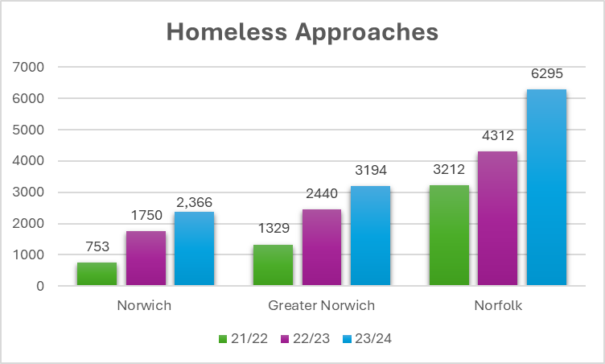

Year | Norwich | Broadland | South Norfolk | KL & West Norfolk | Breckland | Great Yarmouth | North Norfolk
2021 - 2022 | 753 | 271 | 305 | 615 | 0 | 935 | 333
2022-2023 | 1750 | 362 | 328 | 792 | 689 | 0 | 391
2023 - 2024 | 2,366 | 442 | 386 | 765 | 757 | 1,179 | 400

Homelessness prevention and relief cases
8.2 Graph two – households assessed as having a prevention or relief duty owed. Norfolk, Greater Norwich (South Norfolk, Broadland and Norwich councils combined, and Norwich)
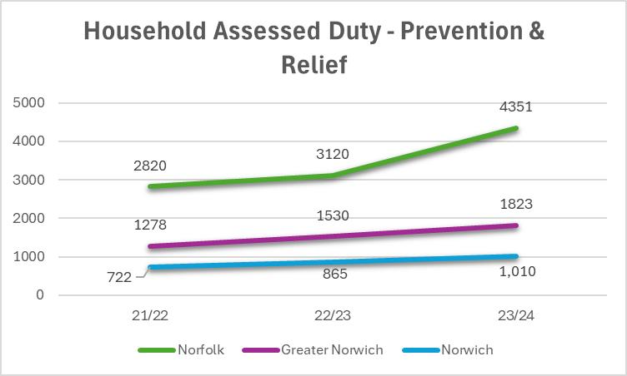

Key trends from this graph
8.2.1 We can see a clear upward trajectory in both relief and prevention cases across Norfolk. It indicates a steady rise year-on-year, with a notable 39% increase from 2022 - 2023 to 2023 - 2024. In Norwich this data highlights a consistent increase, with a total growth of 40% over the three years. Norwich alone makes up roughly 23.2% of the Norfolk total in 2023 -2024 and 55% of the cases in the Greater Norwich area in 2023 - 2024. This provides more of a picture and highlights the ongoing pressures in the city.

8.3 Graph three – households assessed as having a prevention duty

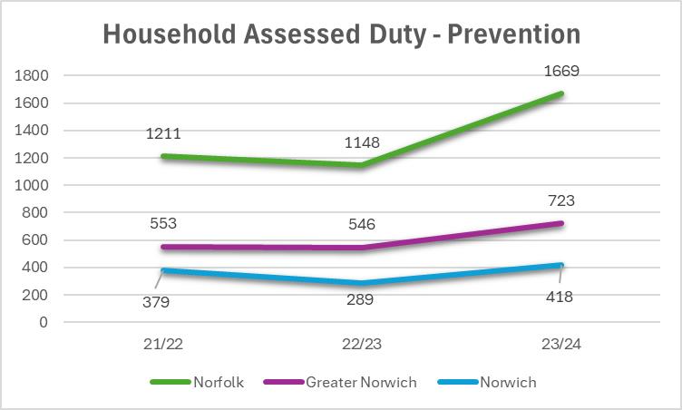
Key trends from this graph
8.3.1 All areas show a dip in 2022-2023 followed by a sharp increase in 2023-2024. Norwich’s 418 cases represent 58% of Greater Norwich’s prevention assessments in 2023-2024, reinforcing the city's role as a key pressure point within the region. The rise in prevention activity during 2023-2024 may reflect changes in the availability of support services. In Norwich specifically, the recruitment of specialist prevention officers may have contributed to early intervention and therefore keeping relief case increases steadily. Additionally, the success of the Accommodation for Ex-Offenders (AFEO) programme across Norfolk during this period may have contributed, as it focuses on early intervention and involves close collaboration with statutory partners such as probation services.

8.4 Graph four – households assessed as having a relief duty
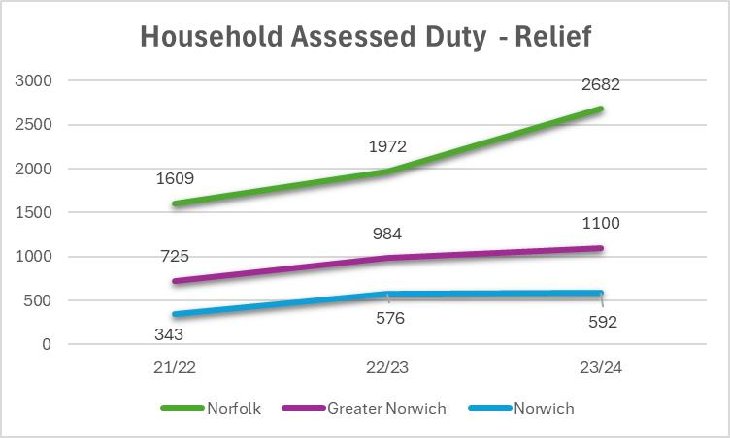

Key trends from this graph
8.4.1 Across Norfolk, increases suggest more people are approaching services at the point of housing crisis. In Norwich we saw a large increase in 2022-2023, then plateaued slightly in 2023-2024. As mentioned above the recruitment of specialist prevention officers may have supported early intervention efforts, helping to maintain a steadier rise in relief cases, in contrast to the sharper increase observed across Norfolk as a whole.

Reasons for loss of accommodation
8.5 Graph five – reason for loss of last settled accommodation - prevention duty
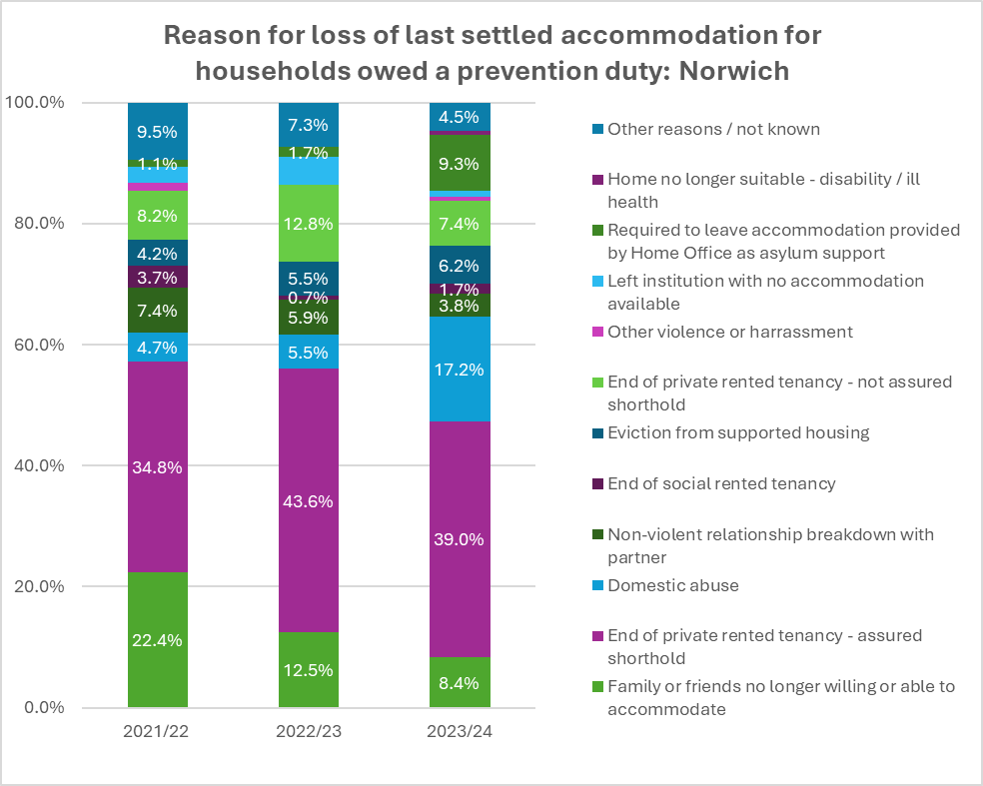
Key trends from this graph
8.5.1 End of private rented tenancy – assured shorthold:
  - 2021-2022: 34.8%
  - 2022-2023: 43.6% - large increase
  - 2023-2024: 39.0% - slight drop but still a dominant reason for individuals by owed a prevention duty.
  - This reason remains the leading cause each year, indicating that instability in the private rented sector remains a major driver of homelessness prevention in Norwich.
8.5.2 Family or friends no longer willing or able to accommodate:
  - 2021-2022: 22.4%
  - 2022-2023 12.5%
  - 2023-2024: 8.4%
    - Significant and steady decrease year on year
8.5.3 Domestic abuse:
  - 2021-2022: 4.7%
  - 2022-2023: 5.5%
  - 2023-2024: 17.2% - large increase
8.5.4 Required to leave Home Office asylum support accommodation:
  - 2021-2022: 1.1%
  - 2022-2023: 1.7%
  - 2023-2024: 9.3% - these numbers peaked in 2023 –2024
8.5.5 Eviction from supported housing:
  - 2021-2022: 4.2%
  - 2022-2023: 5.5%
  - 2023-2024: 6.2%
    - These numbers are consistent, with a small rise year on year.

8.6 Graph six – reason for loss of last settled accommodation - relief duty
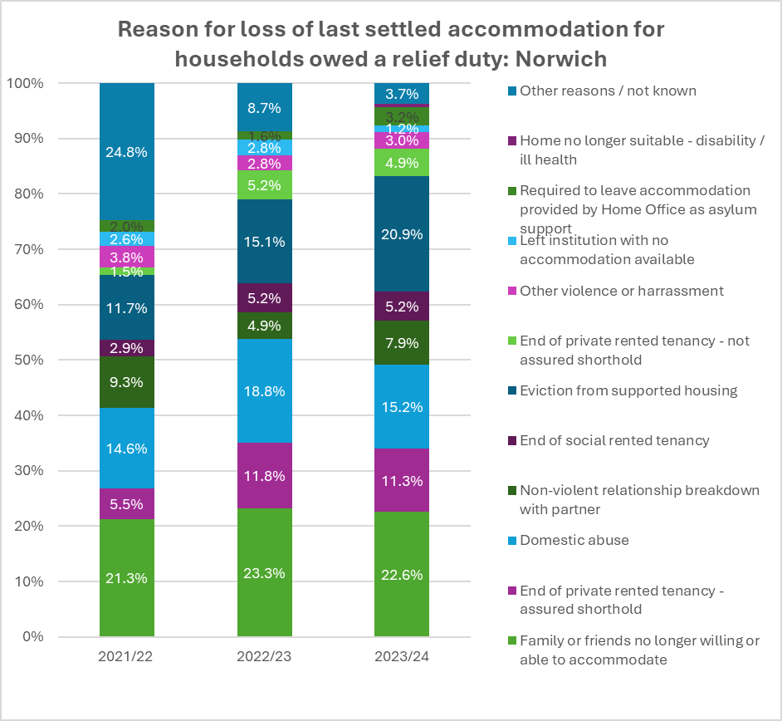

Key trends from this graph
8.6.1 Family or friends no longer willing or able to accommodate:
- This reason consistently remains one of the biggest causes of an individual being owed a relief duty.
8.6.2 Eviction from supported accommodation
- 2021-2022: 11.7%
- 2022-2023: 15.1%
- 2023-2024: 20.9%
- This reason has significantly increased year on year (we have also seen a rise within prevention cases, above). In 2023-2024 this was the second highest reason after friends and family eviction. In Norwich, we have the highest number of supported housing options in Norfolk. We recognise that eviction is typically a last resort for providers. However, collaborating as early as possible with both providers and customers to prevent homelessness is a more desirable approach than escalating to eviction. This suggests that there may be a need for further efforts in working alongside supported housing providers to reduce the risk of homelessness.
8.6.3 Eviction from supported accommodation
- 2021-2022: 11.7%,
- 2022-2023: 15.1%
- 2023-2024: 20.9%
- This reason has significantly increased year on year (we have also seen a rise within prevention cases, above). In 2023-2024 this was the second highest reason after friends and family eviction. In Norwich, we have the highest number of supported housing options in Norfolk. We recognise that eviction is typically a last resort for providers. However, collaborating as early as possible with both providers and customers to prevent homelessness is a more desirable approach than escalating to eviction. This suggests that there may be a need for further efforts in working alongside supported housing providers to reduce the risk of homelessness.
8.6.4 Domestic abuse
  - 2021-2022: 14.6%
  - 2022-2023: 18.8%
  - 2023-2024: 15.2%
    - This indicates a peak in 2022-2023 with a slight reduction in 2023-2024.
    - These numbers remain consistently high.

8.7 Table one: Top three reasons for loss of last settled accommodation - 2023 to 2024
Area | Rank | Prevention Reason | % | Relief Reason | %
England | 1 | End of private rented tenancy: assured shorthold | 39.2% | Family or friends no longer willing or able to accommodate | 28.8%
 | 2 | Family or friends no longer willing or able to accommodate | 23.3% | Domestic abuse | 15.5%
 | 3 | Domestic abuse | 15.4% | End of private rented tenancy: assured shorthold | 12.4%
East of England | 1 | End of private rented tenancy: assured shorthold | 39.7% | Family or friends no longer willing or able to accommodate | 28.9%
 | 2 | Family or friends no longer willing or able to accommodate | 24.3% | Domestic abuse | 14.4%
 | 3 | Domestic abuse | 6.9% | End of private rented tenancy: assured shorthold | 12.6%
Norwich | 1 | End of private rented tenancy: assured shorthold | 39.0% | Family or friends no longer willing or able to accommodate | 22.6%
 | 2 | Domestic abuse | 17.2% | Eviction from supported housing | 20.9%
 | 3 | Required to leave accommodation provided by Home Office as asylum support | 9.3% | Domestic abuse | 15.2%
Norfolk | 1 | End of private rented tenancy: assured shorthold | 46.4% | Family or friends no longer willing or able to accommodate | 30.6%
 | 2 | Family or friends no longer willing or able to accommodate | 21.9% | Domestic abuse | 25.6%
 | 3 | Domestic abuse | 10.4% | Non-violent relationship breakdown with partner | 9.6%
Greater Norwich | 1 | End of private rented tenancy: assured shorthold | 45.1% | Family or friends no longer willing or able to accommodate | 32.6%
 | 2 | Family or friends no longer willinga or able to accommodate | 20.8% | Domestic abuse | 18.4%
 | 3 | Required to leave accommodation provided by Home Office as asylum support | 6.6% | Eviction from supported housing | 8.8%

Key trends from this table:

8.7.1 In Norwich, the end of a private rented tenancy (assured shorthold) accounts for a significant 39% of prevention cases where individuals lost their last settled accommodation. However, this reason does not feature prominently within the relief duty figures, suggesting that early interventions by the prevention team have been effective in stopping individuals from progressing to the relief stage of homelessness.
8.7.2 Domestic abuse remains a prominent cause across both prevention (17.2%) and relief (15.2%) cases, highlighting an ongoing need for targeted support in this area.
8.7.3 The third most common cause within prevention cases is individuals being required to leave Home Office accommodation, making up 9.3%. Although a smaller proportion compared to the leading causes, this still indicates notable pressure from asylum support transitions in Norwich. Encouragingly, this issue does not appear within the relief cases, suggesting that early intervention, close collaboration with Home Office accommodation providers, and the proactive work of Norwich City Council’s refugee specialist officers have contributed positively to preventing homelessness among this group.

Support needs
8.8 Graph seven – Support needs of households owed a prevention or relief duty 2024
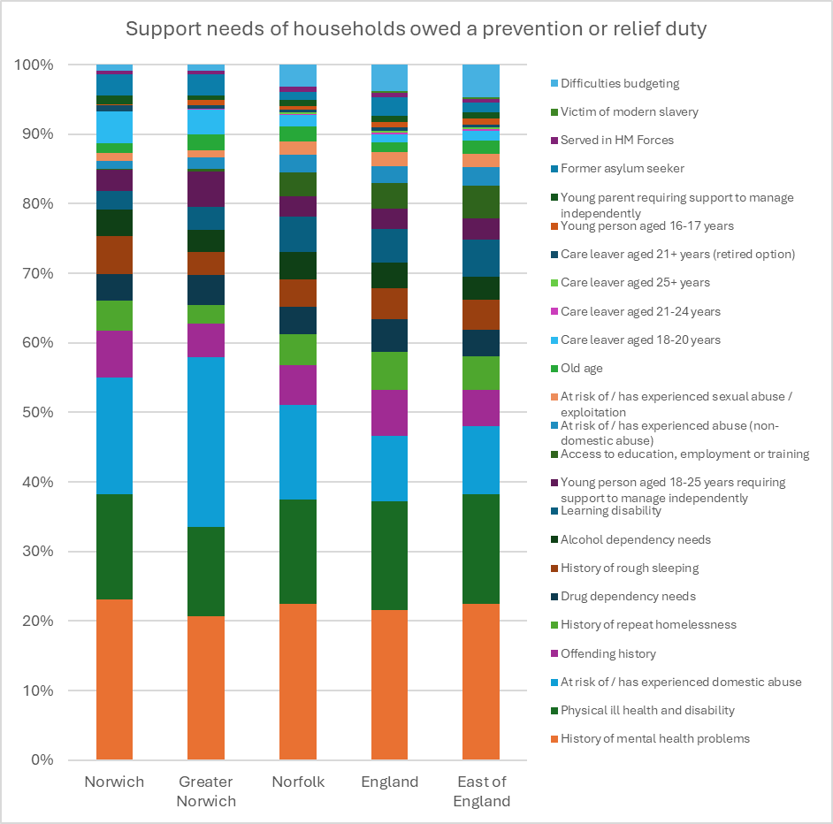
Key trends from this graph
8.8.1 This graph shows that Norwich broadly follows the same trends as wider areas, with the most commonly identified support needs among applicants being a history of mental health problems, physical ill health or disability, and households at risk of or having experienced domestic abuse. In Greater Norwich, domestic abuse support need makes up a significantly larger proportion compared to the rest of Norfolk, the East of England, and England overall.
8.8.2 It's also worth noting that the proportion of applicants with a history of offending is slightly higher in Norwich than in the wider Greater Norwich area. This is likely due to the concentration of Ministry of Justice (MoJ) services located within the city
8.8.3 Additionally, the rate of applicants with a history of rough sleeping is elevated in Norwich compared to Greater Norwich and Norfolk, which aligns with the city hosting the majority of supported housing, hostels, and direct access provision in the county.

Age of main applicants owed a prevention or relief duty
8.9 Graph eight - Age of main applicants owed a prevention or relief duty 2024
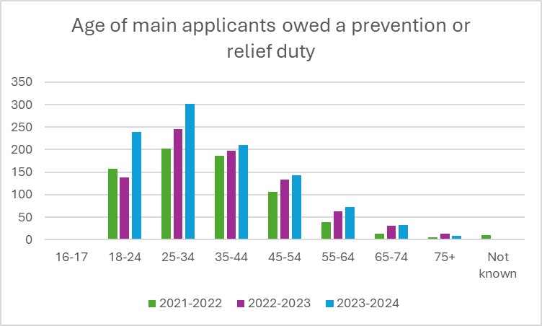

Reasons for households’ prevention and relief duty ending
8.10 Graph nine - Reasons for households’ relief duty ending
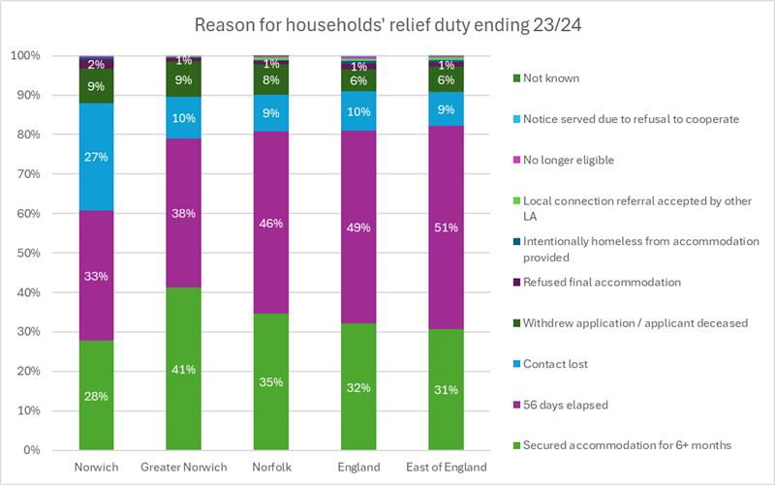

Key trends from this graph
8.10.1 Norwich shows a notably higher proportion of relief duties ending due to ‘contact lost’ compared to both local and national averages. Additionally, Norwich has a lower success rate in securing accommodation for 6+ months to end the relief duty. This may reflect the impact of competing pressures from other organisations also seeking similar accommodation options for their clients.

9 Accommodation secured
9.1 Graph ten - Type of accommodation secured for households at the end of prevention duty
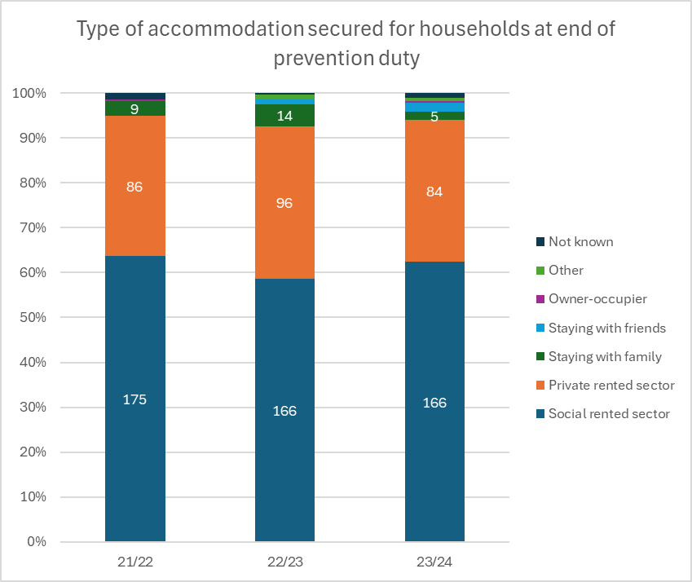

9.2 Graph eleven - Type of accommodation secured for households at end of prevention duty Norwich compared to rest of England 2023 to 2024
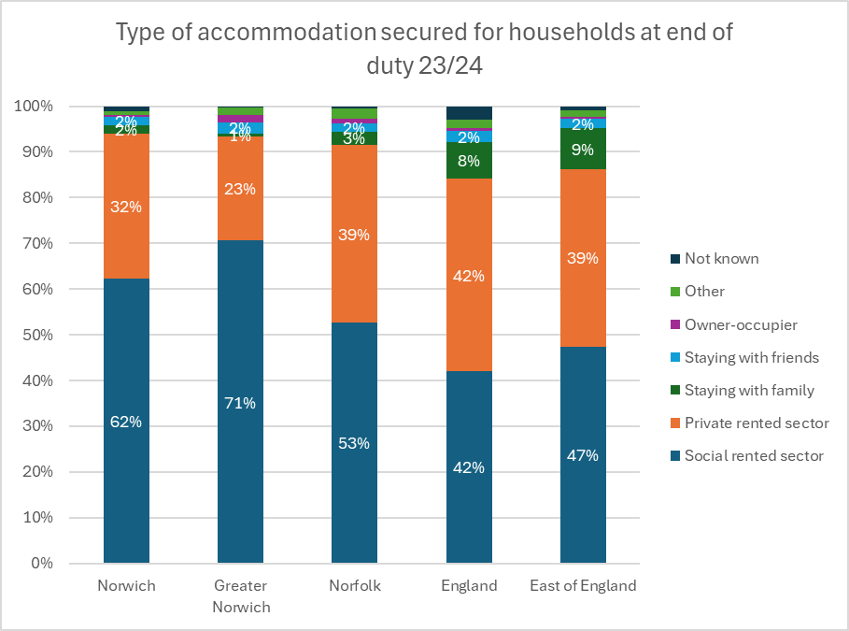

9.3 Graph twelve - Type of accommodation secured for households at the end of relief duty
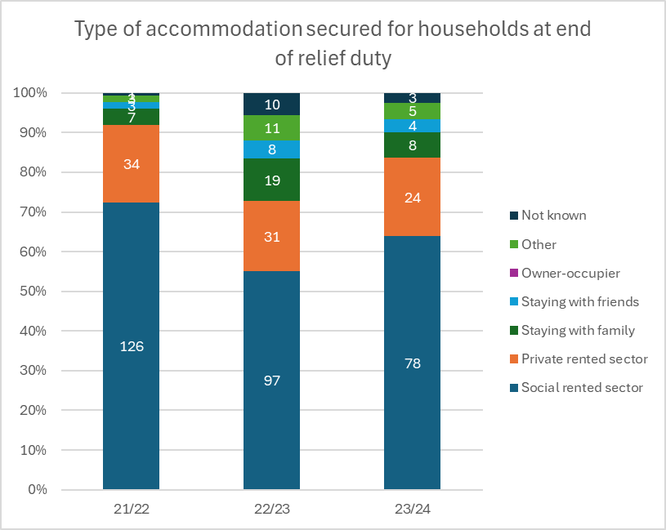

Key trends from this graph
9.3.1 The number of households securing social housing has declined each year, falling by 38% over the three-year period. This trend reflects the growing scarcity of affordable housing. In response, local authorities have increasingly looked to the private rented sector (PRS) as an alternative. However, the continued decrease in PRS placements highlights the ongoing challenges in accessing this sector.

9.4 Graph thirteen - Type of accommodation secured for households at end of relief duty Norwich compared to rest of England 23/24
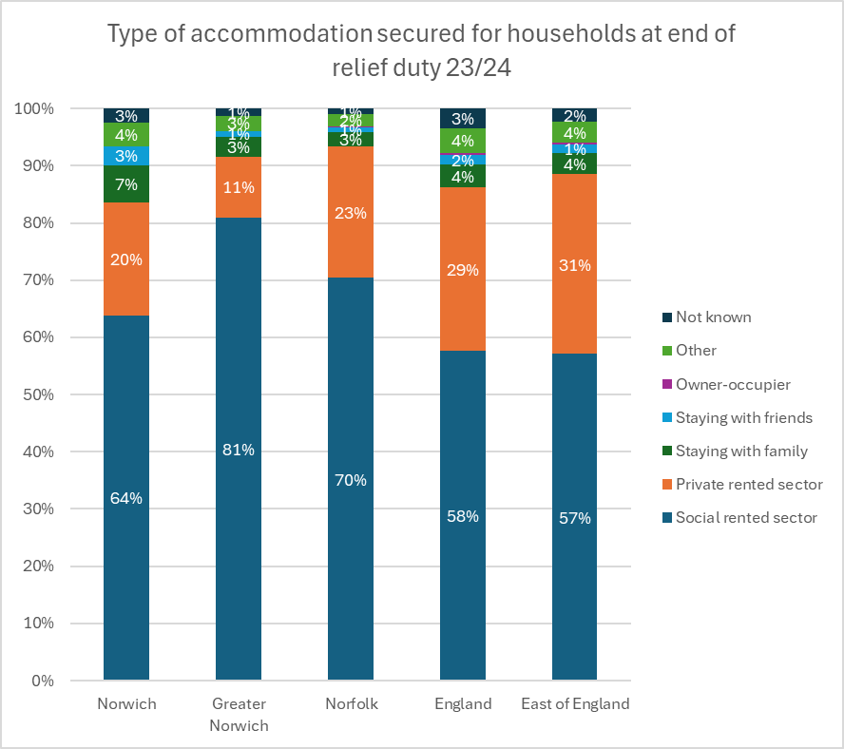

Household type
9.5 Graph fourteen - Type of households owed a prevention duty
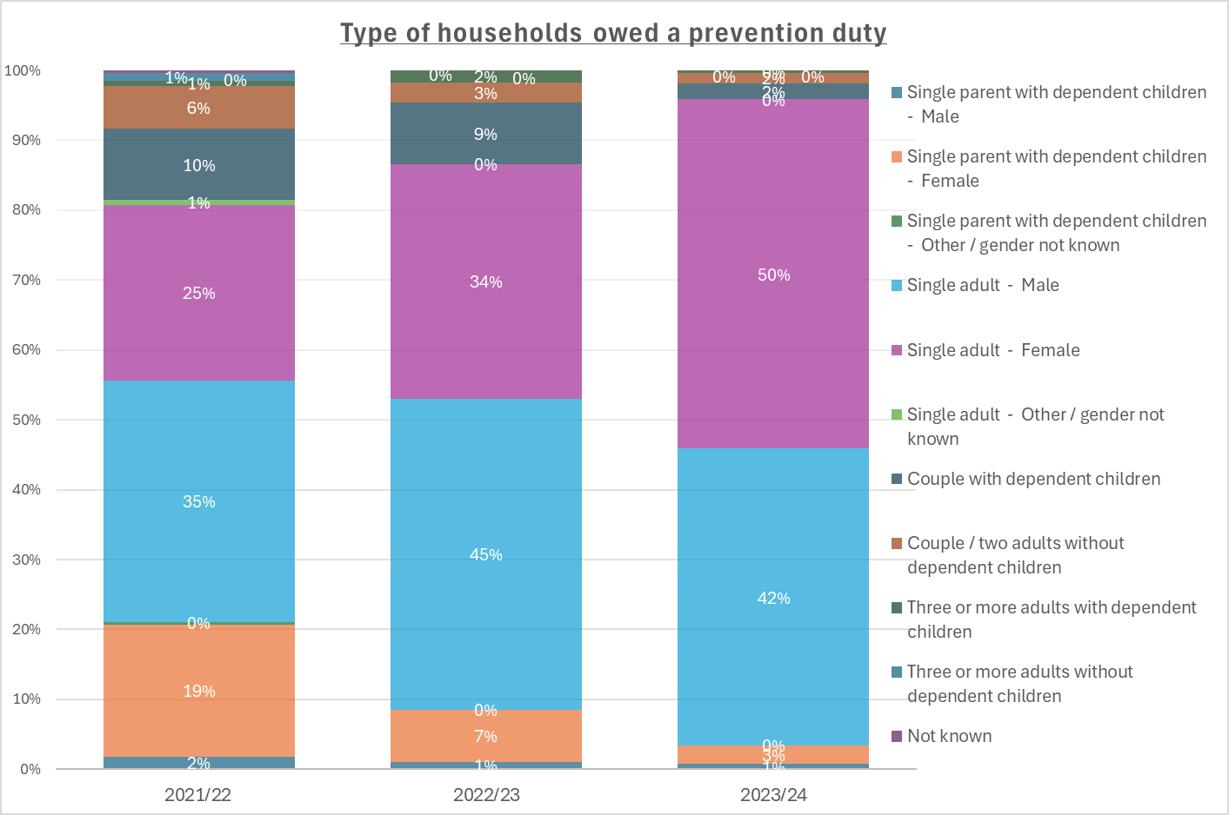
Key trends from this graph
9.5.1 We can see from this graph that there is a steady increase single females being owed a prevention duty, particularly in 2023 to 2024.
9.5.2 Single male households are a prevalent group owed a prevention duty.
9.5.3 There is a smaller percentage of households with dependent children.

9.6 Graph fifteen - Household type of households owed a relief duty
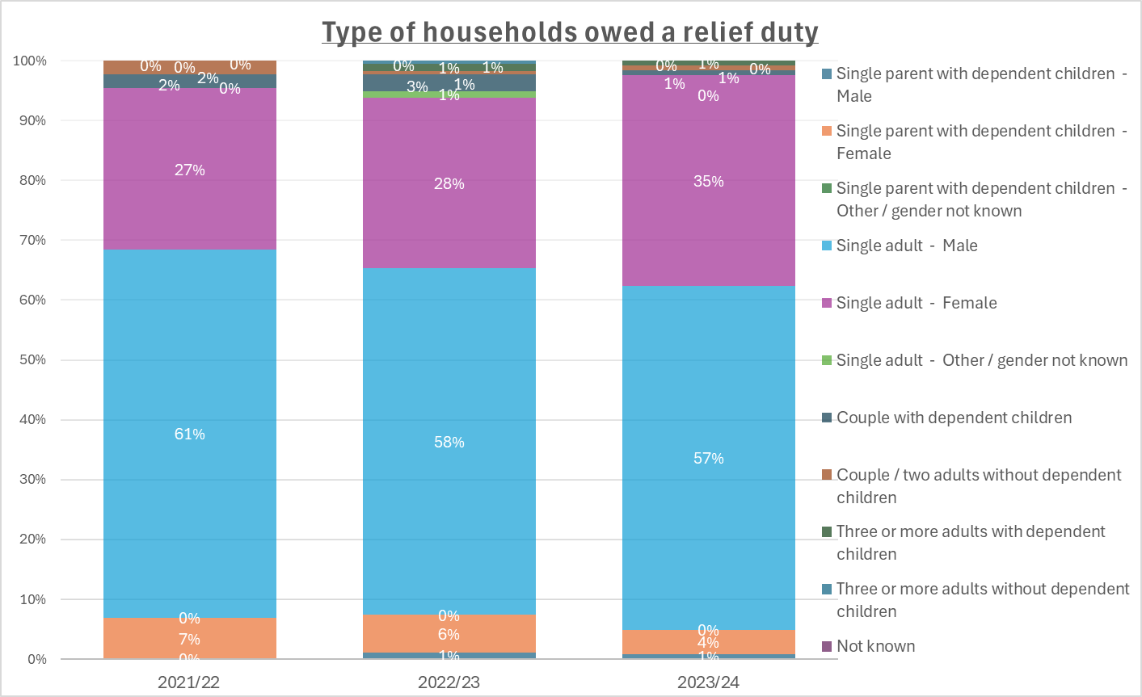

10 Main duty decisions
Outcome of main duty decisions for eligible households
10.1 Graph sixteen – Decision on duty owed at the end of the relief duty
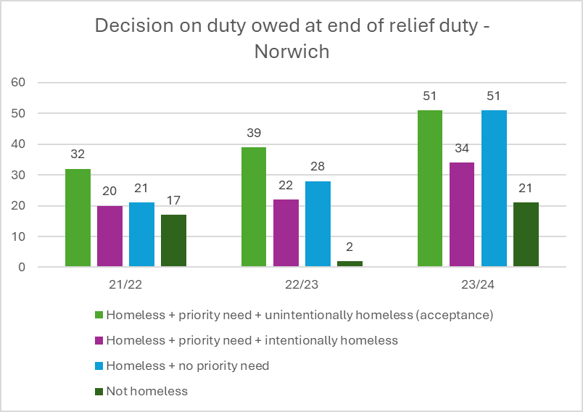
Key trends from this graph
    - There has been a consistent increase in the number of people accepted as homeless with priority need who are unintentionally homeless. There is also a notable increase in the number of applicants who have been found to have no priority need. This growing demand strengthens the case for increased investment in temporary accommodation within Norwich.

10.2 Graph seventeen – Priority need of households owed main duty
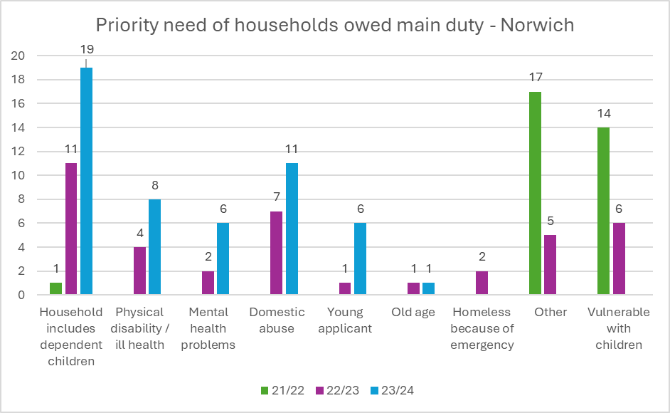
Key trends from this graph
    - The largest increase is among households with dependent children and victims of domestic abuse. There is also a consistent need related to health (both physical and mental).

Employment status
10.3 Graph eighteen – Employment status of main applicants owed a duty
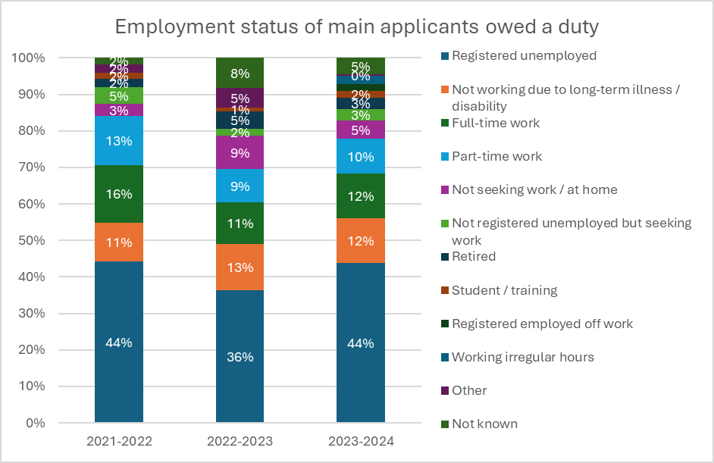
Key trends from this graph
10.3.1 This graph indicates that the majority of individuals in Norwich owed a duty (prevention or relief) are registered unemployed at 44% in 2023 to 2024. This is followed by not working due to long-term illness and or disability.

Ethnicity of main applicant owed a prevention or relief duty
10.4 Graph nineteen – ethnicity of main applicant owed a prevention or relief duty
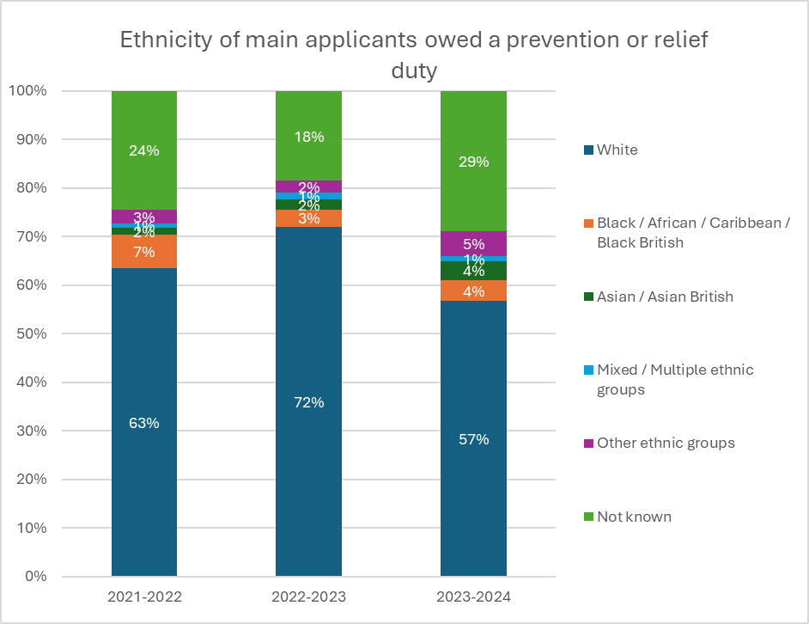

11 Rough sleeping
11.1 In the most recent annual rough sleeper snapshot survey, Norwich City Council recorded 12 rough sleepers in Norwich on a single night. While this is an increase from the previous year's count of 5, it remains within the national average of 8.2 rough sleepers per 1,000 people.
11.2 While one person sleeping rough is one too many, it is important to view these numbers in context. Norwich is recognised as an area of 'flow' due to its location and demographic compared to surrounding districts, and key facilities such as major hospitals, a prison, increased supported accommodation, and Home Office dispersal accommodation. When compared to other similar 'flow' areas, Norwich’s figures remain relatively low for a city authority

11.3 Table two – single night snapshot of people sleeping rough in Norfolk local authority areas. East of England and England.
 | 2019 | 2020 | 2021 | 2022 | 2023 | 2024
England | 4,266 | 2,688 | 2,443 | 3,069 | 3,898 | 4,667
East Of England | 458 | 266 | 241 | 285 | 337 | 412
Breckland | 16 | 8 | 8 | 15 | 6 | 32
Broadland | 1 | 3 | 2 | 1 | 1 | 1
Great Yarmouth | 21 | 18 | 9 | 7 | 8 | 23
King's Lynn and West Norfolk | 3 | 11 | 1 | 3 | 2 | 7
North Norfolk | 10 | 7 | 3 | 4 | 1 | 4
Norwich | 18 | 21 | 10 | 7 | 5 | 12
South Norfolk | 0 | 2 | 1 | 0 | 7 | 1
Greater Norwich | 19 | 26 | 13 | 8 | 13 | 14
Norfolk | 69 | 70 | 34 | 37 | 30 | 80

11.3.1 The table above presents data derived from rough sleeping snapshot figures. Each autumn, local authorities are instructed by the MHCLG to conduct a count of rough sleepers on a single night, providing a one-night snapshot. As shown in the table, there was a noticeable decrease in rough sleeping numbers across most areas and England as a whole in 2020 and 2021. This decline is likely linked to the ‘Everyone In’ initiatives introduced in response to the Covid-19 pandemic. However, if we consider the overall trend excluding the pandemic-affected years, there is a gradual upward trend in rough sleeping emerging across Norfolk.

Age of people sleeping rough
  - Graph twenty – Age of people sleeping rough
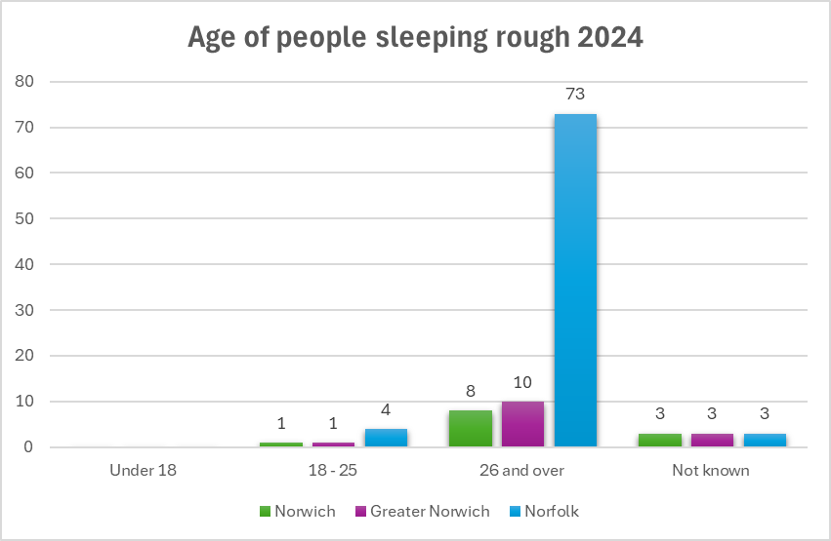
11.4.1 The majority of people sleeping rough are aged 26 and over, reflecting the national picture across England, where 4,019 individuals experiencing rough sleeping fall within this age group

11.5 Graph twenty-one – Gender of people sleeping rough 2024
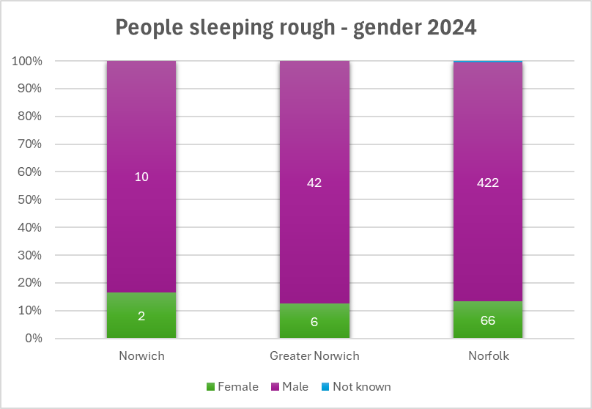

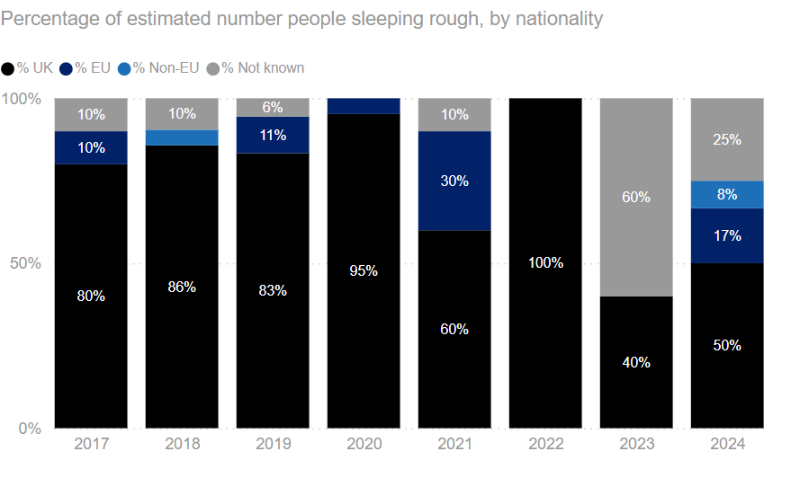
11.6 Graph twenty-two – Nationality of people sleeping rough in Norwich from 2017

11.6.1 Trends from the graph show that UK nationals consistently represent the largest proportion of this group. The number of EU nationals fluctuates over the period, while non-EU nationals make up a small but steady minority.
11.6.2 From 2023 onwards, a notable portion of the data is recorded as 'unknown.' Engaging with people sleeping rough can be challenging, and individuals are under no obligation to disclose personal details such as age, gender identity, or nationality. As a result, it is difficult to determine the exact demographic breakdown by nationality. However, in Norwich, we are supported by organisations that assist individuals for whom English is not a first language, alongside dedicated outreach teams that respond proactively to StreetLink referrals. Thanks to these services, the council maintains a strong understanding of the individuals sleeping rough in the area

12 Pathways Norwich
12.1 The following statistics have been collected from the 2023 to 2024 Pathways annual report. The information gathered is provided by the consortium partners who at the time provided the following services -
12.2 Services offered by Pathways Norwich during this reporting period
- Street Outreach Team with speciality roles
- Tenancy Engagement
- Resettlement Services
- Volunteer Coordinator
- Nourish
- Dry House
- Young person's crash bed support
- Housing First
There is also a mental health nurse and general nurse practitioner.

13 Temporary accommodation
13.1 Table three – Average number of placements in temporary accommodation (TA)
Year | Average number of people placed in TA
2021 to 2022 | 312
2022 to 2023 | 319
2023 to 2024 | 375

13.1.1 Securing suitable temporary accommodation within Norwich presents ongoing challenges. Currently, the council predominantly relies on pay-nightly accommodation, supplemented by a limited number of temporary accommodation units managed by a local homelessness charity. There is a recognised and growing need for Norwich to invest in additional temporary accommodation to better meet demand and provide more stable and supportive housing solutions. While not all applicants with a priority need will require temporary accommodation provided by the council, the data in Graph sixteen clearly shows an upward trend in the number of applicants assessed as having a priority need. This growing demand strengthens the case for increased investment in temporary accommodation within Norwich.

14 Projecting Future Homelessness
14.1 Norwich City Council is facing increasing pressure to meet rising demand for housing services, driven by a combination of local and national factors. The number of individuals and families seeking housing support continues to grow, reflected in a consistent year-on-year increase in homelessness approaches. This trend is particularly pronounced in Norwich, where demand has escalated at a much faster rate than in neighbouring local authorities, which have seen steadier increases over the past four years.
14.2 The cost-of-living crisis is a key driver behind this rise in demand. In addition, Government policies such as the asylum dispersal scheme are likely to further increase pressure. This includes unaccompanied asylum-seeking children (UASC) who when they turn 18 can present to any authority in Norfolk, with the majority choosing to reside in the city.
14.3 The Government’s decision to implement early prisoner releases from summer 2024, aimed at reducing overcrowding in the prison estate, has added further pressure to housing services. At the time of writing, it is anticipated that similar initiatives may be introduced in the future, which could continue to impact local housing demand.
14.4 At present, the council is also awaiting further details on the Renters’ Reform Bill, which could have significant implications for how services are delivered.
14.5 As highlighted earlier in this review, reductions in housing-related support services are already impacting both accommodation-based and non-accommodation-based provision, such as the Pathways Norwich partnership. These pressures combined underscore the urgent need for increased investment and strategic planning in temporary and supported housing solutions.
14.6 The council has developed a model using historic data that helps to predict the future demand for services. We are currently estimating that demand for services in 2025 to 2026 will increase by 15 per cent.

14.7 The emerging 2025 - 2030 Homelessness and Rough Sleeping Strategy will be rolled out in a time of significant uncertainty. Food and fuel prices remain high, the private rented sector continues to contract, and potential changes in government policy may add further unpredictability. The city also faces persistent barriers to increasing the supply of affordable and social housing, including nutrient neutrality requirements and challenges related to planning infrastructure.

14.8 Table four – Cases assessed, and duty owed for the first three quarters of 2024.
Stage of Cases | Case Number April-December 2024
Cases assessed | 1431
Duty owed | 781

14.9 By reviewing data from the first three quarters of 2024 alongside trends since 2021, we can calculate an average to estimate the likely annual totals for both cases assessed and those owed a duty. Projections suggest that the overall number of cases in 2024 to 2025 will be lower than in 2023 to 2024.
14.10 Based on historical trends and the external factors outlined above, it is reasonable to project a 15% increase in homelessness approaches and duties owed by 2026 to 2027. Using the average number of approaches since 2021 as a baseline, a 15% increase would result in approximately 1,950 people seeking advice from the council in 2025 to 2026.
14.11 Despite current challenges and uncertainty around future service demands and external influences, the council is well-prepared to respond to rising needs. This is evidenced by the successful delivery of many actions from the previous Homelessness and Rough Sleeping Strategy. The council remains committed to informed decision-making by enhancing data analysis, staying up to date with central Government guidance, and maintaining strong partnerships with a broad network of stakeholders.


If you need this information by email for use with the
read-aloud function or in an alternative format, please
contact us on 0344 980 3333 or visit norwich.gov.uk/intran

Produced by Norwich City Council
www.norwich.gov.uk

