Festive Light Switch-On 2026 – accessibility information
We’re committed to making the Festive Light Switch On 2026 accessible to everyone. This page provides details on accessible viewing areas, travel options, sensory considerations, and support services. If you need this information in another format or language, please contact us.

Event map
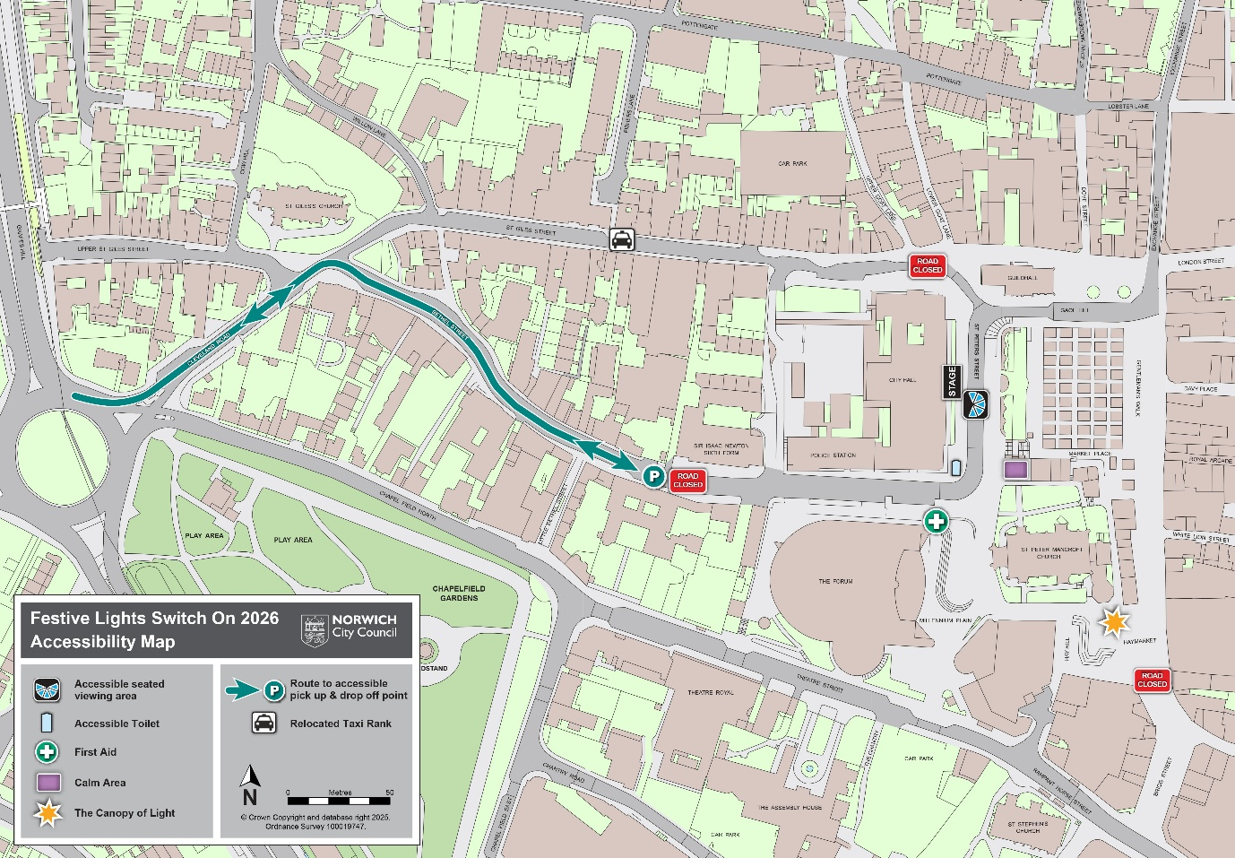

Access points and viewing area
- Street-level access is available throughout the event.
- An accessible viewing area is located on St Peters Street, near the main stage.
  - Access is via level concrete pavements and one low-level ramp.
  - The viewing area is situated on concrete.
  - Booking is required:
    - Email: events@norwich.gov.uk
    - Phone: 01603 989333
    - Deadline: Friday 13 November 2026
  - Opening times: 5:15pm – 7:30pm
    - Bookings are free.
    - Booked spaces will be held until 6pm, then offered on a first-come, first-served basis.
  - Facilities:
    - Moveable chairs available
    - Clear signage
    - Accessible Portaloo, situated at entrance to viewing area, (approx. 20m from viewing area)
    - Additional accessible toilets: The Forum, Norwich Market, Chantry Place
    - Closest Changing Places toilet: inside The Forum
  - Support: Two accessible area stewards and security staff will be present to assist.

Event details

Main stage
- Located on the steps of City Hall, directly in front of the accessible viewing area.
- Showtime: 5:30pm – 7pm
- Sensory information:
  - Noisy and colourful environment during the show times
  - Loud music, flashing lights, pyrotechnics, snow machines, and large beach balls being thrown into crowd
  - Snow is a non-toxic and safe foam, but may dampen clothing
  - No strobe lighting used
  - Earplugs available on request

Food and refreshments
- No designated food court
- Closest food vendors: Norwich Market (street-level, slight gradient)
- No refreshment bar
- No box office – all events are free to attend

Travel and parking
- Public transport: Visit Norfolk County Council for travel and accessibility info
- Road closures:
  - 10am to 9pm: St Peters Street and Bethel Street (Forum Car Park to St Peters St)
  - 5pm to 9pm: Gaol Hill, Guildhall Hill, Gentleman’s Walk, Brigg Street, White Lion Street, London Street, Exchange Street
  - Upper Goat Lane: one-way restriction reversed (northbound traffic allowed)
- Drop-off point: Bethel Street
- Disabled parking bays:
  - Open: St Benedict’s Street, St Giles Street, Brigg Street, Surrey Street, All Saints Green
  - Closed: Bethel Street, Gentleman’s Walk, Exchange Street (outside Halifax), London Street
- Car parks: No closures

Medical and support services
- First Aid available on site
- Assistance dogs welcome: We welcome all assistance dogs, including those trained by their owners.
  - Must stay close to owner
  - Be under control and unlikely to foul
  - Wear a hi-vis jacket

Quiet and calm spaces
- Quiet Room: City Hall Wellbeing Room
  - Entrance: Bethel Street
  - Check-in: Welcome desk with security
  - Security staff available to guide you
- Calm area: Within closed off Motorbike Park (corner of St Peters Street and Bethel Street)

Emergency procedures inside City Hall
- Fire alarm: Evacuate immediately. Please let Staff know when you arrive if you require assistance to evacuate the building.
- Feeling unwell: Contact security for help.

Contact us
Culture and events team
- Email: events@norwich.gov.uk
- Phone: 01603 989333
We aim to respond to accessibility queries within:
- 5 working days (standard)
- 3 working days (within one month of the event)
Note: Applications for the viewing area made less than two weeks before the event may not be guaranteed due to limited capacity.

Alternative formats
If you need this information in another format (e.g. large print, CD, Braille, or another language), please visit www.norwich.gov.uk/Intran or call 0344 980 3333.

